PUBLIC ART
COMMISSIONING
AGREEMENT

The Council of the City of Sydney &
The Artist

City Art Laneways
Temporary Public art Program

The Council of the City of Sydney
Town Hall House
456 Kent Street
SYDNEY NSW 2000

Reference:

©Copyright 2014 - The Council of the City of Sydney

PUBLIC ART COMMISSIONING AGREEMENT

THIS AGREEMENT is made on the date set out in Item 1 of Schedule 1.

BETWEEN

(1) THE COUNCIL OF THE CITY OF SYDNEY of Town Hall House, 456 Kent Street, Sydney, NSW, 2000 (“the City”), and

(2) THE PARTY set out in Item 2 of Schedule 1 (“the Artist”)

BACKGROUND

A. The City wishes to commission the design, fabrication, delivery and installation of the Artwork for the Project.

B. The parties have agreed that the Artwork will be created and delivered on the terms of this Agreement.

OPERATIVE PART

- INTERPRETATION

  - In this Agreement, unless the context otherwise requires:

“Agreement” means this document including all schedules and attachments.

“Artist” means the artist commissioned by the City to undertake the Artwork on the terms and conditions set out in this Agreement.

“Artwork” means the public art described in Item 6 of Schedule 1 and as further developed in the course of this Agreement.

“Stage One Artist Brief” means [insert details].

“Artist’s Created Intellectual Property Rights” means all Intellectual Property Rights, created by the Artist in the Artwork.

“Artist’s Fee” means the fee payable to the Artist for the Commission as specified in Item 9 of Schedule 1.

“City Art Asset Register Form” means the document set out in Schedule 4.

“City’s Representative” means the person specified in Item 3 of Schedule 1.

“Commission” means the commissioning of the Artist to undertake the Artwork in accordance with this Agreement.

“Completion Date” means the date on which the City issues a notice of completion to the Artist under clause 9.

“Confidential Information” means the terms of this Agreement and information of a party (and its employees, officers, agents and contractors) (disclosing party) that is: (i) made available to or otherwise obtained by the other party (or its employees, officers, agents or contractors) (receiving party); or (ii) by its nature confidential or the receiving party knows, or ought reasonably to know, is confidential. Confidential Information does not include information that: (a) is in or enters the public domain through no fault of the receiving party; (b) is or was made available to the receiving party by a person (other than the disclosing party) who is not or was not then under an obligation of confidence to the disclosing party in relation to that information; or (c) is or was developed by the receiving party independently of the disclosing party.

“Contractor” means the person or persons the City may engage to carry out the fabrication and/or installation of the Artwork for the Project.

“Cost Plan” means the budget for the Artwork as set out in Schedule 2 as amended from time to time.
.
“Curatorial Advisor” is the Curator engaged by the City to advise on and oversee the curatorial aspects of the Project.

“Indigenous Cultural and Intellectual Property” (ICIP) means the rights that Indigenous people have, and want to have, to protect their traditional arts and culture. ICIP includes but is not limited to the following rights:
- right to protect traditional knowledge and sacred cultural material;
- right to ensure that traditional laws and customary obligations are respected;
- right to full and proper attribution or naming of the community connected with the ICIP;
- right to prevent insulting, offensive and misleading uses of ICIP in all media; and
- right to control the recording of cultural customs and expressions, and language which may be essential to cultural identity, knowledge, skill, teaching about Indigenous culture.
“Initial Period” means the period specified in Item 4 of Schedule 1.

“Intellectual Property Rights” means all present and future rights conferred in law in relation to any copyright, trade marks, designs, patents, circuit layouts, plant varieties, business and domain names, inventions and Confidential Information, and other results of intellectual activity in the industrial, commercial, scientific, literary or artistic fields, throughout the world, whether or not registrable, registered or patentable that exist or that may come to exist anywhere in the world.

“Program” means the program for completion of the Commission in accordance with the Stages in Schedule 3 to be provided to the Artist in accordance with clause 5 and as amended from time to time.

“Project” means the project specified in Item 5 of Schedule 1.

“Schedule” means a schedule attached to this Agreement and forming part of this Agreement.

“Site” means the location for the Artwork specified in Item 7 of Schedule 1.

“Site Owner” means the person/entity specified in Item 8 of Schedule 1.

“Specifications” means the documentation developed by the Artist and approved by the City in accordance with clause 4, as amended from time to time.

“Stage” means each stage of the Commission as set out in Schedule 3.

“WHS Laws” means the Work Health and Safety Act 2011 (NSW), the Work Health and Safety Regulation 2011 (NSW) and other instruments under them including any codes of practice and any consolidations, amendments, re-enactments, or replacements of them.

  - Headings are for convenience only, and do not affect interpretation. The following rules also apply in interpreting this Agreement, except where the context makes it clear that a rule is not intended to apply.

  - A reference to:

      - a legislative provision or legislation (including subordinate legislation) is to that provision or legislation as amended, re-enacted or replaced, and includes any subordinate legislation issued under it;

      - a document (including this document) or agreement, or a provision of a document (including this document) or agreement, is to that document, agreement or provision as amended, supplemented, replaced or novated;

      - a party to this document or to any other document or agreement includes a permitted substitute or a permitted assign of that party;

      - a person includes any type of entity or body of persons, whether or not it is incorporated or has a separate legal identity, and any executor, administrator or successor in law of the person; and

      - anything (including a right, obligation or concept) includes each part of it.

  - A singular word includes the plural, and vice versa.

  - A word which suggests one gender includes the other genders.

  - If a word or phrase is defined, any other grammatical form of that word or phrase has a corresponding meaning.

  - If an example is given of anything (including a right, obligation or concept), such as by saying it includes something else, the example does not limit the scope of that thing.

  - The words subsidiary, holding company and related body corporate have the same meanings as in the Corporations Act.

  - A reference to dollars or $ is to an amount in Australian currency.

  - Words defined in the GST Act have the same meaning in clauses about GST.

  - This Agreement is not to be interpreted against the interests of a party merely because that party proposed this document or some provision in it or because that party relies on a provision of this document to protect itself.
  - This Agreement applies to the performance of all stages of the Commission detailed in Schedule 3 whether carried out before or after the date of this Agreement.

- THE COMMISSION

  - The Artist must create and deliver the Artwork on the terms of this Agreement.

- PERFORMANCE

  - Warranty

The Artist warrants that it has the skill and ability to undertake the Commission in accordance with the requirements of this Agreement and acknowledges that the City has entered into this Agreement in reliance on this warranty.

  - Performance Standards

The Artist must undertake the Commission with the standard of skill, care and diligence expected of a skilled professional Artist experienced in commissions of that type.

  - Materials

The Artist must use high quality materials which are safe and suitable for the proposed use of the Artwork.

  - Stages

      - The Artist must deliver the Artwork in accordance with the requirements set out in Schedule 3.

      - The Artist must not commence work on a Stage until the City has given written notice. The City may decide not to proceed with a Stage in its absolute discretion.

- VARIATIONS TO THE SPECIFICATION

  - The City may request the Artist to vary the Specifications, and provided that the variation falls within the general scope of the Commission, the Artist must vary the Specifications as requested.

  - The Artist is not entitled to additional payment for any work performed as part of a request for a variation to the Specifications to comply with the approved Cost Plan.

  - If, through no instruction of the City, costs for the Artwork are exceeding or likely to exceed the Cost Plan for the Stage, the Artist (at its cost) must redesign the work in the Stage to ensure the Cost Plan is met.

  - Where the Specifications have been varied in accordance with a request by the City, the Artist may claim any additional costs incurred by it as a result of the variation. Where the City is satisfied that the costs were reasonably incurred as a result of the variation, it will revise the Artist Fee to take into account such reasonable costs.

- VARIATIONS TO THE PROGRAM

  - The City may change the Program by issuing a revised Program.

  - If the Artist will be delayed in completing the Artwork because of one of the reasons set out in clause 5.3, it may request the City to issue a revised Program, including written reasons for the delay and the anticipated length of the delay.

  - The City will issue a revised Program following a request under clause 5.2 if it is satisfied that the delay is due to:

      - an event beyond the reasonable control of the Artist;

      - delay caused by the City, its employees, contractors or other agents; or

      - breach of this Agreement by the City.

  - Where a revised Program is issued under clause 5.1 or 5.3, the Artist may claim any additional costs incurred by it as a result of the issue of the revised Program. Any claim for additional costs must be made within 30 days of the revised Program being issued. Where the City is satisfied that the costs were reasonably incurred as a result of the issue of the revised Program, it will revise the Artist Fee to take into account those reasonable costs.

- LIAISON BETWEEN THE ARTIST AND CITY

  - The City’s Representative will be available on reasonable notice to the Artist to discuss the Artwork as required.

  - The Artist must be available for discussions with the City’s Representative, the Site Owner or other persons nominated by the City on reasonable notice.

  - The City will secure permits and other approvals to install the Artwork.

  - The City will support the Artist in:

      - working collaboratively with the City in order to integrate the Artwork into the Site;

      - securing permits and other approvals to install the Artwork;

      - consultation with key stakeholders and the community; and

      - marketing and promoting the Project.

- NON-CONFORMING WORK AND DEFECTS

  - The City may at any time direct the Artist to correct non-conforming work or any defect in the Artwork, which may include removal or replacement, at no cost to the City and within a specified time.

  - If the Artist does not correct the non-conforming work or defect within the period specified by the City:

      - the City may engage others to carry out the rectification work; and

      - the Artist will be responsible for the reasonable costs of any rectification work undertaken by others engaged by the City; and

      - the Artist must pay those costs on demand, and the City may set off those costs against any money the City owes the Artist.

- CARE OF SITE

  - The Artist acknowledges and agrees that upon being granted access to the Site, it will be responsible for the care of the Site.

  - The Artist must keep the Site in a safe and clean condition until the installation of the Artwork is completed and the City issues a completion notice under clause 9.

  - The City may at any time direct the Artist to undertake any restoration of the Site which the City reasonably considers necessary. The Artist must comply with the direction within the time specified in the direction at its own cost.

  - If the Artist does not comply with a direction under clause 8.3:

      - the City may engage others to carry out the restoration of the Site;

      - the Artist will be responsible for the costs of the restoration;

      - if the Artist fails to pay such costs, the City may deduct those costs from the Artist’s Fee.

- COMPLETION

  - When the Artist is of the opinion the Artwork is satisfactorily completed in accordance with this Agreement the Artist must deliver to the City a written notice requesting the City to inspect the Artwork and the Site.

  - Upon receipt of a notice under clause 9.1, the City will inspect the Artwork and the Site and if the City is satisfied that:

      - the Artwork has been satisfactorily completed;

      - the Site has been restored to the satisfaction of the City and the Site Owner; and

      - the Artist has completed the City Art Asset Form,

the City will issue a notice of completion to the Artist nominating the Completion Date. Upon issue of the notice of completion, all title and risk in the Artwork will pass to the City.

  - If the City disputes that the Artwork has been satisfactorily completed according to the Specifications or that the Site has been satisfactorily restored, it must provide to the Artist within 14 days of the inspection a written notice stating the nature of the dispute and the required action by the Artist to achieve completion within a reasonable specified period.

  - If the Artist does not comply with a direction under clause 9.3:

      - the City may engage others to carry out the work required to achieve completion;

      - the Artist will be responsible for the reasonable costs of any completion work as per the Artist’s scope in Schedule 3 of this agreement;

      - if the Artist fails to pay such costs, the City may deduct those costs from the Artist’s Fee.

- PAYMENT & GST

  - The City will pay to the Artist the Artist’s Fee in accordance with Item 9 of Schedule 1 following the Artist’s performance of the terms of this Agreement and the receipt of a valid tax invoice.

  - Subject to satisfactory performance of the Artist and its subcontractors under this Agreement, the Artist’s Fee must be paid to the Artist or to a subcontractor nominated by the Artist at the completion of each stage of the Commission, or at other such times as agreed between the Artist and the City. The Artist must provide the City with a claim for payment supported by evidence of the amount due to the Artist or to the Artist’s subcontractors.

  - The City must:

      - where the City does not dispute a claim, pay the Artist or subcontractor nominated by the Artist the amount claimed; or

      - notify the Artist that it disputes the amount claimed.

  - If the Artist and the City are unable to resolve a dispute which arises under clause 10.3(b), the City will pay the Artist any undisputed amounts and clause 20 will apply.

  - Amounts referred to in this Agreement are exclusive of GST.

  - If one party (Supplying Party) makes a taxable supply and the consideration for that supply does not expressly include GST, the party that is liable to provide the consideration (Receiving Party) must also pay an amount (GST Amount) equal to the GST payable in respect of that supply.

  - Subject to first receiving a tax invoice or adjustment note as appropriate, the Receiving Party must pay the GST Amount when it is liable to provide the consideration.

  - If one party must indemnify or reimburse another party (Payee) for any loss or expense incurred by the Payee, the required payment does not include any amount which the Payee (or an entity that is in the same GST group as the Payee) is entitled to claim as an input tax credit, but will be increased under clause 10.6 if the payment is consideration for a taxable supply.

- CONTRACTOR STATUS

  - The Artist is an independent contractor without authority to bind the City by contract or otherwise and the Artist is not an agent or employee of the City.

  - The Artist must not assign its rights or interests under this Agreement.

  - If the Artist is more than one person then the obligations of those persons are joint and several.

- SUBCONTRACTORS

  - The Artist must not engage any subcontractor other than those listed in Item 11 of Schedule 1 without the City’s prior written consent. The City may withhold or condition its consent in its absolute discretion.

  - The appointment of one or more subcontractors does not relieve the Artist of its obligations under this Agreement. The Artist:

      - is responsible for ensuring each subcontractor performs its subcontract in accordance with this Agreement; and

      - is liable to the City for the acts and omissions of the Artist’s subcontractors as if they were acts or omissions of the Artist.

  - The Artist:

      - agrees that the City may direct the Artist to remove any subcontractor from performing any part of the Commission:

        - for misconduct; or

        - for failure to perform its obligations.

      - must comply with a direction given in accordance with clause 12.3(a) within the period specified by the City.

- WORK HEALTH AND SAFETY

  - The Artist must:

(a) comply with all applicable legislation, including the WHS Laws; and

(b) have a work health and safety management system in place that is capable of complying with this Agreement and the WHS Laws.

13.2 The Artist and the City will if necessary, consult, cooperate and coordinate activities with each other and with any other persons who have a common duty under the WHS Laws.

- INSURANCE

  - The Artist must effect and keep current until the Completion Date insurance policies as specified in Item 12 of Schedule 1.

  - On signing this Agreement and when requested in writing the Artist must give the City:

      - acceptable proof of the insurance policies taken out; and

      - acceptable proof of the maintenance of insurance for the period required.

- INTELLECTUAL PROPERTY

  - The Artist will retain ownership of the Artist’s Created Intellectual Property Rights.

  - The Artist grants to the City a perpetual, worldwide, irrevocable, royalty free and non-exclusive licence to use and reproduce the Artist’s Created Intellectual Property Rights in the Artwork including:

      - the right to retain a digital copy of the Artwork for archival purposes; and

      - the right to reproduce the Artwork in annual reports, on the City’s website, print media or other promotional publications.

      - the right to reproduce images of and materials about the Artwork for displays, documentaries’ and exhibitions.

  - The City may sublicense the rights in clause 15.2 to its contractors for the purposes of the City enjoying its licence rights.

  - The Artist warrants that:

      - it has the authority to enter into this Agreement; and

      - the Artwork will be an original work and will not infringe the Intellectual Property Rights of any person; and

      - where the Artwork contains third party material, the Artist has obtained all consents and licences necessary to permit the use of the material in accordance with this Agreement.

The City must not grant any third party the right to exploit the Artwork commercially.

- Indigenous Cultural and Intellectual Property (ICIP)

  - The City acknowledges and agrees:

      - It will respect the ICIP of the Service Provider

      - The ownership of the ICIP in the Deliverables will remain with the Service Provider at all times.

      - The City will not use the Deliverables for any other purposes than agreed to by the Service Provider; [for example]
        - the right to reproduce the Deliverables in annual reports on the City’s websites, print media or other promotional productions; and
        - the right to produce images of and materials about the Deliverables for displays documentaries and exhibitions.

      - The City will clearly credit the Service Provider as the owner and provider of the Deliverables as part of its use of the Deliverables.

      - The ownership of the ICIP in the Deliverables remains at all times the property of the Service Provider. The City acknowledges that its use of the Deliverables will not affect the Service Provider’s ICIP ownership in the Deliverables.

      - The City warrants and agrees that it will not use the Deliverables in a materially different context or edit, enhance, distort or alter the Deliverables in any way which would substantially discredit the Service Provider or be derogatory or bring into disrepute or otherwise adversely affect the image or reputation of the Service Provider, the ICIP in the Deliverables, or any person involved in the production of the Deliverables.

      - The City warrants and agrees that it will not lend, give, sell or allow use of the Deliverables to or by any person, organisation or company, and will not copy, duplicate or store the Deliverables, other than for the purposes agreed to in this Contract.

      - The City must not take any steps to damage or adversely impact the Service Provider’s IPR in the Deliverables. The City must notify the Service Provider as soon as it becomes aware of any infringement or suspected infringement of the Service Provider’s IPR in the Deliverables.

- LIFE OF AND SUBSEQUENT DEALINGS WITH THE ARTWORK

  - If, following the Initial Period, the City decides that the condition of the Artwork has deteriorated or it is no longer suitable for the Site the City may remove, relocate, destroy or otherwise dispose of the Artwork. Before the removal or relocation of the Artwork the City must give the Artist written notice stating:

      - the City’s intention to remove, relocate, destroy or otherwise dispose of the Artwork; and

      - that the Artist may, within three weeks of the notice seek to have access to the Artwork for:

        - making a record of the Artwork; and /or

        - consulting in good faith with the City about the removal or relocation of the Artwork.

16.2 If the Artist notifies the City within 3 weeks that it would like access to the Artwork for recording or consulting the City must give the Artist a reasonable opportunity to access the Artwork within a further three week period. The City must consult in good faith with the Artist in relation to the removal, relocation, destruction or disposal of the Artwork

16.3 Despite clauses 16.1 and 16.2, the City may remove from public display, modify or destroy the Artwork at any time for reasons of public safety or where circumstances such as substantial damage or deterioration compromise the condition or integrity of the Artwork, or where the environs of the Artwork are being redesigned as part of a public domain improvement program.

16.4 The City agrees to take all practicable steps to maintain the Artwork in good condition and will consult with the Artist where reasonable and practicable about repairs or conservation treatment to the Artwork.

16.5 The Artist consents to the City carrying out maintenance of the Artwork and any urgent repairs required for reasons of public safety, without further consultation with the Artist.

16.6 The City will ensure that the Artist is acknowledged as the creator of the Artwork at the Site. If the City removes, relocates or destroys the Artwork, the Artist may request the removal of the acknowledgment.

- CONFIDENTIALITY

  - A party (receiving party) which acquires Confidential Information of another party (disclosing party) must not:

      - use any of the Confidential Information except to the extent necessary under this Agreement; or

      - disclose any of the Confidential Information to any third party without the other party's prior consent unless required by law, a stock exchange or government agency, or in the case of the City to its agents, contractors and advisors necessary to exercise its rights under this Agreement.

  - The receiving party must, and must ensure that any person to whom Confidential Information is disclosed must, keep the Confidential Information confidential.

- INCAPACITY OF ARTIST

  - If the Artist is incapacitated due to ill health or is unable to complete the Commission due to other reasons beyond its reasonable control, the Artist must give the City written notice as soon as possible,

  - Upon receipt of a notice under clause18.1, the City may (at its sole discretion):

      - terminate this Agreement by written notice to the Artist; or

      - select a substitute artist to complete the Commission; or

      - suspend the Commission until such time as the Artist is able to complete the Commission.

The City will give the Artist written notice of its decision under this clause 18.2 as soon as practicable.

18.3 If the City elects to suspend the Commission under clause 18.2(c) and the Commission is suspended for more than sixty days, the City may terminate this Agreement by written notice to the Artist.

- TERMINATION AND INDEMNITY

  - Termination by the City

The City may terminate this Agreement by notice in writing if:

      - the City decides not to proceed to any subsequent stage of the Project as outlined in Schedule 3;

      - the Artist is in breach of this Agreement and the Artist does not remedy the breach within 21 days of receiving written notice from the City requiring the breach to be remedied;

      - the Artist becomes bankrupt, insolvent, or enters into an arrangement with its creditors; or

      - the Artist breaches any law or WHS obligation.
.
  - If this Agreement is terminated in accordance with clause 19.1:

      - the City must pay the Artist in accordance with clause 10 the portion of the Artist’s Fee due for performance of the Commission in the relevant period up to the date of termination or the date the Artist ceased performance of the Commission;

      - the City may deduct from the portion of the Artist’s Fee paid in accordance with clause 19.2(a) any costs incurred or likely to be incurred by the City as a result of a breach of this Agreement by the Artist; and

      - the Artist is not entitled to any other payment, including for any consequential costs, losses (including loss of profits) or damages.

  - Termination by the Artist

The Artist may terminate this Agreement by giving written notice to the City if the City fails to pay a portion of the Artist’s Fee within 90 days of the date when the payment is due.

  - Effect of Termination

Termination of this Agreement is without prejudice to the accrued rights or remedies or either party. Where termination is due to the fault or default of the Artist, upon termination, the Artwork, whether complete or incomplete, will become the property of the City.

19.5 The Artist indemnifies the City and each of its officers, employees, agents and contractors from and against all losses, liabilities, costs, expenses and taxes arising out of or incurred in connection with:

      - any injury to or death of any person or any damage to or loss of property;

      - any negligence, wrongful act or omission, or breach of statutory duty by the Artist or its subcontractors; or

(c) any claim that the Artwork, its use or any material provided by the Artist or it subcontractors infringes the Intellectual Property Rights of any person;

except to the extent that any loss is caused by the City's negligence.

- DISPUTES

  - If a dispute arises at any time, the party raising the dispute is to notify the other party in writing of the nature of the dispute, including adequate particulars. Within 7 days of giving the written notice the dispute must be referred to a dispute resolution committee consisting of:

      - a nominee of the Artist; and

      - a nominee of the City.

  - If the dispute resolution committee cannot resolve the dispute within 21 days of the dispute being referred to it, then the dispute must be referred to senior representatives of each party for further negotiation for a period of 14 days.

  - Despite the provisions of clauses 20.1 and 20.2:

      - the Artist must proceed without delay to continue to perform the Commission; and

      - both parties must perform their other obligations under this agreement.

- COSTS

The parties must each bear their own respective costs and expenses of and incidental to the preparing of this Agreement.

- GENERAL

  - This Agreement and the attached Schedules contain the entire agreement between the parties and any previous negotiations, agreements, representations or warranties relating to the subject matter of this Agreement are of no effect.

  - The waiver by either party of a particular breach is not a waiver of any other breach.

  - Nothing in this Agreement in any way restricts or otherwise affects the City’s unfettered discretion to exercise its statutory powers as a public authority.

  - The invalidity, illegality or unenforceability of any provisions of this Agreement will not affect the validity or enforceability of any other provisions.

  - This Agreement may only be varied in writing by the agreement of the parties.

  - This Agreement is governed by, and construed in accordance with, the law for the time being in the State of New South Wales.

  - The parties submit to the non-exclusive jurisdiction of the courts of New South Wales in relation to all matters arising under, or relating to, this Agreement.

- NOTICES

  - A notice or demand under this Agreement must be in writing and faxed, posted or delivered to the address of the recipient shown in Item 13 of Schedule 1.

  - A notice is taken to be received:

(a) if hand delivered, on delivery;

(b) if sent by pre-paid post, three days (excluding Saturday, Sunday and any public holidays) after the date of posting;

(c) if sent by facsimile, when the sender’s facsimile generates a message confirming successful transmission of the total number of pages of the notice.

- PUBLICITY

24.1 The Artist agrees that it will make itself available for media appearances and to record an oral history about the Artwork and its previous work as reasonably required by the City for the purpose of promotion of the Artwork. No additional fee is payable by the City for any media appearance or recording.

24.2 The Artist agrees not to issue any media release about the Artwork, or its participation in the Artwork without the City’s prior written consent.

24.3 The Artist consents to the City or persons authorised by the City taking photos or recordings of the Artwork and the development of the Artwork.

24.4 The Artist agrees that the City may use any recording or photo of the Artwork (in whole or part) in any media format to promote the Artwork. No additional fee is payable by the City for these rights.

25 CATALOGUE

25.1 If the City publishes a catalogue for the Artwork (“Catalogue”), the City will have full responsibility for the selection of its writers, editing, text and design.

25.2 At the City’s request, the Artist agrees to provide suitable material for inclusion in the Catalogue, or for use in the media including:

(a) a recent photograph and biography; and

(b) reproduction-quality images of its earlier works.

25.3 The City will endeavour to consult with the Artist about:

(a) the proposed text in the Catalogue as it relates to the Artist; and

(b) the quality of the reproduction of the Artwork.
SCHEDULE 1
REFERENCE SCHEDULE

Item | Name | Description
Item 1 | Date of Agreement
Item 2 | Artist’s Name  Artist’s ABN  Artist’s Address  Contact Details
Item 3 | City’s Representative`
Item 4 | Initial Period
Item 5 | Project
Item 6 | Artwork
Item 7 | Site
Item 8 | Site Owner
Item 9 | Artist Payments  Artist Fee
Item 10 | Artist Payment Schedule
Item 11 | Approved Sub-consultants  Total Fees
Item 12 | Insurance
Item 13 | Notices | City of Sydney  Town Hall House  456 Kent Street  SYDNEY NSW 2000  Attention:  Phone:  Email:  The Artist
Item 14 | Preliminary Artwork Program | Note: Program is contingent on public domain project planning and subject to change. The artist will be given notice as soon as practicable if any changes to artwork programming occur.
Item 15 | Artist’s Requirements | Insert details of the artists requirements if artwork is to be removed, relocated, destroyed or demolished (if any).  The artist will be attributed through a standard City of Sydney art plaque at the site of the artwork and on the City Art Website.

SCHEDULE 2
COST PLAN

SCHEDULE 3
Schedule of Services – Staging Requirements

SCHEDULE 4
CITY ART ASSETT REGISTER FORM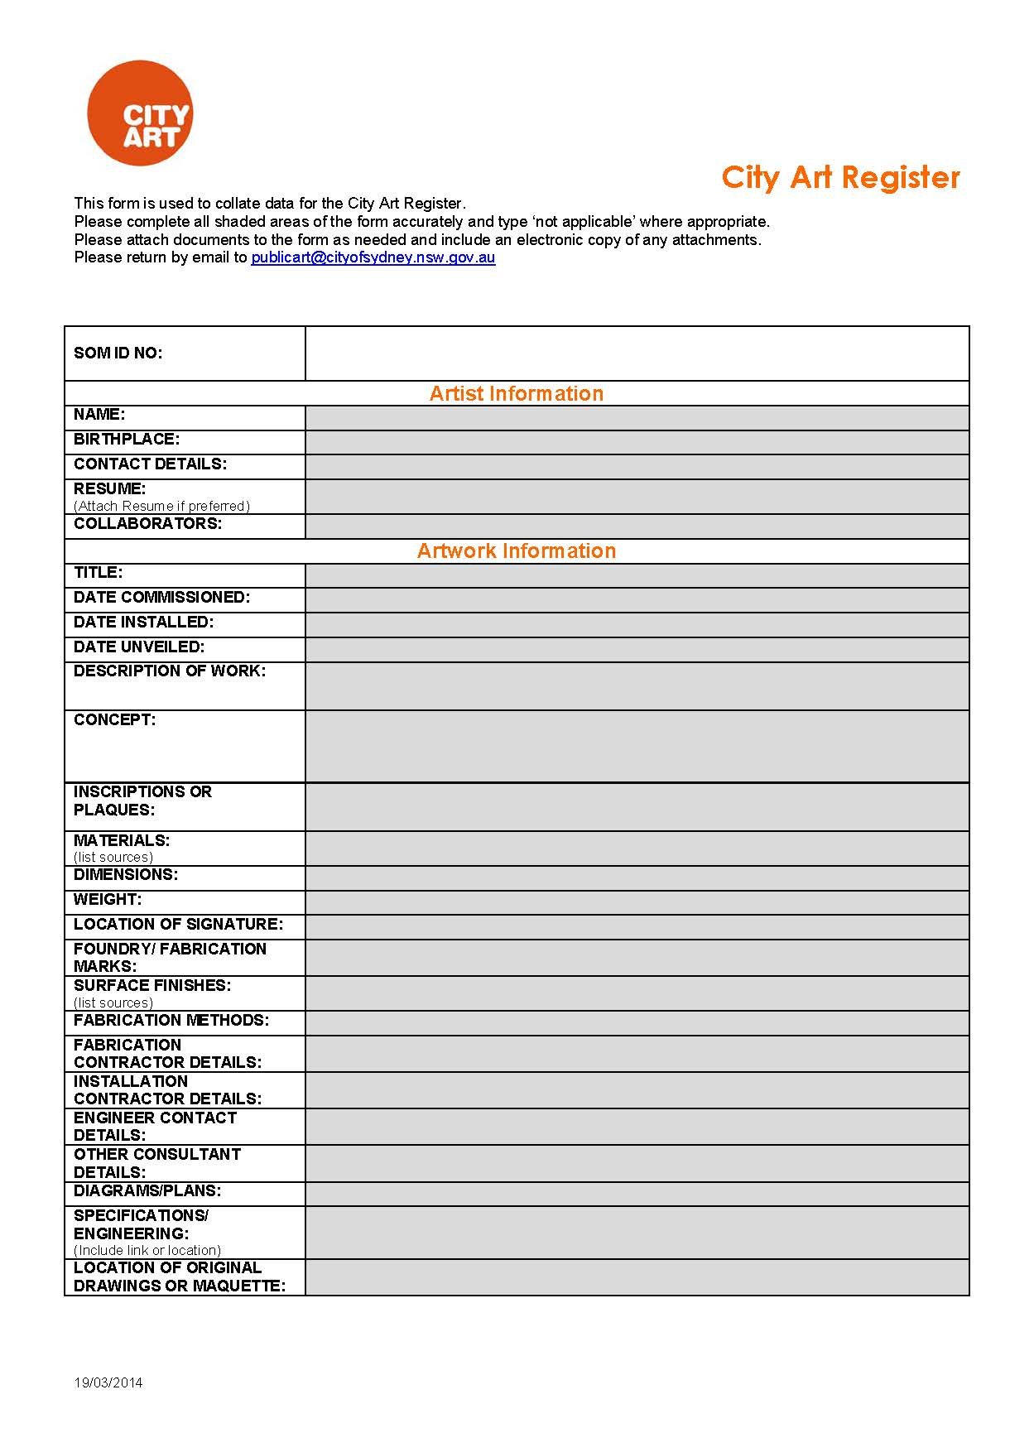

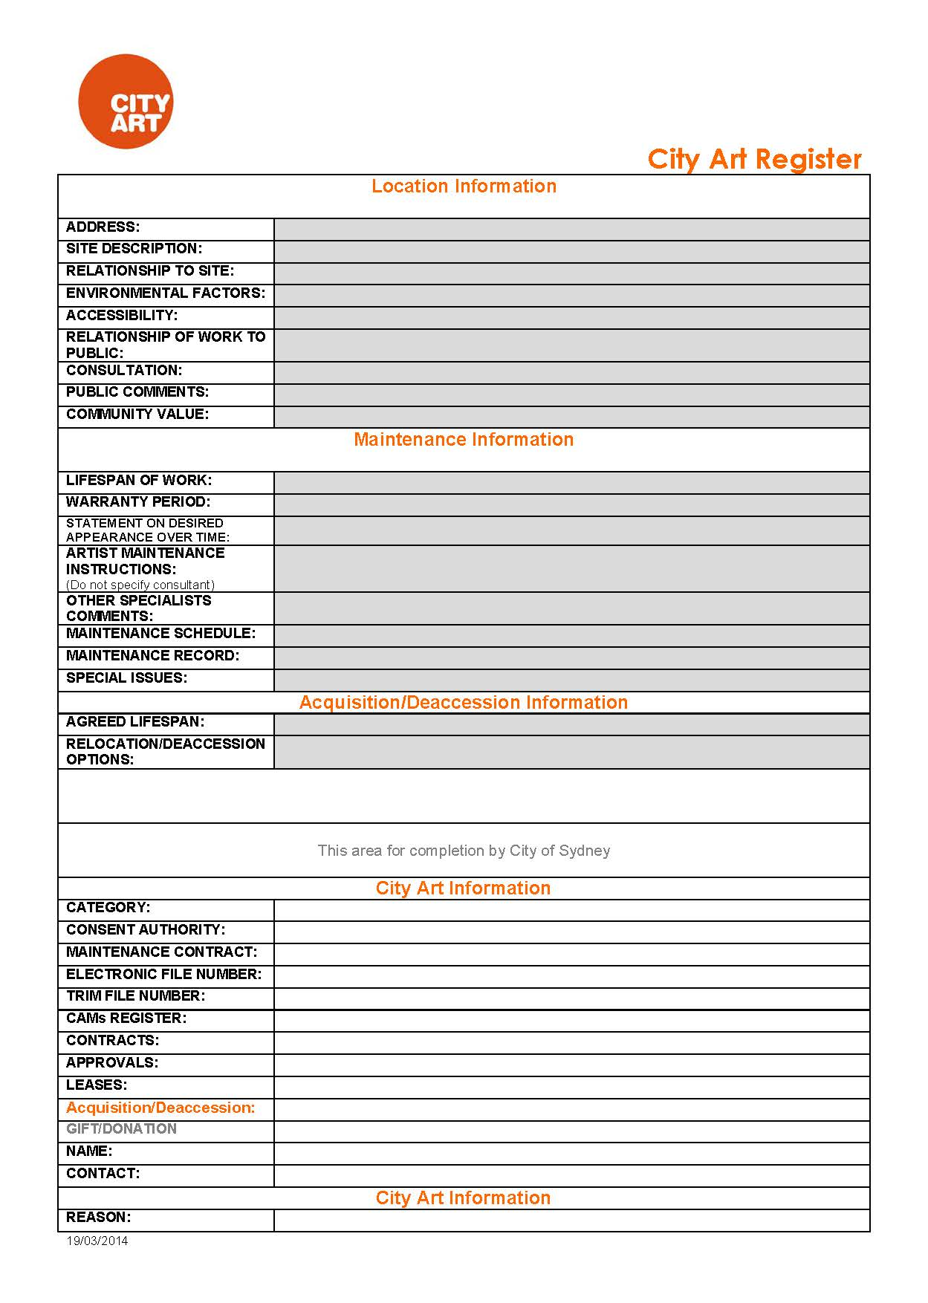
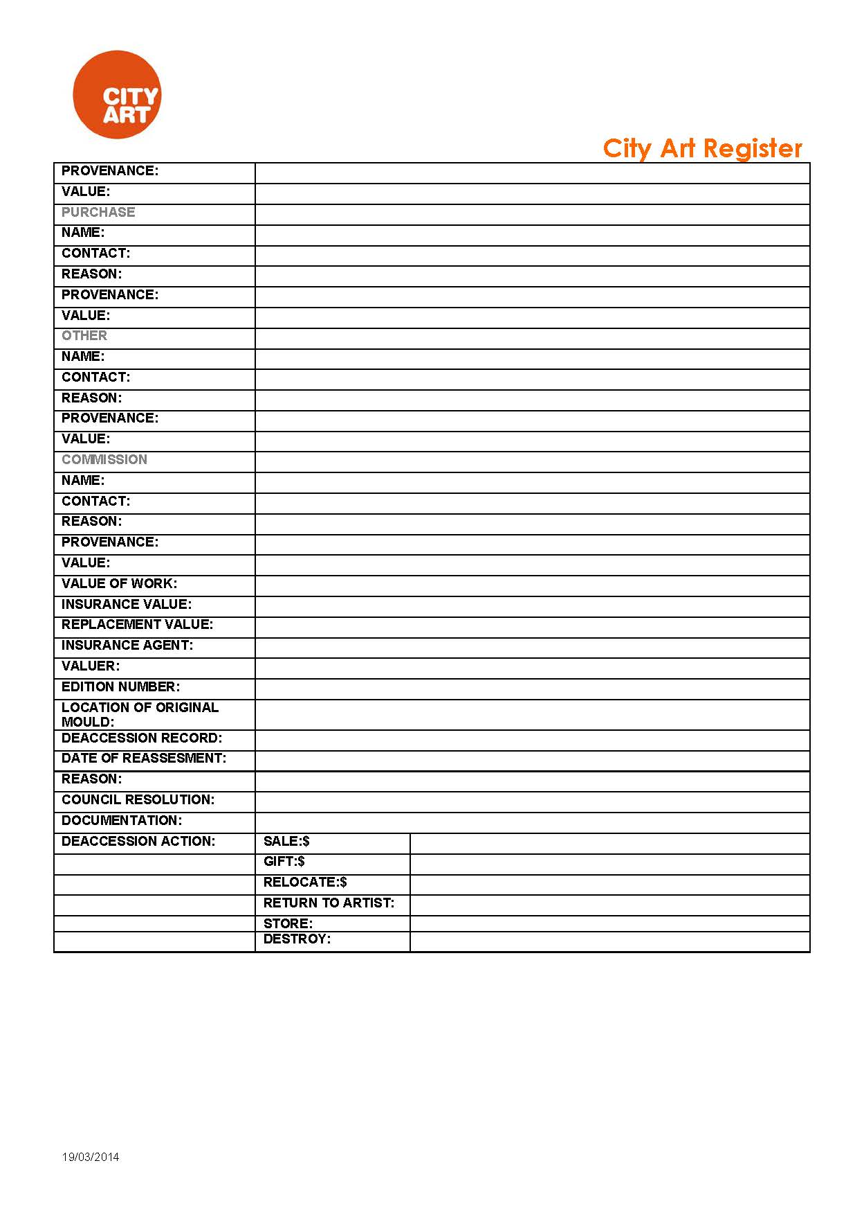

Executed as an Agreement by:

Signed for and on behalf of the CITY OF SYDNEY COUNCIL by its duly authorised officer in the presence of: | )  )  )
Witness: |  |  | Signature:
Name (printed): |  |  | Name of Authorised Officer:

SIGNED by the Artist in the presence of: | )  )
Witness: |  |  | Person:
Name & Address (printed): |  |  | Name (printed):

