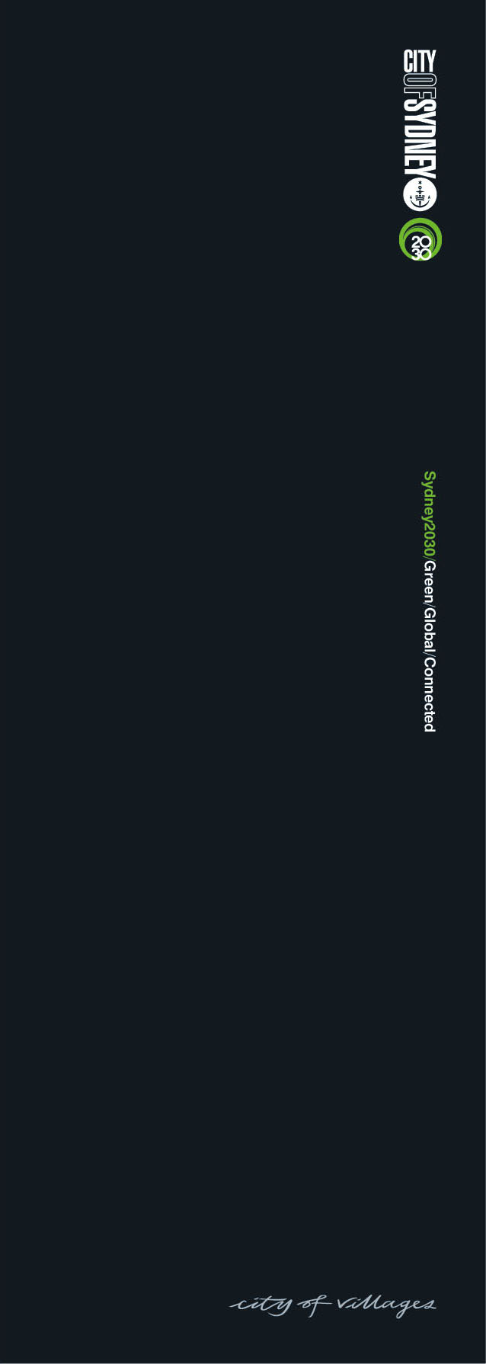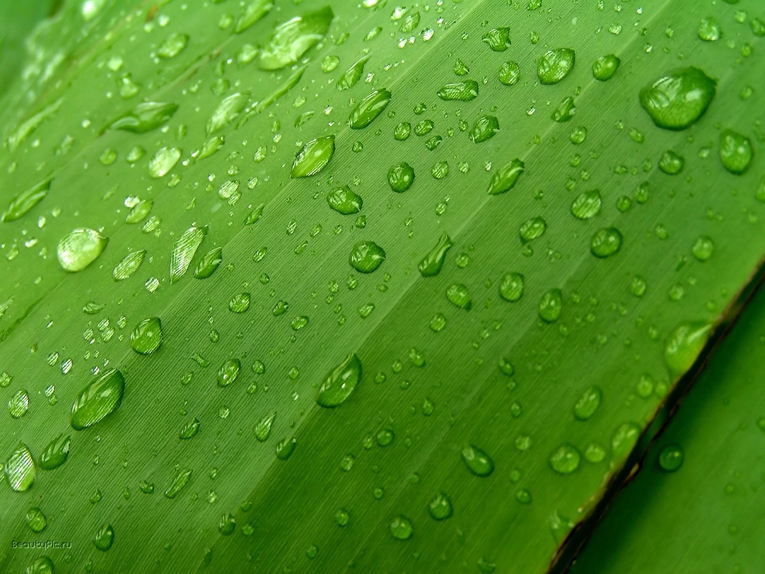

Green Roofs and Walls

Waterproofing Guide

[Introduction 2](#_Toc407699821)

[Waterproofing membranes on green roofs 3](#_Toc407699822)

[International context 4](#_Toc407699823)

[Australian context 5](#_Toc407699824)

[Waterproofing green roofs and walls 6](#_Toc407699825)

[Perceived issues 7](#_Toc407699826)

[Waterproofing technology 8](#_Toc407699827)

[Selection criteria 10](#_Toc407699828)

[Protecting the waterproofing layer 12](#_Toc407699829)

[Leak detection, testing and warranties 13](#_Toc407699830)

[Common issues 14](#_Toc407699831)

[Green walls 16](#_Toc407699832)

[Glossary 17](#_Toc407699833)

[References 18](#_Toc407699834)

**Published**: December 2014

This paper was prepared by Fifth Creek Studio on behalf of the City of Sydney.

# Introduction

In April 2014 the City of Sydney Council adopted its Green Roofs and Walls Policy and Policy Implementation Plan. The policy is one of the first of its kind in Australia and confirms the City’s commitment to support the installation of high quality green roofs and walls in Sydney.

The Green Roofs and Green Walls Perception Study undertaken by the City identified that some sections of the building and construction industry are concerned about the potential for green roofs and walls to leak or pose a waterproofing risk to buildings.

Proper waterproofing is fundamental to the success of green roofs and green walls. This waterproofing guide has been published to address misconceptions and a lack of independent information on waterproofing green roofs and walls.

This guide outlines the common types of waterproofing, as well as common issues and selection criteria for waterproofing green roof or green wall projects.

The purpose of this guide is to address concerns about green roofs and walls, and the lack of reliable and accessible information on waterproofing.

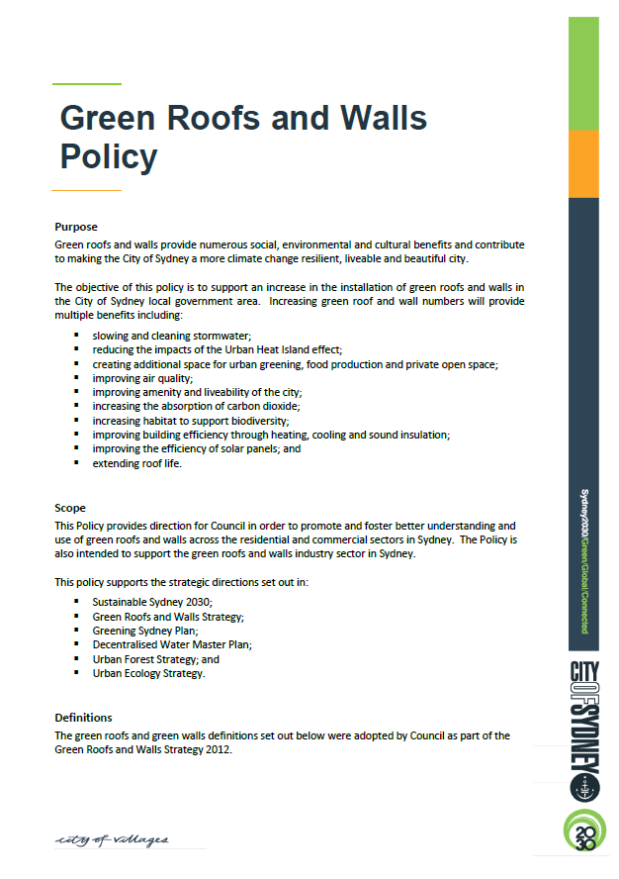

|  |
| --- |
| PLEASE NOTE:  This guide provides information of a general nature only. It does not replace the expert advice required to ensure proper waterproofing of a green roof or green wall. Every green roof or green wall project is unique and needs to respond to the differing site and building conditions. |
|  |
| Usually in a new or retrofit project the architect or builder is responsible for the waterproofing of the external surface of the building. With a green roof or wall there are other factors to consider with the waterproofing layer, so the expertise of a suitably qualified professional is advisable within the overall process. |

By the City’s definition, a green roof is vegetation covering at least 30% of available rooftop space - that is, space which is not occupied by structures housing plant, equipment, lifts or stairway accesses. A green roof should provide measurable benefits to the environment.

# Waterproofing membranes on green roofs

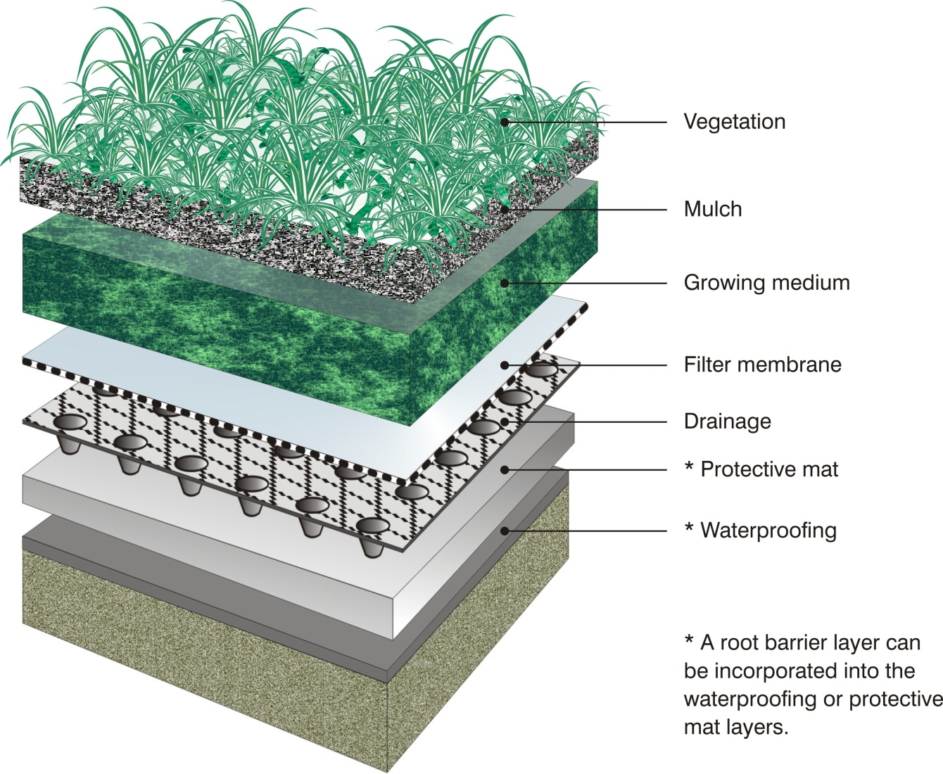

Green roofs are made up of a series of layers: vegetation, mulch, substrate layer (growing medium), filter membrane, drainage layer, and the waterproofing membrane laid over the building’s roof structure. In addition, there may be root barrier and protection layers and insulation included in a green roof system.

The diagram below shows where the waterproofing membrane is located within a green roof system.

In cities around the world, green roofs and walls make a positive contribution to urban environments. These include retention and detention of stormwater, mitigation of the urban heat island effect, insulation of buildings and increases in habitat and biodiversity. Wider benefits to the community include providing communal spaces and opportunities for economic activity such as urban agriculture.

Contemporary green roofs have been developing since the 1960s in Europe, but in the past two decades we have seen significant growth in the green roofs and walls industry worldwide. For example, it has been estimated that 13.5 million square metres of green roofs were installed per year in Germany in the late 2000s.

The North American green roof industry grew by 115% in 2011, with around 100 million square feet of green roofs in place by 2012.

A Lux Research report (Lux 2012) states that green roofs are a $5.5 billion burgeoning world market, projected to reach $7.7 billion by 2017. Green walls are projected to be a $680 million market by 2017 (Tan 2013).

Dense cities are increasingly integrating plants into the urban fabric to improve the liveability of cities and support better environmental outcomes.

Singapore has built on its long held image as a tropical ‘Garden City’ with a more recent coordinated focus on implementing ‘Skyrise Greenery’.

Skyrise Greenery is a term that incorporates green roofs, sky terraces, landscaped balconies, green walls, and sky bridges linking buildings.

Toronto (Canada) has mandated green roofs on all buildings over 2,000m² and Copenhagen (Denmark) has made green roofs mandatory on all buildings with a roof slope of less than 30 degrees.

Dozens of cities in Asia, Europe, the United Kingdom and United States offer incentives to encourage the uptake of green roofs and walls (City of Sydney, 2013).

# International context

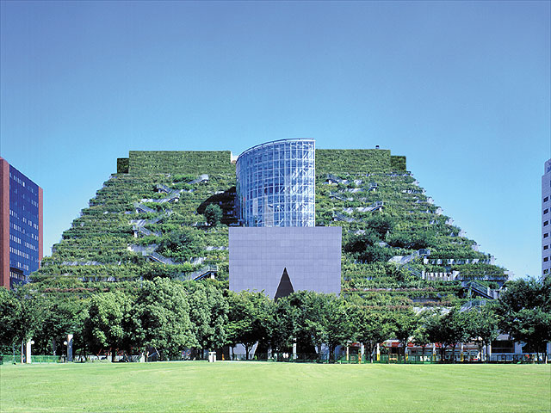

*Fukuoka prefectural international hall – green roof*

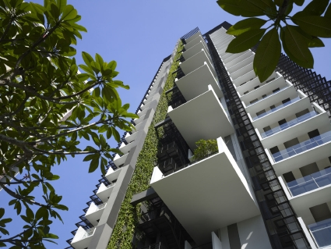

*Newtown Suites – Singapore*

*Photo courtesy WOHA / Patrick Bingham-Hall*

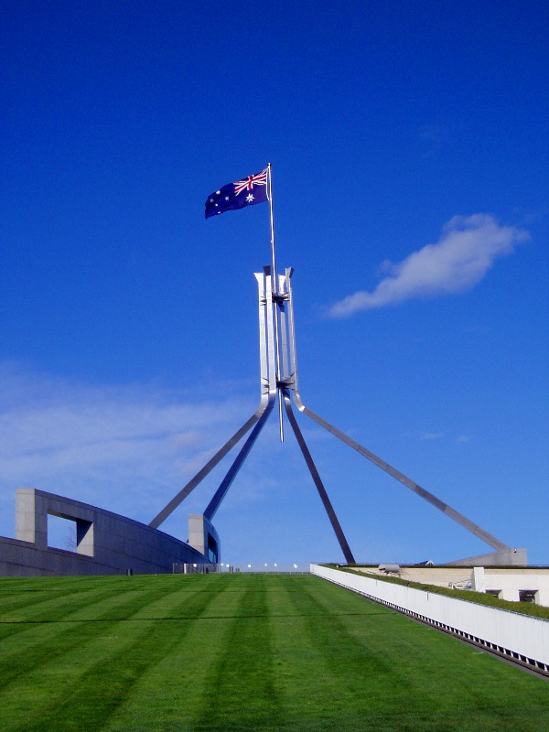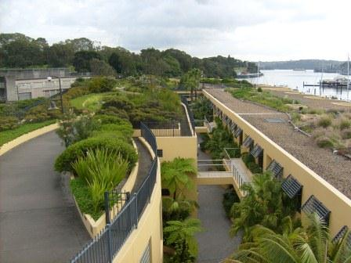In Australia, green roofs have been installed from the 1930s and increasingly since the late 1960s. Green walls have more routinely been installed since the 1980s. Since the 2000s there has been a rapid expansion in the installation of green roofs and green walls in Australia and recognition of a national living architecture industry.

*Wharf Terraces - Sydney*

Today, there are large scale green roofs and walls in all capital cities and in some of the larger regional centres, as well as a growing awareness of the benefits of living architecture at a domestic scale.

# Australian context

The City of Sydney plays a leading role in supporting sustainable design of green roofs and walls through policy development, research, education and practical implementation.

The City’s vision is to achieve 50 per cent increase in canopy cover by 2030 and 75 per cent increase by 2050 (Greening Sydney Plan), with green roofs and walls additional to these targets.

The adoption of the Green Roofs and Walls Policy by Council in 2014 is a clear demonstration of the City’s commitment to fostering and growing the uptake of green roofs and walls.

*Parliament House - Canberra*

Waterproofing systems and materials have been used and tested in Europe and especially Germany since the 1970s. This experience led to the development of the world renowned *Guidelines for the Planning, Execution and Upkeep of Green Roof Sites* produced by FLL: German Landscaping and Landscape Development Research Society. The guidelines helped set a standard for green roof systems in Europe.

In North America the waterproofing industry is well established because the common roofing systems were flat built-up systems designed to accommodate snow loads. A comparison of waterproofing membranes used in Europe and the United States provides some useful background for the Australian context.

According to Weiler and Scholz-Barth (2009), European installers typically ‘*use 60 to 80 mil PVC single-ply roof systems for the most efficient, cost-effective construction*’. Reinforced PVC works well as seams are heat sealed, which reduces the risk of leaks and also protects against root penetration.

The manufacturing and disposal of PVC materials can have impacts on the environment. To reduce potential impacts, PVC products can be manufactured to the Best Practice Guidelines provided by Green Building Council Australia (www.gbca.org.au).

# Waterproofing green roofs and walls

Other waterproofing materials commonly used in Europe include rubber membrane (EPDM) or hypolan (CSPE).

The seams of EPDM need to be bonded with adhesives or tape, which could have a higher risk of potential leaks than with PVC.

Thermoplastic olefins (TPOs) are also specified in Europe and may be considered as an acceptable alternative to PVC, but they have not been as well tested in the United States. Also in the U.S. manufacturers of TPOs may need to add bromides (fire retardants) to meet the more stringent U.S. fire codes. Bromides can interfere with the longer-term performance of TPO waterproofing membranes.



*Green Roof Code of Best Practice*

*United Kingdom*

[](http://www.fll.de/Startseite.1.0.html)

*Guidelines for Planning, Execution and Upkeep of Green Roofs - Germany*

The primary aim of using a waterproof membrane on a roof or wall is to prevent water from entering the building from the outside. Under a green roof or behind a green wall the membrane must also be capable of resisting physical damage from penetrating plant roots, gardening tools and other activities.

The roof and external walls of a building need to be water tight. Depending on the contractual arrangements, in new buildings the responsibility for the installation of a waterproof membrane is held by the architect, builder, landscape architect and/or green roof or wall designer.

Green roof or green wall installers are typically more likely to be responsible for waterproofing where a green roof or green wall is retrofitted to an existing building.

As the responsibility for the waterproofing membrane crosses various disciplines, there needs to be a cooperative approach by the various designers and builders to install a permanent waterproof surface that meets the stringent requirements of the particular green roof or green wall design.

Many architects, builders and building owners or developers can remember the unsatisfactory waterproofing materials and installations of the 1970s, where planter boxes and podiums notoriously developed leaks. This was a period of new materials and untrained or unsupervised installations.

The legacy of this period still survives as a perception that waterproof membranes leak, even though materials and systems have advanced markedly since then and many products have been proven over a 30 year installation period.

Studies from Europe and especially Germany, have shown that a green roof can at least double the life expectancy of a roof membrane.

A green roof protects the waterproof membrane from damage including hail, wind-blown dust and UV radiation from sunlight. It also reduces the daily fluctuations of temperature at the membrane level. Temperature related expansion and contraction of materials is lessened, therefore reducing cracking and damage.

# Perceived issues

As part of the development of the City of Sydney’s *Green Roofs and Walls Strategy* in 2012, a Perception Study was undertaken to identify attitudinal factors influencing the growth of the local green roofs and walls industry. One of the key findings of the study was:

*The reliability of waterproofing and irrigation systems is a key consideration in green roof and wall installation. There are significant concerns about the reliability of systems and risks associated with leaks. Latest technological advancements are considered to be affectively addressing risks, though perceptions of risks remain high* (City of Sydney 2012).

The purpose of this guide is to provide general information on the different types of waterproofing that are currently used for green roof and green wall installations in New South Wales.

In Australia, waterproofing membranes fall into three major categories:

1. Liquid applied membrane treatments
2. Preformed sheets, including ‘single-ply’
3. Integrated systems

Liquid applied membrane

The membrane material can be made from a variety of compounds such as bitumen emulsions, modified bitumen, polymer cement systems, polyurethane, polyurethane modified acrylic, acrylic or two part polyurethane hybrid elastomers.

The liquid application is a cold process where the material is in a liquid state and adheres to the substrate. This membrane system can be applied manually by brush, roller, spreader or spraying, and is suitable for small roofs or roofs with a number of upstands, penetrations, corners or steep slopes.

Some of the proprietary products have a built-in root resistant feature that is in the form of a chemical within the product. Where this is not available then a separate root-resistant layer or root barrier needs to be provided.

# Waterproofing technology

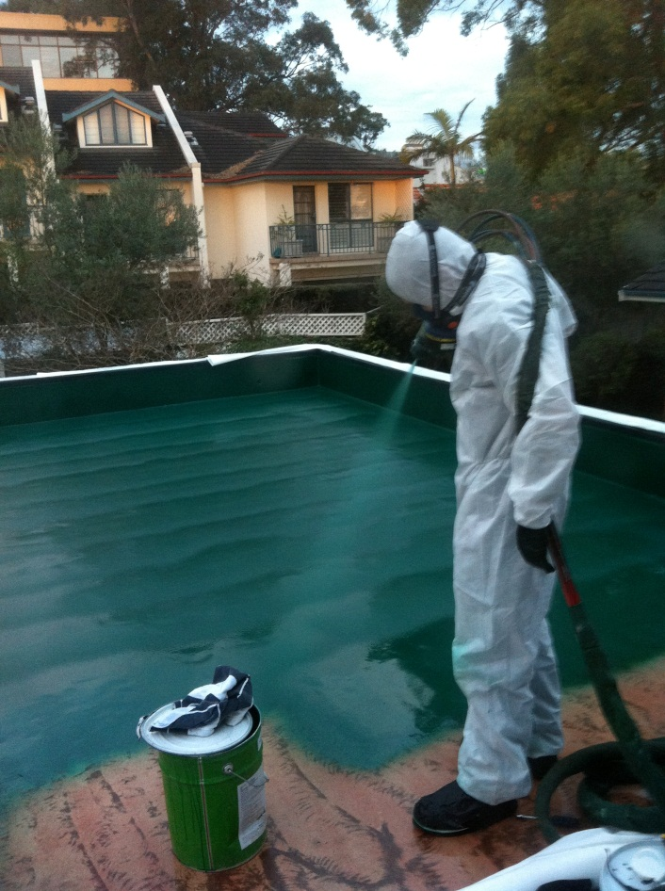

*Liquid applied membrane on domestic scale green roof*

*Photo courtesy Claire Hanley*

### Advantages of liquid applied membranes:

* Easy to apply
* Seamless
* Tolerant to surface imperfections
* Easily repaired or re-applied
* Bonded to substrate
* Flexible and can be stretched or elongated

Disadvantages:

* Not root resistant, therefore a root barrier may also be required
* Not easy to ensure uniformity of thickness
* May become brittle with long exposure to sunlight and high temperatures
* Pin-holes and blisters may develop over poorly prepared substrate
* With ply or cement sheeting surfaces, additional reinforcement of joints may be required to minimise movement

Preformed membrane

Preformed waterproofing membranes suit large, flat or gentle sloping roofs with relatively few interruptions or penetrations. These membranes can also be used to waterproof ‘felt system’ green walls, such as those used at 1 Central Park (right).

*Preformed waterproofing membrane*

*Adelaide Zoo green roof – Photo courtesy Hassell*

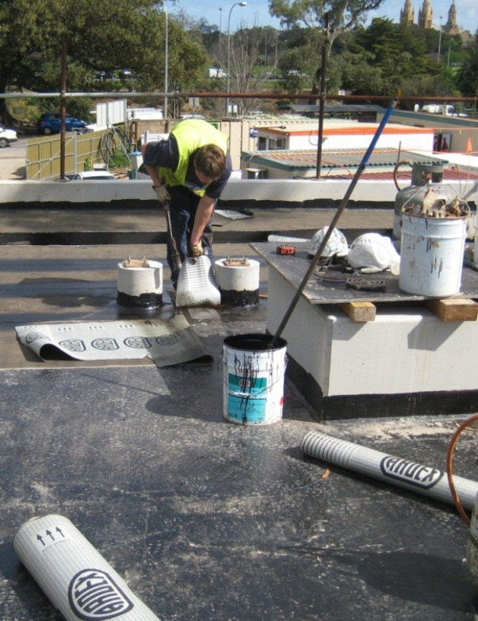

These membranes are sometimes referred to as ‘single-ply’ systems and can be divided into two major categories:

1. Asphalt-based
2. Polymer-based, consisting of either Thermosetting polymers (Ethylene propylene diene monomer (EPDM) and Butanoyl membrane) or Thermoplastic polymers (PVC, thermoplastic polyolefin, ethylene vinyl acetate and ethylene butyl acrylate membrane)

Advantages:

* Option of loose-laid or fully bonded to substrate
* Fully bonded systems are resistant to wind uplift
* Uniformity of thickness
* Asphalt base systems are torched down and seam welded for superior sealing and strength
* Thermoplastics are UV stable and PVC membranes are classified as root resistant
* Thermosetting is UV stable
* EPDM and Butanoyl membranes are root resistant

Disadvantages:

* Loose lay systems are not recommended in high wind uplift zones and membranes should be fully bonded to the substrate
* Requires high level of skill for installation
* Asphalt base is usually not trafficable, UV stable or root resistant
* Condensation or moisture may soften glue or adhesive tapes along seams and bonding to substrate
* Thermosetting materials such as EPDM or Butanoyl have carbon content unsuitable for electronic leak detection (see Leak detection section below).

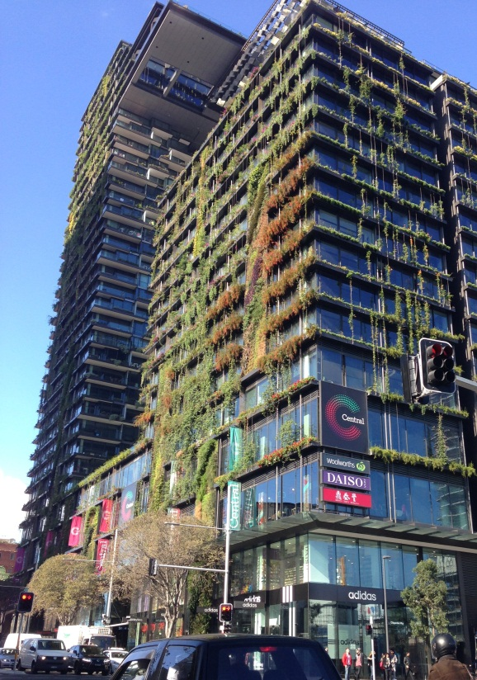

*1 Central Park – Broadway Sydney*

Integrated systems

Integrated waterproofing systems are where additives are included in the concrete mix to waterproof the concrete. This is commonly used for larger concrete structures such as podium level gardens, landscaping over car parks or on car parking buildings. This is also used in pre-cast panels or tilt-up wall panels on external facades for green walls.

Selecting a waterproofing system

Waterproofing is the primary protective element of the roof and structure. Typically the waterproofing membrane is below all the layers of a green roof so it is difficult to inspect and access or repair. The selection, installation and protection of the waterproofing membrane is fundamental to the success and length of life of a green roof system.

Technological advances in the design, fabrication, installation and longevity of waterproof membranes over the last 20 years, along with the availability of leak detection systems, are helping to reduce the perception of leaking membranes.

It is important that both the client and builder are involved in selecting and specifying the membrane, so they understand the implications and maintenance requirements.

Below is a checklist to assist in the selection of waterproofing for different situations.

### Complexity and configuration of roof

Where there are complex roof structures with many upturns and penetrations a liquid applied system may be more appropriate.

# Selection criteria

Where there are large vertical surfaces with no or few interruptions consider using a preformed system.

### Size of roof

For a small or sloping roof consider a liquid applied membrane. For larger or relatively flat roofs preformed systems may be more appropriate.

### Building purpose or activity

A more or less conservative approach to waterproofing will depend on how important it is to protect the building’s use and contents. For example a green roof system over an unheated car parking structure may use a less conservative waterproofing system than over a library or art collection, where it is more critical that the building remains absolutely watertight. A more conservative approach may include thicker or additional layers of waterproofing, leak detection and root barrier layers. The additional layers have the potential to add to the cost of the project, but can provide additional protection for sensitive buildings or building contents.

### Construction techniques

The roof structure will often determine the type of waterproofing membrane selected, due to its construction type. The waterproof membrane needs to be matched with the roof substrate construction techniques and materials, so that they work together and not against each other.

If the roof is a concrete slab of large area and relatively flat, with expansion and contraction joints running across the slab, then the waterproofing membrane needs to be capable of movement. This may require preformed sheets with the necessary junctions.

A large flat concrete slab without any penetrations might be more suitable for preformed sheets of uniform thickness and quality, rather than a liquid applied base, which may vary in thickness, and have possible pinhole breaches.

### U:\Land Use and Planning\PROJECTS - CURRENT\Green Roofs & Walls\CASE STUDIES\Local\Readers Digest Building\IMG_0312.JPGMaintenance

The necessity to access the water proofing layer for maintenance may also affect the type of waterproofing system you select. Need to access the waterproofing to inspect and repair seams, check drainage outlets, penetrations and expansion joints may lend itself to preformed sheets as opposed to a liquid applied membrane.

### Access to the membrane

If the membrane is easily accessible for inspection and repair, a liquid applied system may be acceptable compared to an inaccessible green roof with many complicated landscape elements placed above the waterproofing layer.

Where large trees and complex landscapes are installed on a roof, they may prevent easy access to the waterproofing layer for inspection and maintenance. In this case preformed sheet systems may be more appropriate, or the use of a leak detection system to be able to readily pin point issues should they arise.

### Protecting the membrane

Green roof on the Readers Digest building – Surry Hills

Photo courtesy: L Sharman

Once the waterproof membrane is installed, if it is then protected from UV and unintended construction activity by protective boards or a topping screed layer, (such as a cement and sand mixture) then a less conservative waterproofing system may be used.

### Climate

Local climatic conditions should be considered, such as closeness to salt water and spray, areas of high relative humidity, and exposure to afternoon heat build-up, as this will require different membrane characteristics such as thermal movement and resistance to corrosive chemicals.

### Approved contractors

Many proprietary waterproofing systems can be installed by a manufacturer’s approved contractors who are familiar with the product and experienced in the specific construction.

Using approved contractors gives access to trades people with specific skills and experience in water proofing for green roofs and walls. Using approved contractors can also improve access to available product warranties.

As for any roof, protecting the waterproofing membrane from physical damage is one of the most important tasks once the membrane is installed and certified watertight. It is important that the installed waterproofing membrane is protected both before and after the growing media and plants are installed.

There are a few common causes of failure to the membrane such as:

1. Physical damage such as onsite construction activity like cuts, tears and penetrations from working over the membrane
2. Prolonged exposure to UV from the sun causing deterioration of the material
3. Movement stress caused by temperature variation from day to night
4. Weak structure of the selected material

The physical onsite damage can be eliminated by restricting access and work practices over the membrane once installed and also by providing a protective layer over the membrane immediately after the installation and certification.

There are three common methods of protecting the membrane:

* Protective mat
* Protective board or foam boards
* Protective concrete screed

# Protecting the waterproofing layer

Protective mats are usually made from synthetic fibres of polyester, polypropylene or polyethylene and by its very nature are flexible, soft and porous.

The mat should be between 5 to 10mm thick to provide the cushioning effect required, but in heavy use areas additional protection may be required.

Protective board needs to be semi-rigid, durable and made from material that does not deteriorate in water, such as 6mm cement board. Foam boards are typically made from expanded polystyrene (EPS) or extruded polystyrene (ExPS) 25-50mm thick and laid loosely on the membrane. Coreflute or polyethylene (LDPE) sheets may also be used. Foam boards may need sealing to stop water build-up in the material.

Protective concrete screed may be applied over the top of the membrane in a mixture of cement and sand, to a ratio of 1:3 respectively. The minimum thickness is 25mm, as any thinner will crack and disintegrate, thus allowing damage to the membrane. The screed should be laid in such a manner that there is a minimum fall of 1:100, to prevent any ponding and for free drainage with an even gradient to the outlet.

## Root barrier layer

Root barriers are intended to prevent root damage to the waterproofing membrane. These barriers provide permanent resistance to plant roots and rhizome invasion, especially along seam joints, wall connections and any other penetrations in the membrane.

Some synthetic membranes are already resistant to root invasion, such as thermosetting EPDM and thermoplastic PVC and TPOs, therefore acting as both waterproof and root barrier systems.

If a separate root barrier sheet is used it should be compatible with the waterproofing membrane so that no adverse reaction or chemical action occurs between the layers. Typical materials used are polyethylene (plastic) sheets and polypropylene geotextile fabric.

Leak detection is an integral part of a green roof and sometimes a living wall. It is seen as the main risk management system for a green roof, especially the waterproofing membrane, to give confidence to building management and users.

Testing the waterproofing membrane is an important process, especially for certifying that the membrane is watertight. There are three methods commonly used:

* Flood testing
* Electrical field vector mapping (EFVM)
* Destructive testing

It is prudent to perform an additional leak test if:

* There has been significant construction activity or traffic over the roof
* Prior to the installation of the growing substrate
* If there has been considerable time between the membrane and growing media installation.

Flood testing

This is suitable for flat roofs with slopes of up to two per cent. The test involves submerging the membrane with a minimum layer of water for 48 hours. This tests the membrane for any faults or leaks for water conditions under normal atmospheric and hydrostatic pressure.

Areas where this test is unsuitable are sloping roofs and walls, vertical surfaces and retrofitting an existing building with sensitive contents.

## Electrical field vector mapping (EFVM)

This is a convenient and simple testing operation suitable for electrically conductive and electrically grounded roof decks like steel and reinforced concrete roofs. This method can be adapted to wooden roofs and precast concrete slab roofs by adding a conductive layer of metal foil or mesh before the waterproofing membrane is installed.

This system gives pin point accuracy if a failure occurs and can be used on an existing green roof with substrate depth up to one metre. This allows for existing and new roofs to be checked manually after the green roof is installed.

In projects where higher risk management is required, the system can remotely and constantly monitor the roof membrane and alert the building owner or manager if the membrane fails.

# Leak detection, testing and warranties

Destructive testing

This test is used on preformed membranes only, and often on older existing green roofs. The process involves perforating the membrane at the lowest point of the deck to check for any presence of water beneath the membrane. The hole in the membrane must be repaired to restore the membrane’s integrity. This process does not identify where the breach in the membrane occurs but only shows if there is a beach.

Warranties

It is important to understand who provides the warranty for the waterproofing for your project.

Warranty on the installation of waterproofing for a green roof or wall may involve the waterproofer as a third party installer or as part of a proprietary system, where the parent company warrants against failure of any or all of the components of the proprietary system.

A third party installer will certify the membrane as watertight on completion and may not take responsibility for any breaches of the membrane after certification.

At the project completion the contractor and sub-contractor must provide the waterproofing certificate for the necessary documentation of inspections.

There are three main areas where issues and problems occur with waterproofing for green roofs and to some extent with living walls:

1. Physical damage
2. Potential leakage zones
3. Drainage issues

## Physical damage

This is where other construction work continues over and around the waterproofing membrane that has been laid down without any substantial protection.

Some examples are:

* Mobile lifting machinery travelling over the membrane and creating stress points in the membrane and when changing direction placing shear forces on the membrane
* Other trades using the membrane as a clear platform for their work and preparation
* Allowing nails, screws or metal filings to be dropped and walked into the membrane material
* Leaving the membrane uncovered and allowing long exposure to sunlight before being covered, which causes UV breakdown to occur
* Penetrations or damage from landscapers tools, where the membrane is not properly protected.

# Common issues

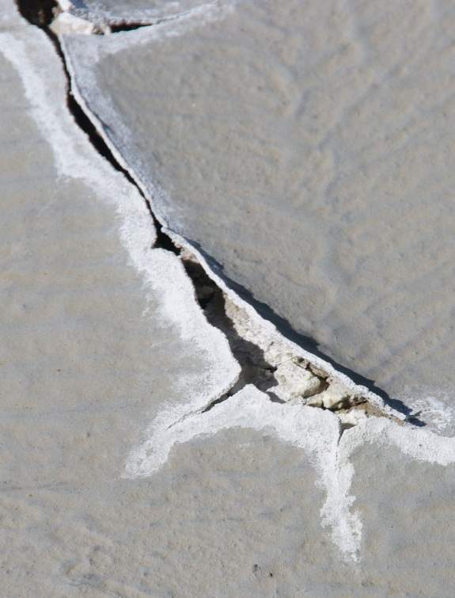

*UV damage to waterproofing membrane on a commercial building roof*

*Photo courtesy Fifth Creek Studio*

The chance of physical damage occurring is mitigated by isolating the zone of the waterproofing membrane from the rest of the construction works until the remaining layers of green roof are installed.

## Potential leakage zones

Joints, seams and penetrations are potential leakage zones of the membrane. Skilled workmanship should occur with these items, in order to maintain high standards.

Inspection openings should be installed to allow for regular continuous inspections.

Post installation penetrations must be avoided if possible, but if they must proceed, then specify the correct waterproofing procedure and be aware of the potential reaction between various waterproofing materials.

Also be aware of the effects of water penetrating the membrane caused by metal fixings being installed and the membrane not adequately repaired. This failure can create rusting and decomposition of the fixture and potentially create a leakage point.

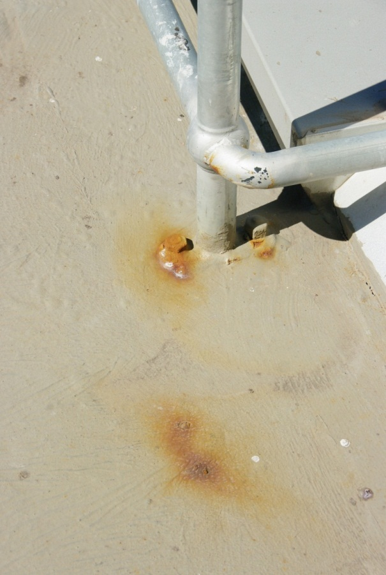

*Rust damage caused by penetration after waterproofing installation on a commercial building roof*

*Photo courtesy Fifth Creek Studio*

## Drainage issues

These issues occur where the drainage slope of the substrate is not free draining, such as slopes flatter than one percent or 1:100, and slopes that have undulations within the gradient that form ponding basins. Drainage on green roof systems must be designed to integrate with the building’s stormwater runoff.

For example, drainage outlets or premade sumps are often incorrectly installed higher than the waterproofing membrane, thus preventing water entering the sump or outlet. This is often the result of construction techniques such as precast panels and slabs that do not allow for outlets to be finished flush with the surface. The waterproofing membrane must be folded down into the outlet, so the outlet is at the lowest point of the roof.

The drainage layer above the waterproof membrane must be designed and installed to allow water to escape, even under the most extreme events, to a minimum of 1:100 year rain events. If the drainage layer cannot carry this volume of water then ponding will occur and hydrostatic loading on the waterproofing membrane may cause it to fail or leak.

## Other issues

### UV exposure

The top of the waterproofing membrane on a vertical or upturn should be shielded from the sun and ultraviolet light to prevent material breakdown. Flashing can be used to cover and protect the membrane.

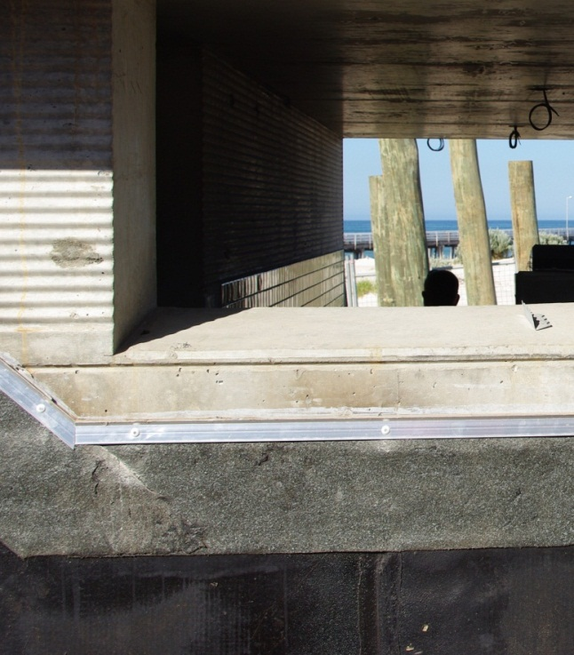

*Capping to flashing top of vertical waterproofing membrane at Grange public toilets in Adelaide*

*Photo courtesy Fifth Creek Studio*

### Steep roof slope

Steep sloping green roofs may use less conservative waterproofing membranes because there is little possibility of ponding or retaining water on the substrate.

### Movement of substrate against joints

Substrate materials that have the possibility of movement at the joints may require reinforcement in the waterproofing membrane to maintain continuity for the membrane.

# Green walls

All habitable buildings require the external walls to be waterproof to protect the building interior. Wall materials vary in their waterproofing qualities and some materials may require added protection for the occupants’ peace of mind when a green or living wall is installed. The use of a liquid applied waterproofing layer is advisable as added protection if the wall material or owner concern warrants it.

The air gap between the back of the green wall and the building wall is important for waterproofing and protecting the wall surface from damage.

Many proprietary systems have a structural support system for the living wall modules that is fixed to the building wall allowing a minimum gap. In many climates if this gap is insufficient, then the micro climate in the gap becomes moist, humid and still, creating an environment where moss, fungus or moisture retention can develop on the wall.

The Rose of Australia pub – Erskineville

To avoid coating the wall with a waterproofing membrane, the following air gaps can be used instead of waterproofing the supporting wall.

* In hot dry climates 20mm to 100mm is sufficient to allow air movement and drying to occur
* In temperate and slightly humid climates such as Sydney, the gap required should be 50mm to 100mm to allow the natural convection air movement behind the wall which also removes the humidity
* 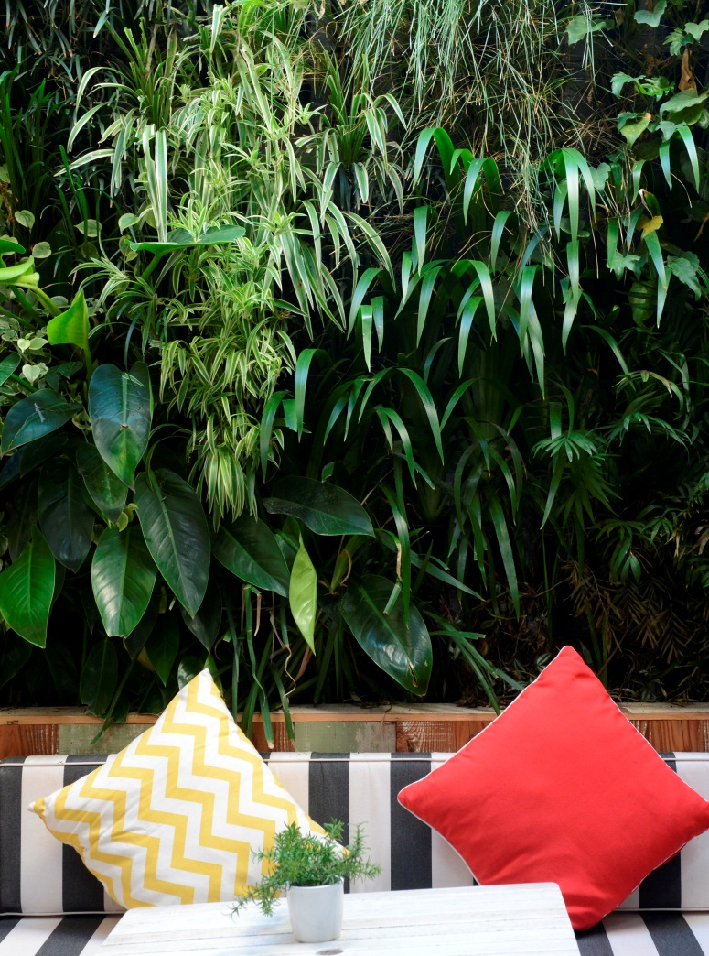In hot, humid climates like coastal, temperate rainforest gullies, the gap should be 100mm to 200mm to avoid any fungal growth or moisture retention on the wall

# Glossary

|  |  |
| --- | --- |
| Term | Description |
| Bonded system | The waterproofing layer is chemically bonded to the roof deck. |
| Butanoyl membrane | Polymer-based product used in preformed waterproofing. |
| EPDM | Ethylene propylene diene monomer – polymer-based product used in preformed waterproofing. |
| EFVM | Electrical field vector mapping – a low voltage test method that creates an electric potential difference between a non-conductive membrane surface and a conductive substrate (roof material), which is earthed or grounded. |
| Integrated system | Where chemical waterproofing is built into the structural material. |
| Leak detection system | A system that identifies and locates a defect or leak in the waterproofing membrane. |
| Liquid applied system | Waterproofing consists of a product that is liquid at room temperature and is applied as a liquid. |
| Living architecture | The integration of plants and living organisms into building design. |
| Loose lay | Where waterproofing is laid on top of the roof but not chemically bonded to the roof as opposed to a fully bonded waterproofing system. |
| Penetrations | An opening or hole, pipe or structure passing through the roof structure. |
| Preformed system | Waterproofing is provided as pre-made sheets that are laid on the roof. |
| Screed | A topping layer usually made from a sand and cement mix. |
| Single-ply system | A system of waterproofing using a single layer, preformed system. |
| Upstands | A vertical change in the roof structure or surface. |
| Wind uplift | The negative pressure on a roof structure caused by wind over the roof, which tends to lift the roof surface. |

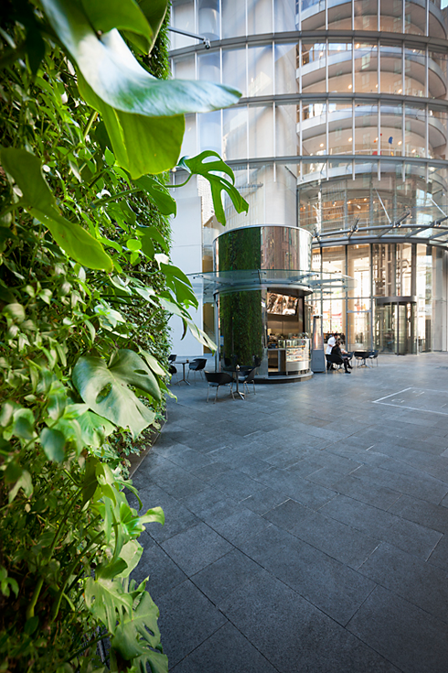

1 Bligh Street - Sydney

## Websites

### Centre for Urban Greenery & Ecology.

Guidelines on Waterproofing for Rooftop Greenery. CUGE Standards CS E05: 2012,

Centre for Urban Greenery & Ecology, Singapore.

City of Sydney: Green Roofs and Walls **-** www.cityofsydney.nsw.gov.au/green-roofs-and-walls

### City of Sydney (2014) Green Roofs and Walls Policy and Policy Implementation Plan

www.cityofsydney.nsw.gov.au/green-roofs-and-walls

### City of Sydney (2012a)

Green Roofs and Walls Perception Study

www.cityofsydney.nsw.gov.au/green-roofs-and-walls

Green Building Council Australia

Best Practice Guidelines for the Life Cycle of PVC Building Products

www.gbca.org.au

Growing Green Guide

A Guide to Green Roofs, Walls and Facades in Melbourne and Victoria, Australia (2014) http://www.growinggreenguide.org

## Publications

### Hopkins G and Goodwin C (2011)

Living Architecture: Green roofs and walls,

CSIRO Publishing, Australia.

### Lux Research (2012)

**Burgeoning Green Roofs and Green Walls Market to be Worth $7.7 Billion in 2017.**

http://www.luxresearchinc.com/news-and-events/press-releases/read/burgeoning-green-roofs-and-green-walls-market-be-worth-77

# References

### Osmundson T (1999)

Roof Gardens: History, Design & Construction.

W Norton & Co, New York.

### State Government of Victoria (2014)

Growing Green Guide: A Guide to Green Roofs, Walls and Facades in Melbourne and Victoria, Australia.

### Tan Puay Yok (2013)

Vertical Garden City: Straits Times Press, Singapore.

### Waterproof! Magazine.

Roof Leaks: Pinpointing and repairing.

Winter 2010. Online US based magazine.

http://www.waterproofmag.com/back\_issues/201001/roof-leaks.php

### Weiler S and Scholz-Barth K (2009)

Green Roof Systems: A Guide to the planning, design, and construction of landscapes over structure. John Wiley & Sons, USA.