d
Visitor Accommodation Monitor June 2016 | City of Sydney  Town Hall House  456 Kent Street  Sydney NSW  2000
Introduction

The City of Sydney recognises the availability of visitor accommodation is important to the success of the local and national economies. Over 12 million domestic and international overnight visitors stay in our city annually for a range of purposes including leisure, education or carrying out business.
The City of Sydney’s Community Strategic Plan (Sustainable Sydney 2030 or SS2030) sets the framework for the future of the city. There are a number of targets the City has set to reach the vision of where the community wants the city to be in 2030.
SS2030 Strategic Direction 1 – A globally competitive and innovative city is a core component of the vision where the City will strive to strengthen globally competitive clusters and networks, develop innovative capacity and enhance business competitiveness. Tourism and accommodation is recognised as one of the key sectors which will continue to play a major role in the city’s economy as it primes itself as being a premier destination on both the local and international scale. Objective 1.4 states
Sydney’s tourism infrastructure, assets and brand contribute to its role as a global visitor destination.
This objective recognises the delivery of key tourism infrastructure such as projects designed to improve the city’s public spaces making them attractive and accessible to visitors and enhancing our profile as a global visitor destination.
Urban planning is one of the City’s core responsibilities. In association with the NSW Government, the City creates the framework for how the city develops so we have the space and infrastructure we need for our residents, workers, businesses and visitors. Recognising this core role, the City has a significant level of influence in the timely and targeted delivery of tourism infrastructure and accommodation as demonstrated through the statutory planning framework. In most cases, the City is the determining authority for development applications for visitor accommodation which includes hotels, serviced apartments, backpackers accommodation and hosted accommodation (such as bed and breakfast establishments). The City can also influence the supply of visitor accommodation through advocacy to encourage a diverse sector, including more 3 star hotels to fulfil demand, and reviewing existing planning controls as well as investigating opportunities to encourage development of these hotels in Central Sydney through potential reductions of development contributions.
In 2014, the City adopted its Tourism Action Plan which presents actions to support the visitor economy. One of the key actions set out in the plan is:
Continue monitoring supply and demand and engaging with industry.
The Visitor Accommodation Monitor addresses this action by providing a comprehensive overview of pipeline activity as at 30 June year end as well as a snapshot of total visitor accommodation stock by establishment type including hotels, serviced apartments and backpackers in the city and geographic variation by small area.

Report objectives
The purpose of this report is to provide a comprehensive summary of visitor accommodation development activity and stock across the City of Sydney local government area (LGA) as at 30 June 2016. Information on visitor accommodation projects is mapped, tabulated, graphed and described based on the status of developments at the end of the reporting period.
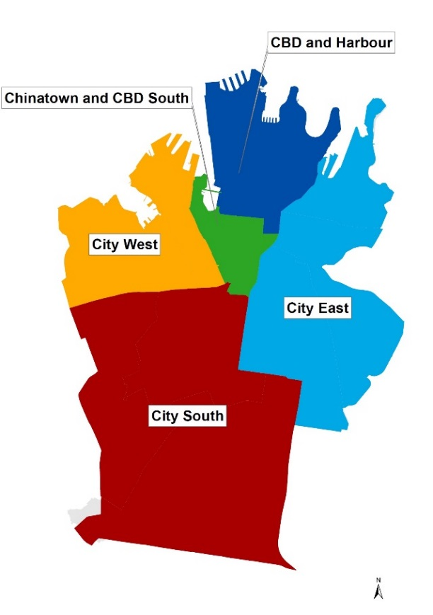
Developments are grouped by the following categories:
- Completed –developments that have completed construction within five years of the report date.
- Commenced –developments that are currently under construction but have yet to be completed at the report date.
- Approved –developments that have been approved by relevant authorities but have yet to commence at the report date.
- Lodged – developments that have been submitted for approval but have not yet been approved by the relevant authority at the report date.
The number of rooms in hotels and serviced apartments as well as the number of beds in backpacker establishments are also reported for developments in the pipeline
and recently completed developments are mapped for the following areas:
City West: Glebe Point Road, Harris Street
City South: Green Square and City South, King Street, Redfern Street
City East: Macleay Street and Woolloomooloo, Oxford Street, Crown and Baptist Streets
Please note the tables and maps for existing accommodation show only those establishments with a capacity of 20+ rooms/units/beds. Visitor accommodation captured in this report also meet the following criteria:
- Any new visitor accommodation establishment contributing to total accommodation stock
- Any existing visitor accommodation establishment contributing to total accommodation stock (for example, net addition of rooms or beds due to change of use, conversion or alteration / addition)
In some instances, DAs have been reported for those existing hotels undergoing major refurbishments which result in loss of rooms. These will be shown as negative figures in the tables and total stock numbers will be adjusted once these developments have been completed. The following abbreviations have been used in the reported tables:
VA type | Visitor Accommodation type | DA type | Development type
BP | Backpackers (share rooms) | A | Alteration or addition
HT | Hotel (including private hotels, clubs, B&B) | AR | Adaptive reuse
PB | Pub based hotel accommodation | C | Conversion or change of use
SA | Serviced apartments | NB | New build
 |  | R | Refurbishment
E – represents existing visitor accommodation (e.g. E-HT represents existing hotel)
N – represents new visitor accommodation (e.g. N-HT represents new hotel)
Summary of existing visitor accommodation stock , June 2016
At 30 June 2016, there were an estimated 18,997 hotel rooms and 739 pub accommodation rooms located in the City of Sydney LGA. In addition, there were 5,504 serviced apartments and 7,648 backpacker beds.
Over half (53%) of hotel rooms were located in CBD and Harbour whilst nearly a quarter of hotel rooms were located in Chinatown and CBD South (23%). There were no hotel rooms in Green Square and City South at 30 June 2016. At 30 June 2016, Chinatown and CBD South had the highest number of serviced apartments representing 37% of all serviced apartment units in the City of Sydney LGA. Chinatown and CBD South also had the highest number of backpacker beds (3,121) followed by Macleay Street and Woolloomooloo (2,098), accounting for 41% and 27% of all backpacker beds in the LGA.
Each village area offers diverse visitor accommodation options catering from budget to world class five star hotel establishments. CBD and Harbour and Chinatown and CBD South attracts a significant share of the city’s larger 4-5 star hotel establishments with room capacities exceeding 200+ rooms. Recently, we have seen a number of high end boutique operations located outside CBD and Harbour entering the market with the opening of three adaptive reuse hotels – the Primus hotel located in the heritage listed Sydney Water building in Chinatown and CBD South, the Clare Hotel adjacent to the former CUB brewery site in the Redfern Street village area and 1888 on Murray Street in the Harris Street village area.

EXISTING VISITOR ACCOMMODATION STOCK BY VILLAGE AREA
Village area | Hotel  rooms | Pub  rooms | Serviced apartments (units) | Backpackers  (beds)
CBD and Harbour | 9,995 | 177 | 1,538 | 927
Chinatown and CBD South | 4,351 | 57 | 2,025 | 3,121
Crown and Baptist Streets | 649 | 115 | 115 | 603
Glebe Point Road | 232 | 22 | 47 | 321
Green Square and City South | 0 | 35 | 501 | 0
Harris Street | 647 | 34 | 688 | 8
King Street | 149 | 39 | 55 | 90
Macleay Street & Woolloomooloo | 1,489 | 25 | 433 | 2,098
Oxford Street | 763 | 90 | 0 | 248
Redfern Street | 722 | 145 | 102 | 232
Total capacity at 30 June 2016 | 18,997 | 739 | 5,504 | 7,648

Visitor accommodation trends – ABS and TRA collections
During the 2015/16 financial year, 5.16 million international and domestic overnight visitors stayed in commercial accommodation located in the City of Sydney LGA. Collectively, this represented over 29.4 million guest nights associated with international and domestic overnight visitors staying in commercial accommodation. Over a ten year period to 2015/16, the number of international and domestic overnight visitors staying in commercial accommodation has increased by 12% or over half a million visitors. The number of guest nights increased by just over 14% over the same period.
The chart below shows the occupancy rate as well as room stock figures presented as rolling annual averages derived from the ABS Tourist Accommodation Cat No. 8635.0 release. Data from this ABS collection is no longer provided at an LGA level therefore an estimate is shown based on numbers aggregated for the following eleven statistical area 2 (SA2) regions from June 2013 onwards: Sydney-Haymarket-The Rocks; Darlinghurst; Erskineville – Alexandria; Glebe – Forest Lodge; Newtown – Camperdown – Darlington; Potts Point; Pyrmont – Ultimo; Redfern – Chippendale; Surry Hills, Waterloo – Beaconsfield; and Paddington – Moore Park.
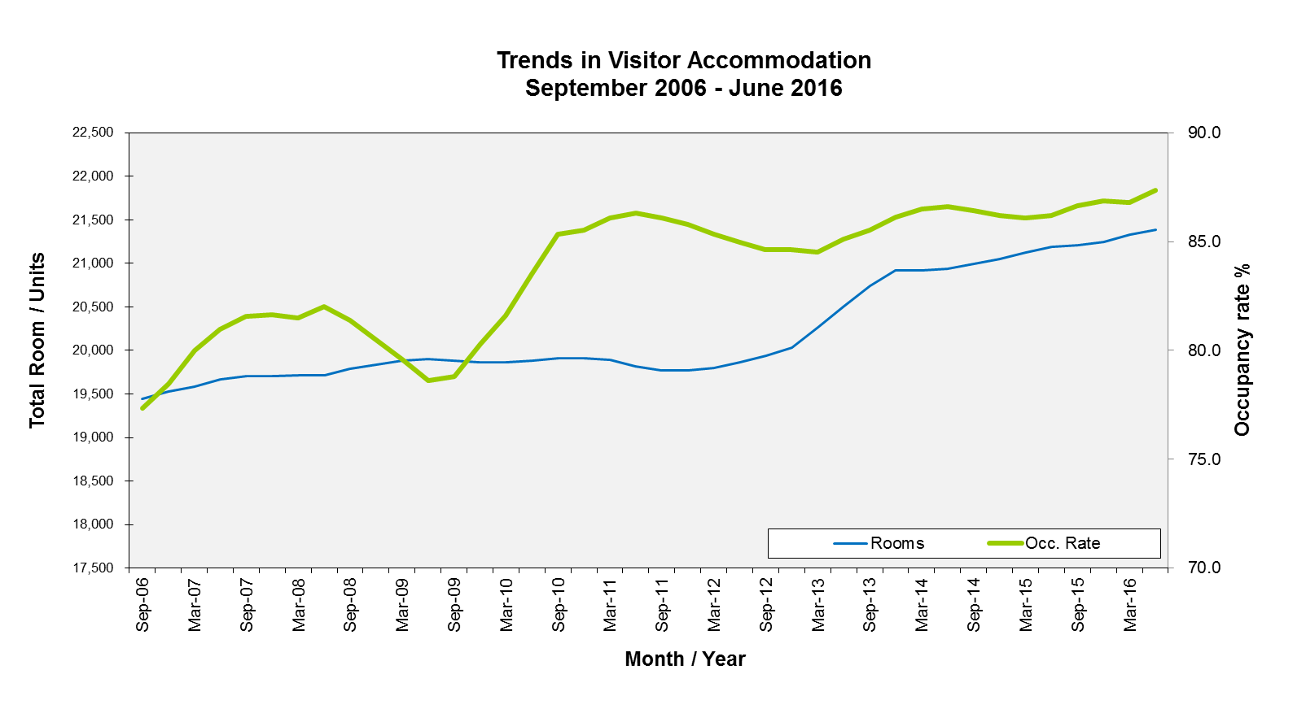
The occupancy rate for the City of Sydney LGA has consistently been over 80.0% since December 2009. In June 2016, the annual occupancy rate for the LGA peaked to 87.3% and since December 2013 occupancy rates have consistently ranged above 86.0%. As at June 2016, total room stock in the City of Sydney LGA was 21,388 rooms/units based on a derived rolling annual average calculated from the ABS Tourist Accommodation release. Whilst the numbers presented on the previous page provides our estimate of all visitor accommodation stock regardless of size of establishment in the City of Sydney LGA, the numbers derived from the ABS Tourist Accommodation release is based on the Survey of Tourist Accommodation (STA) for establishments with at least 15 rooms or units and includes hotels, motels, guest houses and serviced apartments. Between September 2006 and June 2016, the number of rooms/units in the City of Sydney LGA increased by 10 % or about 1,900+ rooms/units.

The total takings from accommodation as at June 2016 was estimated to be around $1.66 billion for the City of Sydney LGA.
Visitor accommodation type by size of establishment
The charts show the proportion of total rooms or units which are based in establishments across varying sizes: < 20 rooms; 20 – 49 rooms, 50 – 99 rooms; 100 – 199 rooms; 200 rooms and over (200+). At 30 June 2016, nearly 70% of total hotel rooms in the City of Sydney LGA were based in very large establishments that have 200+ rooms. Around a fifth (17.6%) of total hotel rooms were based in establishments with 100 -199 rooms. In contrast, accommodation found in pubs are linked to smaller properties with over 70% of total rooms are based in establishments offering less than 20 rooms on site. Serviced apartments are more widely distributed across properties of varying sizes with around 16% of total apartments located in establishments accommodating between 50 – 99 units and around 45% of total apartments in establishments accommodating between 100 – 199 units. Establishments accommodating 200+ beds had the largest share of the City’s backpacker beds representing just over 46% of all beds in the City of Sydney LGA.

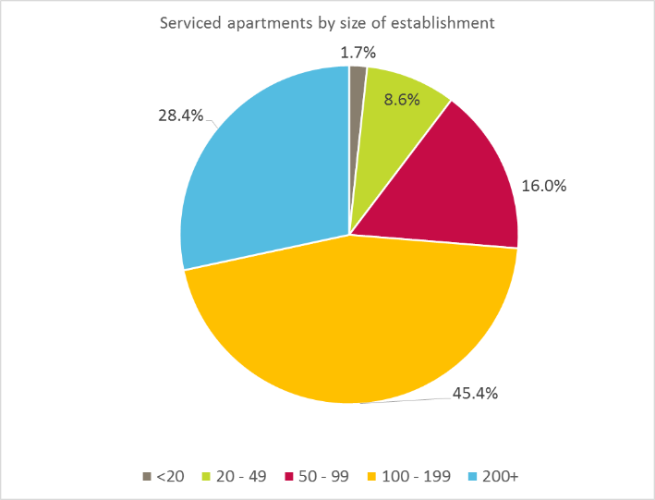
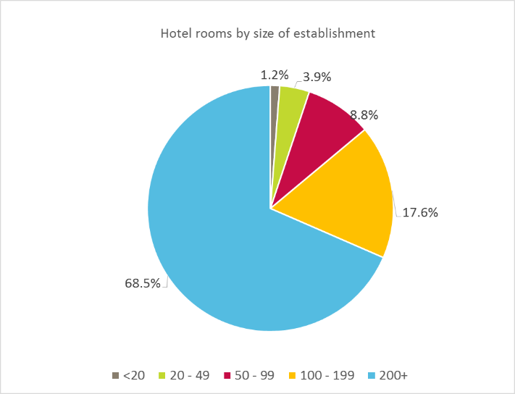

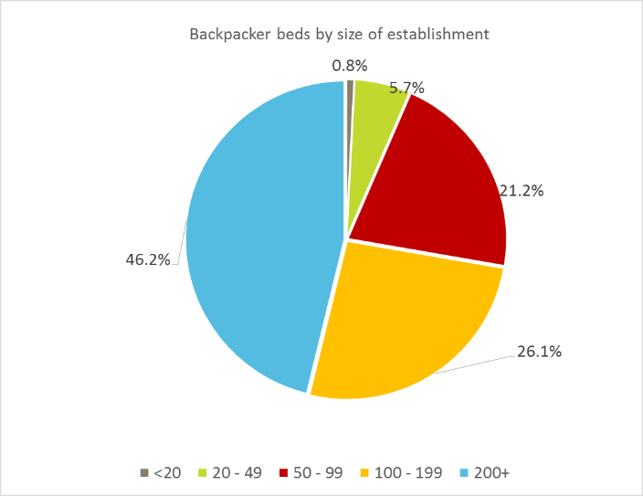
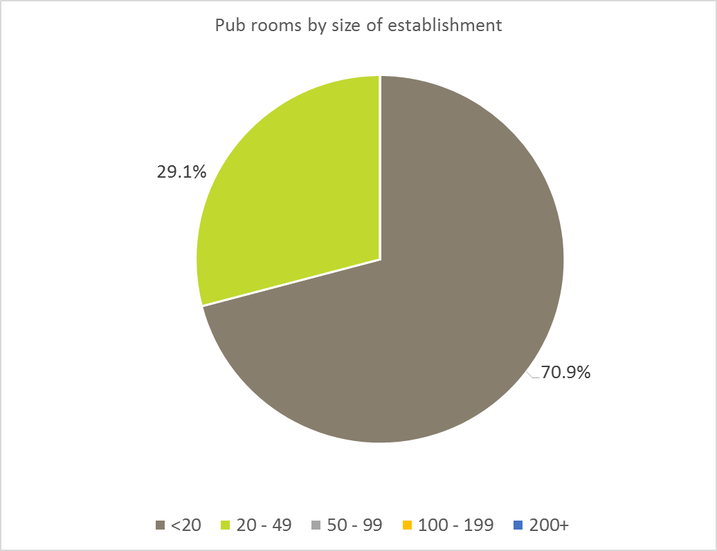

CBD & Harbour existing accommodation, June 2016

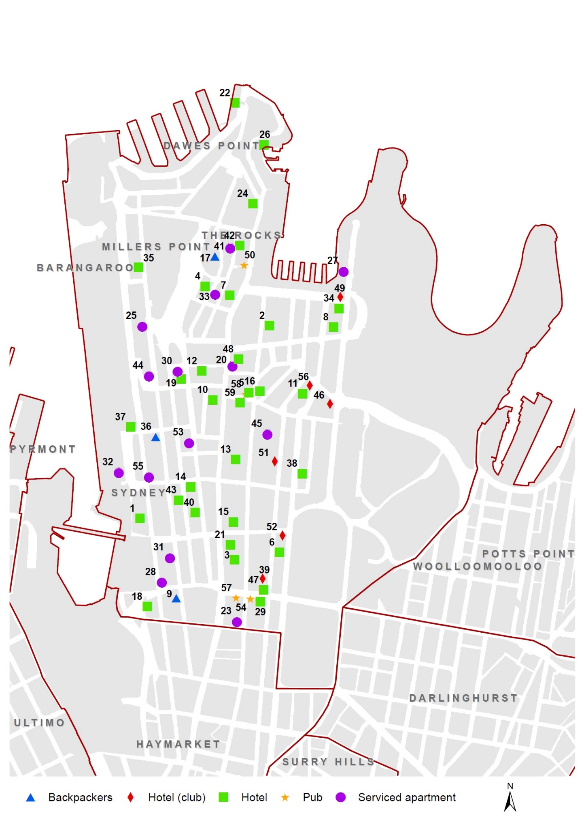
CBD & Harbour existing accommodation, June 2016
CBD AND HARBOUR EXISTING ACCOMMODATION (20 + rooms/ units / beds), 30 JUNE 2016
Map Ref. | Address | Name |  |  |  | Type | Capacity  (rooms / units/ beds)
1 | 121-185 Sussex Street, Sydney | FOUR POINTS BY SHERATON |  |  |  | HT | 200+
2 | 30 Pitt Street, Sydney | SYDNEY HARBOUR MARRIOTT HOTEL |  |  |  | HT | 200+
3 | 259 Pitt Street, Sydney | HILTON HOTEL |  |  |  | HT | 200+
4 | 158-180 Cumberland Street, The Rocks | SHANGRI-LA HOTEL |  |  |  | HT | 200+
5 | 97-99 Pitt Street, Sydney | TANK STREAM HOTEL |  |  |  | HT | 200+
6 | 161 Elizabeth Street, Sydney | SHERATON ON THE PARK |  |  |  | HT | 200+
7 | 199 George Street, The Rocks | FOUR SEASONS HOTEL |  |  |  | HT | 200+
8 | 115-119 Macquarie Street, Sydney | INTERCONTINENTAL HOTEL |  |  |  | HT | 200+
9 | 477-481 Kent Street, Sydney | X BASE BACKPACKERS |  |  |  | BP | 200+
10 | 289-307 George Street, Sydney | MENZIES HOTEL |  |  |  | HT | 200+
11 | 61-101 Phillip Street, Sydney | SOFITEL WENTWORTH SYDNEY |  |  |  | HT | 200+
12 | 11-19 Jamison Street, Sydney | AMORA JAMISON HOTEL |  |  |  | HT | 200+
13 | 1 Martin Place, Sydney | WESTIN HOTEL |  |  |  | HT | 200+
14 | 77-79 York Street, Sydney | THE GRACE HOTEL |  |  |  | HT | 200+
15 | 70 Market Street, Sydney | SWISSOTEL |  |  |  | HT | 200+
16 | 64-66 Pitt Street, Sydney | RADISSON BLU PLAZA HOTEL SYDNEY |  |  |  | HT | 200+
17 | 110 Cumberland Street, The Rocks | SYDNEY HARBOUR YHA |  |  |  | BP | 200+
18 | 150 Day Street, Sydney | PARKROYAL DARLING HARBOUR |  |  |  | HT | 200+
19 | 7-9 York Street, Sydney | TRAVELODGE WYNYARD |  |  |  | HT | 200+
20 | 2 Bond Street, Sydney | MANTRA 2 BOND STREET |  |  |  | SA | 200+
21 | 49-51 Market Street, Sydney | QT SYDNEY |  |  |  | HT | 100 - 199
22 | 11 Hickson Road, Dawes Point | PIER ONE SYDNEY HARBOUR |  |  |  | HT | 100 - 199
23 | 327 Pitt Street, Sydney | MERITON SA |  |  |  | SA | 100 - 199
24 | 53-65 George Street, The Rocks | HOLIDAY INN OLD SYDNEY |  |  |  | HT | 100 - 199
25 | 183 Kent Street, Millers Point | AEA GRAND SA |  |  |  | SA | 100 - 199
26 | 7 Hickson Road, The Rocks | PARK HYATT SYDNEY |  |  |  | HT | 100 - 199
27 | 61-69 Macquarie Street, Sydney | PULLMAN QUAY GRAND SYDNEY HARBOUR |  |  |  | SA | 100 - 199
28 | 252-258 Sussex Street, Sydney | SEASONS HARBOUR PLAZA |  |  |  | SA | 100 - 199
29 | 27 Park Street, Sydney | PARK REGIS |  |  |  | HT | 100 - 199
30 | 5 York Street, Sydney | THE YORK APARTMENTS |  |  |  | SA | 100 - 199
 | FOUR POINTS BY SHERATON

CBD & Harbour existing accommodation, June 2016
CBD AND HARBOUR EXISTING ACCOMMODATION (20 + rooms/ units / beds), 30 JUNE 2016
Map Ref. | Address | Name |  |  |  | Type | Capacity  (rooms / units/ beds)
31 | 433-435 Kent Street, Sydney | MANTRA ON KENT |  |  |  | SA | 100 - 199
32 | 55 Shelley Street, Sydney | ADINA APARTMENT HOTEL HARBOURSIDE |  |  |  | SA | 100 - 199
33 | 111 Harrington Street, The Rocks | QUAY WEST SUITES |  |  |  | SA | 100 - 199
34 | 93-97 Macquarie Street, Sydney | SIR STAMFORD AT CIRCULAR QUAY |  |  |  | HT | 100 - 199
35 | 89-105 Kent Street, Millers Point | THE LANGHAM HOTEL |  |  |  | HT | 100 - 199
36 | 301 Kent Street, Sydney | SIESTA INN SYDNEY |  |  |  | BP | 50 - 99
37 | 12-20 Shelley Street, Sydney | HOTEL IBIS |  |  |  | HT | 50 - 99
38 | 165 Phillip Street, Sydney | TRAVELODGE PHILLIP STREET |  |  |  | HT | 50 - 99
39 | 169-173 Castlereagh Street, Sydney | NEW SOUTH WALES MASONIC CLUB |  |  |  | HT (club) | 50 - 99
40 | 93 York Street, Sydney | MEGABOOM CITY HOTEL |  |  |  | HT | 50 - 99
41 | 35-75 Harrington Street, The Rocks | RENDEZVOUS HOTEL THE ROCKS |  |  |  | SA | 50 - 99
42 | 34-36 Harrington Street, The Rocks | HARBOUR ROCKS HOTEL |  |  |  | HT | 50 - 99
43 | 193-195 Clarence Street, Sydney | BREAKFREE ON CLARENCE |  |  |  | HT | 50 - 99
44 | 219 Kent Street, Sydney | NAPOLEON ON KENT SA |  |  |  | SA | 20 - 49
45 | 1 Hosking Place, Sydney | MEDINA SA MARTIN PLACE |  |  |  | SA | 20 - 49
46 | 165-169 Macquarie Street, Sydney | AUSTRALIAN CLUB |  |  |  | HT (club) | 20 - 49
47 | 48-48A Park Street, Sydney | PARK 8 HOTEL |  |  |  | HT | 20 - 49
48 | 248-252 George Street, Sydney | ESTABLISHMENT HOTEL |  |  |  | HT | 20 - 49
49 | 89-91 Macquarie Street, Sydney | ROYAL AUTOMOBILE CLUB OF AUSTRALIA |  |  |  | HT (club) | 20 - 49
50 | 143 George Street, The Rocks | RUSSELL HOTEL |  |  |  | Pub | 20 - 49
51 | 19-29 Martin Place, Sydney | CTA |  |  |  | HT (club) | 20 - 49
52 | 135-137C Elizabeth Street, Sydney | THE QUEENS CLUB LIMITED |  |  |  | HT (club) | 20 - 49
53 | 57-59 York Street, Sydney | CARRINGTON APARTMENTS |  |  |  | SA | 20 - 49
54 | 258-260 Pitt Street, Sydney | CRITERION HOTEL |  |  |  | Pub | 20 - 49
55 | 132-136 Sussex Street, Sydney | METRO ON DARLING HARBOUR SA |  |  |  | SA | 20 - 49
56 | 59 Phillip Street, Sydney | UNION CLUB |  |  |  | HT (club) | 20 - 49
57 | 5-7 Park Street, Sydney | HOTEL CORONATION |  |  |  | Pub | 20 - 49
58 | 30-32 Hunter Street, Sydney | THE GRAND HOTEL |  |  |  | Pub | 20 - 49
59 | 15 Hunter Street, Sydney | CITY LODGE HOTEL |  |  |  | HT | 20 - 49
 | FOUR POINTS BY SHERATON

Chinatown & CBD South existing accommodation, June 2016

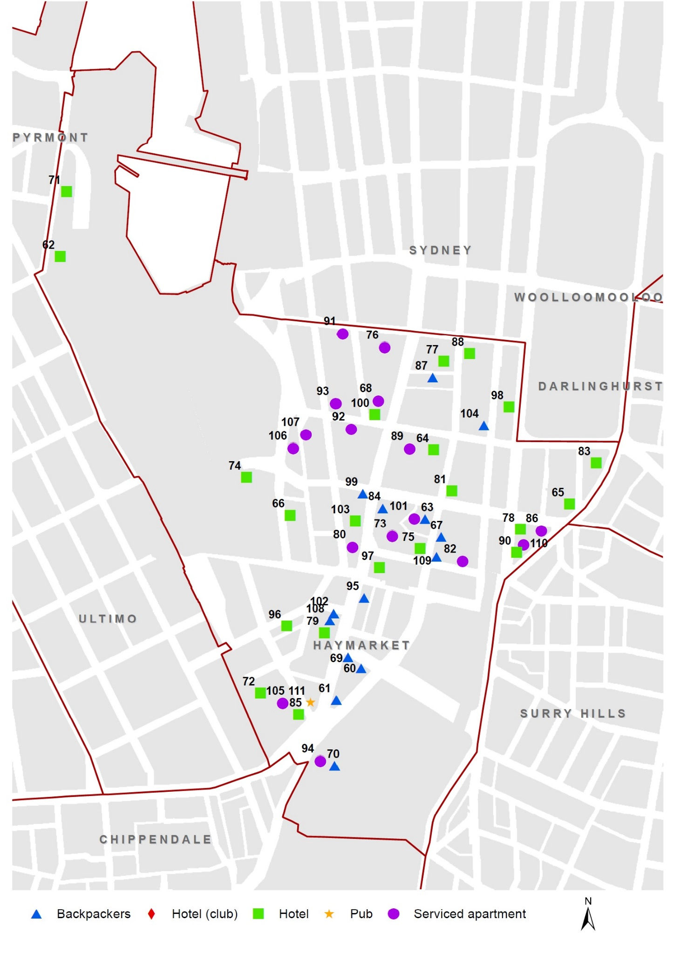

Chinatown & CBD South existing accommodation, June 2016
CHINATOWN AND CBD SOUTH EXISTING ACCOMMODATION (20 + rooms/ units / beds), 30 JUNE 2016
Map Ref. | Address | Name |  |  |  | Type |  | Capacity  (rooms / units/ beds)
60 | 11-23 Rawson Place, Haymarket | SYDNEY CENTRAL YHA |  |  |  | BP |  | 200+
61 | 814 George Street, Haymarket | WAKE UP! |  |  |  | BP |  | 200+
62 | 80 Murray Street, Sydney | NOVOTEL DARLING HARBOUR |  |  |  | HT |  | 200+
63 | 403-427 Pitt Street, Haymarket | MAZE BACKPACKERS |  |  |  | BP |  | 200+
64 | 93 Liverpool Street, Sydney | RYDGES WORLD SQUARE |  |  |  | HT |  | 200+
65 | 27-33 Wentworth Avenue, Sydney | TRAVELODGE SYDNEY |  |  |  | HT |  | 200+
66 | 68 Harbour Street, Haymarket | HOLIDAY INN DARLING HARBOUR |  |  |  | HT |  | 200+
67 | 412 Pitt Street, Haymarket | NOMADS BACKPACKERS SYDNEY |  |  |  | BP |  | 200+
68 | 537-551 George Street, Sydney | MERITON SA |  |  |  | SA |  | 200+
69 | 790-798 George Street, Haymarket | 790 ON GEORGE STREET |  |  |  | BP |  | 200+
70 | 8-10 Lee Street, Haymarket | RAILWAY SQUARE YHA |  |  |  | BP |  | 200+
71 | 50 Murray Street, Sydney | IBIS DARLING HARBOUR |  |  |  | HT |  | 200+
72 | 169-179 Thomas Street, Haymarket | NOVOTEL SYDNEY CENTRAL |  |  |  | HT |  | 200+
73 | 4-10 Campbell Street, Haymarket | MERITON SA |  |  |  | SA |  | 200+
74 | 17 Little Pier Street, Haymarket | NOVOTEL ROCKFORD |  |  |  | HT |  | 200+
75 | 431-439 Pitt Street, Haymarket | METRO HOTEL MARLOW  SYDNEY CENTRAL |  |  |  | HT |  | 200+
76 | 487-503 George Street, Sydney | FRASER SUITES |  |  |  | SA |  | 200+
77 | 115-119 Bathurst Street, Sydney | PRIMUS HOTEL SYDNEY |  |  |  | HT |  | 100 - 199
78 | 164-182 Elizabeth Street, Sydney | VIBE HOTEL |  |  |  | HT |  | 100 - 199
79 | 715-723 George Street, Haymarket | THE GREAT SOUTHERN HOTEL |  |  |  | HT |  | 100 - 199
80 | 653-659 George Street, Haymarket | BREAKFREE ON GEORGE HOTEL |  |  |  | SA |  | 100 - 199
81 | 384A-388 Pitt Street, Sydney | IBIS WORLD SQUARE |  |  |  | HT |  | 100 - 199
82 | 414-418 Pitt Street, Haymarket | REGIS TOWERS SERVICED APARTMENTS |  |  |  | SA |  | 100 - 199
83 | 5-11 Wentworth Avenue, Sydney | Y HOTEL HYDE PARK |  |  |  | HT |  | 100 - 199
84 | 698-704 George Street, Haymarket | THE GEORGE BUDGET AND BACKPACKER ACCOMMODATION |  |  |  | BP |  | 100 - 199
85 | 803-813 George Street, Haymarket | RENDEZVOUS HOTEL SYDNEY CENTRAL |  |  |  | HT |  | 100 - 199
86 | 35-45 Wentworth Avenue, Sydney | WYNDHAM VACATION RESORTS SYDNEY |  |  |  | SA |  | 100 - 199
87 | 7-9 Wilmot Street, Sydney | SYDNEY BACKPACKERS |  |  |  | BP |  | 100 - 199
88 | 300 Pitt Street, Sydney | METRO HOTEL ON PITT |  |  |  | HT |  | 100 - 199
89 | 93 Liverpool Street, Sydney | MERITON SA |  |  |  | SA |  | 100 - 199
 | FOUR POINTS BY SHERATON

Chinatown & CBD South existing accommodation, June 2016
CHINATOWN AND CBD SOUTH EXISTING ACCOMMODATION (20 + rooms/ units / beds), 30 JUNE 2016
Map Ref. | Address | Name | Type | Capacity  (rooms / units/ beds)
90 | 184-196 Elizabeth Street, Sydney | CENTRAL STATION HOTEL | HT | 100 - 199
91 | 511-513 Kent Street, Sydney | ADINA APARTMENT HOTEL SYDNEY KENT STREET | SA | 100 - 199
92 | 57-67 Liverpool Street, Sydney | WALDORF SYDNEY SERVICED APARTMENTS | SA | 100 - 199
93 | 352 Sussex Street, Sydney | RADISSON HOTEL & SUITES SYDNEY | SA | 100 - 199
94 | 2 Lee Street, Haymarket | ADINA APARTMENT HOTEL SYDNEY CENTRAL | SA | 50 - 99
95 | 752-752A George Street, Haymarket | EASY GO BACKPACKERS | BP | 50 - 99
96 | 35-39 Ultimo Road, Haymarket | AARONS HOTEL | HT | 50 - 99
97 | 730-742 George Street, Haymarket | CAPITOL SQUARE HOTEL | HT | 50 - 99
98 | 271-279 Elizabeth Street, Sydney | HYDE PARK INN | HT | 50 - 99
99 | 611-613 George Street, Haymarket | CENTRAL PERK BACKPACKERS | BP | 50 - 99
100 | 88 Liverpool Street, Sydney | SYDNEY HOTEL CBD | HT | 50 - 99
101 | 2-4 Cunningham Street, Haymarket | APX WORLD SQUARE | SA | 50 - 99
102 | 701 George Street, Haymarket | MOUNTBATTEN HOTEL | BP | 50 - 99
103 | 631-635 George Street, Haymarket | PENSIONE HOTEL | HT | 50 - 99
104 | 249-253 Castlereagh Street, Sydney | THE DOWNING HOSTEL | BP | 50 - 99
105 | 107-121 Quay Street, Haymarket | OAKS HARMONY | SA | 50 - 99
106 | 28 Harbour Street, Sydney | SEASONS DARLING HARBOUR | SA | 50 - 99
107 | 2-8 Dixon Street, Sydney | APX APARTMENTS DARLING HARBOUR | SA | 20 - 49
108 | 707-709 George Street, Haymarket | CITY CENTRAL BUDGET ACCOMMODATION | BP | 20 - 49
109 | 428 Pitt Street, Haymarket | SYDNEY CENTRAL INN | BP | 20 - 49
110 | 61-65 Wentworth Avenue, Sydney | ZARA TOWER | SA | 20 - 49
111 | 789-791 George Street, Haymarket | CRYSTAL PALACE HOTEL | Pub | 20 - 49

City East existing accommodation, June 2016

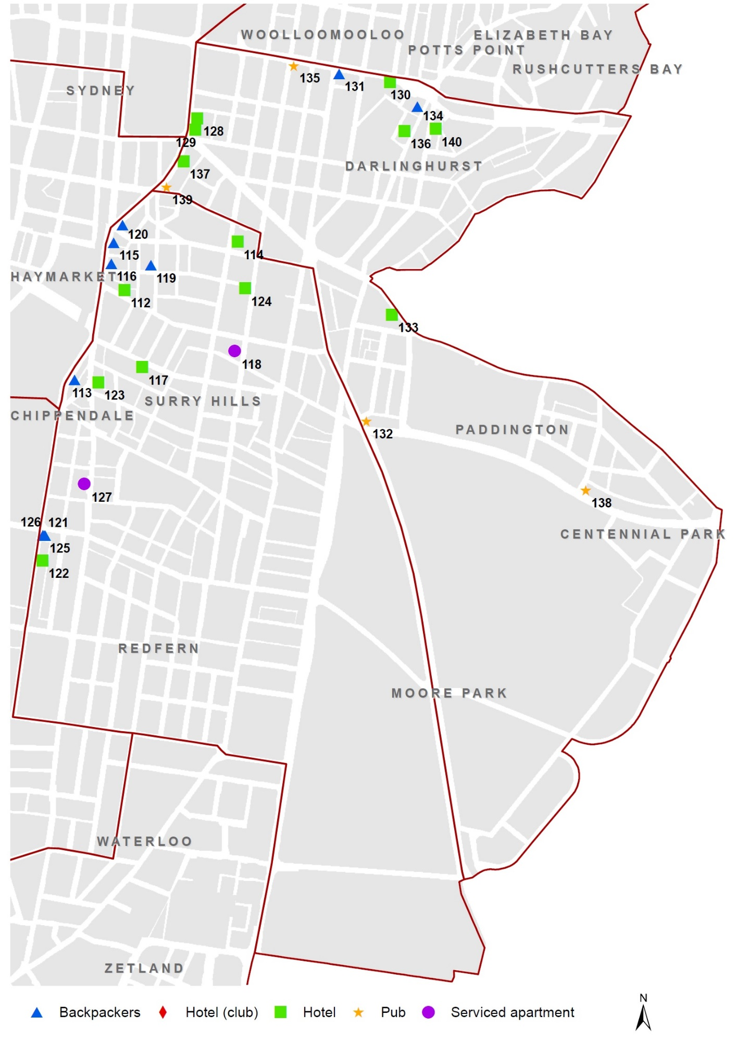
City East existing accommodation, June 2016
CITY EAST EXISTING ACCOMMODATION (20 + rooms/ units / beds), 30 JUNE 2016
Map Ref. | Address | Name | Type | Capacity  (rooms / units/ beds)
112 | 28 Albion Street, Surry Hills | RYDGES SYDNEY CENTRAL | HT | 200+
113 | 20-28 Chalmers Street, Surry Hills | BOUNCE SYDNEY | BP | 100 - 199
114 | 208-218 Riley Street, Surry Hills | CAMBRIDGE HOTEL | HT | 100 - 199
115 | 212-214 Elizabeth Street, Surry Hills | BIG HOSTEL | BP | 100 - 199
116 | 232-236A Elizabeth Street,  Surry Hills | HOME BACKPACKERS | BP | 100 - 199
117 | 57-61 Foveaux Street, Surry Hills | 57 HOTEL | HT | 50 - 99
118 | 353-359 Crown Street, Surry Hills | ADINA APARTMENT HOTEL CROWN STREET | SA | 50 - 99
119 | 141-155 Commonwealth Street, Surry Hills | OASIS BACKPACKERS | BP | 50 - 99
120 | 88-90 Wentworth Avenue, Surry Hills | HYDE PARK BACKPACKERS | BP | 50 - 99
121 | 243 Cleveland Street, Redfern | TOKYO VILLAGE | BP | 20 - 49
122 | 238-240 Chalmers Street, Redfern | CENTRAL RAILWAY HOTEL | HT | 20 - 49
123 | 356-358 Elizabeth Street, Surry Hills | CENTRAL PRIVATE HOTEL | HT | 20 - 49
124 | 287-289 Crown Street, Surry Hills | CITY CROWN MOTEL | HT | 20 - 49
125 | 245 Cleveland Street, Redfern | TOKYO VILLAGE | BP | 20 - 49
126 | 247 Cleveland Street, Redfern | TOKYO VILLAGE | BP | 20 - 49
127 | 517-527 Elizabeth Street, Surry Hills | SERVICED APARTMENTS | SA | 20 - 49
128 | 26-36 College Street, Darlinghurst | PULLMAN SYDNEY HYDE PARK | HT | 200+
129 | 38-52 College Street, Darlinghurst | OAKS HYDE PARK PLAZA | HT | 100 - 199
130 | 191-205 William Street, Darlinghurst | IBIS BUDGET EAST SYDNEY | HT | 100 - 199
131 | 135-145 William Street, Darlinghurst | WOODDUCK BOOMERANG BACKPACKERS | BP | 50 - 99
132 | 162 Flinders Street, Paddington | CAPTAIN COOK HOTEL | Pub | 50 - 99
133 | 21-25 Oxford Street, Paddington | ARTS HOTEL | HT | 50 - 99
134 | 191-199 Darlinghurst Road, Darlinghurst | BUDGET ACCOMMODATION | BP | 20 - 49
135 | 99 William Street, Darlinghurst | STRAND HOTEL | Pub | 20 - 49
136 | 229-231 Darlinghurst Road, Darlinghurst | THE KIRKETON HOTEL | HT | 20 - 49
137 | 4-6 Wentworth Avenue, Surry Hills | HOTEL STELLAR | HT | 20 - 49
138 | 308 Moore Park Road, Paddington | OLYMPIC HOTEL | Pub | 20 - 49
139 | 40-44 Wentworth Avenue, Surry Hills | HOTEL HARRY | Pub | 20 - 49
140 | 304-310 Victoria Street, Darlinghurst | MORGAN'S BOUTIQUE HOTEL | HT | 20 - 49

City East existing accommodation, June 2016

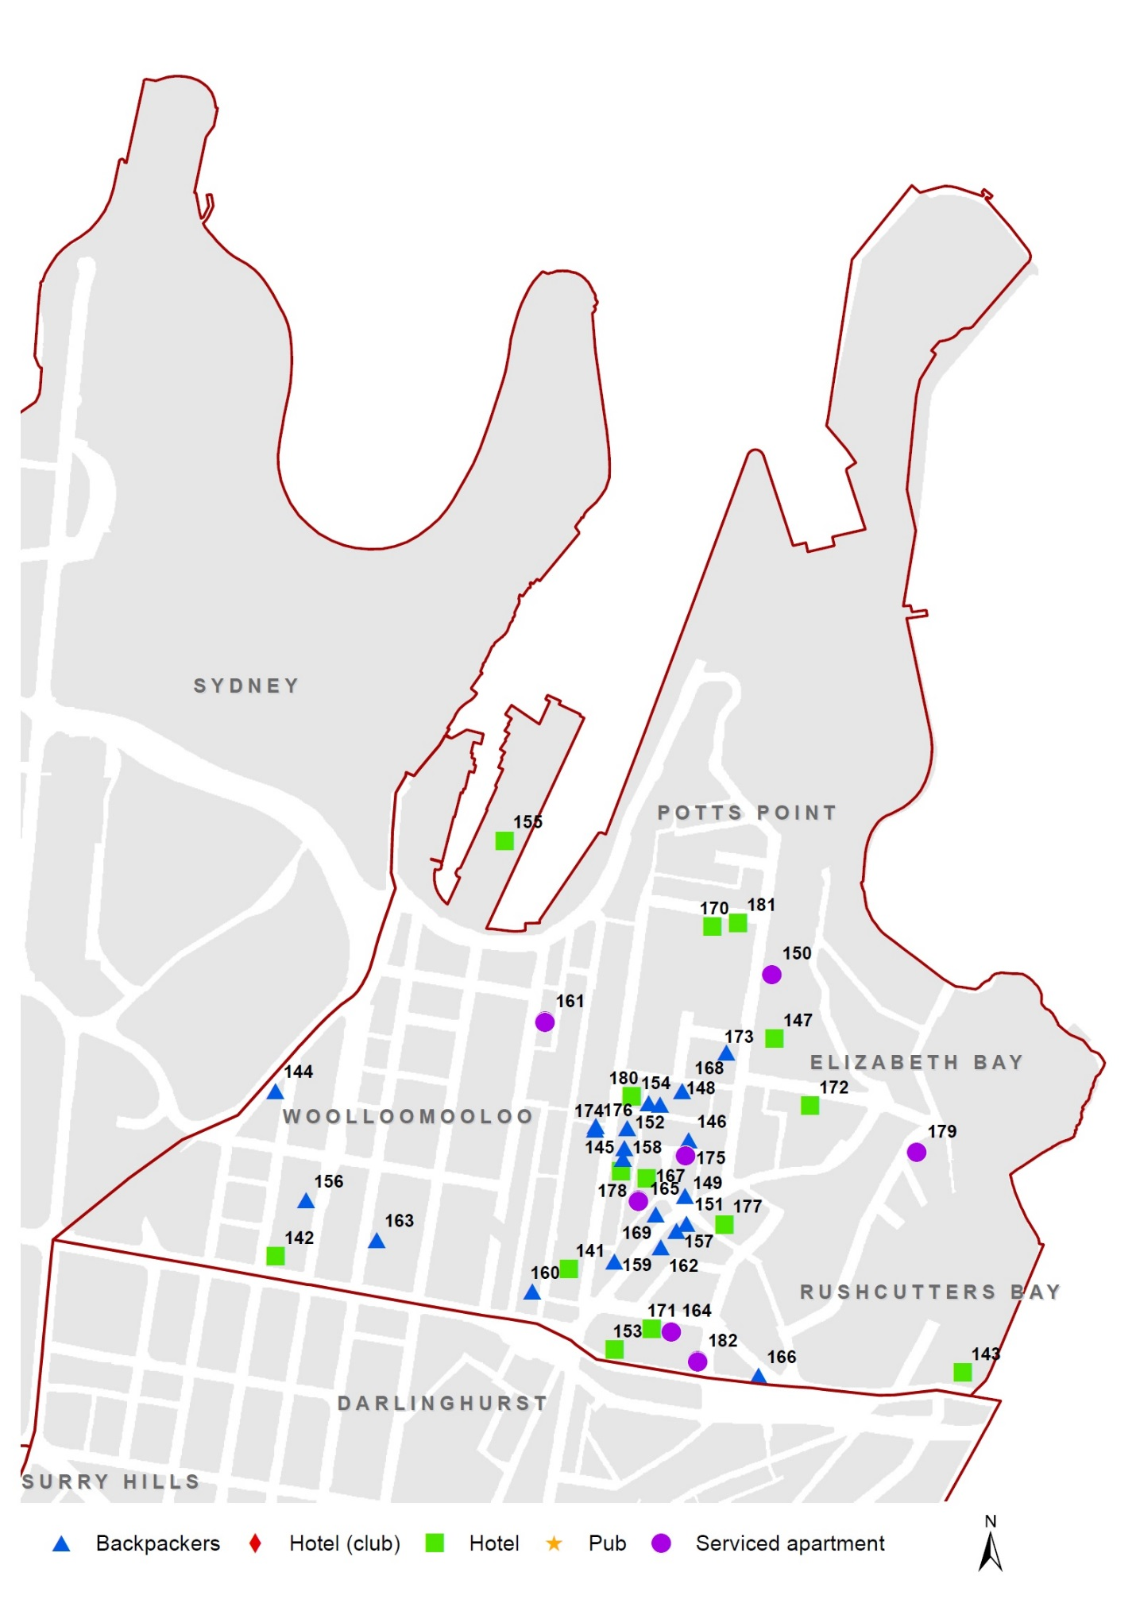

City East existing accommodation, June 2016
CITY EAST EXISTING ACCOMMODATION (20 + rooms/ units / beds), 30 JUNE 2016
Map Ref. | Address | Name | Type | Capacity  (rooms / units/ beds)
141 | 203-225 Victoria Street, Potts Point | HOLIDAY INN POTTS POINT | HT | 200+
142 | 88-108 William Street, Woolloomooloo | THE SYDNEY BOULEVARD HOTEL | HT | 200+
143 | 100 Bayswater Road,  Rushcutters Bay | VIBE HOTEL RUSHCUTTERS BAY | HT | 200+
144 | 50-58 Sir John Young Crescent, Woolloomooloo | ELEPHANT BACKPACKERS | BP | 200+
145 | 160-162 Victoria Street, Potts Point | ORIGINAL BACKPACKERS LODGE | BP | 100 - 199
146 | 27 Orwell Street, Potts Point | FAMOUS JOLLY SWAGMAN BACKPACKERS | BP | 100 - 199
147 | 44-46 MacLeay Street, Elizabeth Bay | DEVERE HOTEL | HT | 100 - 199
148 | 14-16 Orwell Street, Potts Point | SYDNEY CENTRAL BACKPACKERS | BP | 100 - 199
149 | 23-31 Darlinghurst Road, Potts Point | THE FUNK HOUSE | BP | 100 - 199
150 | 28 MacLeay Street, Elizabeth Bay | MACLEAY SERVICED APARTMENTS | SA | 100 - 199
151 | 34-36A Darlinghurst Road, Potts Point | MAD MONKEY BACKPACKERS | BP | 100 - 199
152 | 144 Victoria Street, Potts Point | CHILI BLUE BACKPACKERS | BP | 100 - 199
153 | 6-8 Orwell Street, Potts Point | EVA'S BACKPACKERS | BP | 100 - 199
154 | 6G Cowper Wharf Roadway, Woolloomooloo | OVOLO WOOLLOOMOOLOO | HT | 100 - 199
155 | 103-105 Palmer Street, Woolloomooloo | CITY RESORT HOSTEL | BP | 100 - 199
156 | 40-40D Darlinghurst Road, Potts Point | THE HUMP BACKPACKERS | BP | 100 - 199
157 | 156 Victoria Street, Potts Point | ZING | BP | 50 - 99
158 | 109A Darlinghurst Road, Potts Point | THE JACKAROO HOSTEL | BP | 50 - 99
159 | 201 Brougham Street, Woolloomooloo | ASYLUM SYDNEY | BP | 50 - 99
160 | 88 Dowling Street, Woolloomooloo | WALDORF WOOLLOOMOOLOO | SA | 50 - 99
161 | 2-14 Kings Cross Road, Potts Point | LARMONT HOTEL | HT | 50 - 99
162 | 48-48A Darlinghurst Road, Potts Point | DURY HOUSE | BP | 50 - 99
163 | 132 Bourke Street, Woolloomooloo | SYDNEY STAR BACKPACKERS | BP | 50 - 99
164 | 19-35 Bayswater Road, Potts Point | SERVICED APARTMENTS | SA | 50 - 99
165 | 3 Earl Place, Potts Point | QUEST SERVICED APARTMENTS | SA | 50 - 99
166 | 50-58 Sir John Young Crescent, Woolloomooloo | KINGS CROSS BACKPACKERS | BP | 200+
167 | 111-139 Darlinghurst Road, Potts Point | SPRINGFIELD LODGE | HT | 200+
168 | 23 Hughes Street, Potts Point | THE PALMS BACKPACKERS | BP | 50 - 99
169 | 39-43 Darlinghurst Road | KINGS CROSS BUDGET ACCOMMODATION | BP | 50 -99
170 | 21-23 Challis Avenue | HOTEL CHALLIS | HT | 50 -99

City East existing accommodation, June 2016
CITY EAST EXISTING ACCOMMODATION (20 + rooms/ units / beds), 30 JUNE 2016
Map Ref. | Address | Name | Type | Capacity  (rooms / units/ beds)
171 | 17 Bayswater Road, Potts Point | THE BAYSWATER SYDNEY | HT | 50 - 99
172 | 11-13 Greenknowe Avenue, Elizabeth Bay | COUNTRY WOMEN'S ASSOCIATION RESIDENTIAL CLUB | HT | 50 - 99
173 | 87 MacLeay Street, Potts Point | BLUE PARROT BACKPACKERS | BP | 50 - 99
174 | 141 Victoria Street, Potts Point | KANGA HOUSE BACKPACKERS | BP | 20 - 49
175 | 18 Springfield Avenue, Potts Point | REGENT COURTS | SA | 20 - 49
176 | 141A Victoria Street, Potts Point | KANGA HOUSE BACKPACKERS | BP | 20 - 49
177 | 2 Roslyn Street, Potts Point | LIDO SUITES | HT | 20 - 49
178 | 166 Victoria Street, Potts Point | HIGHFIELD PRIVATE HOTEL | HT | 20 - 49
179 | 4-14 Roslyn Gardens, Rushcutters Bay | ROSLYN GARDENS SERVICED APARTMENTS | SA | 20 - 49
180 | 122-124 Victoria Street, Potts Point | SPICERS POTTS POINT | HT | 20 - 49
181 | 31 Challis Avenue, Potts Point | THE MAISONETTE HOTEL | HT | 20 - 49
182 | 46 Kings Cross Road, Potts Point | ANNAM APARTMENTS | SA | 20 - 49

City West existing accommodation, June 2016

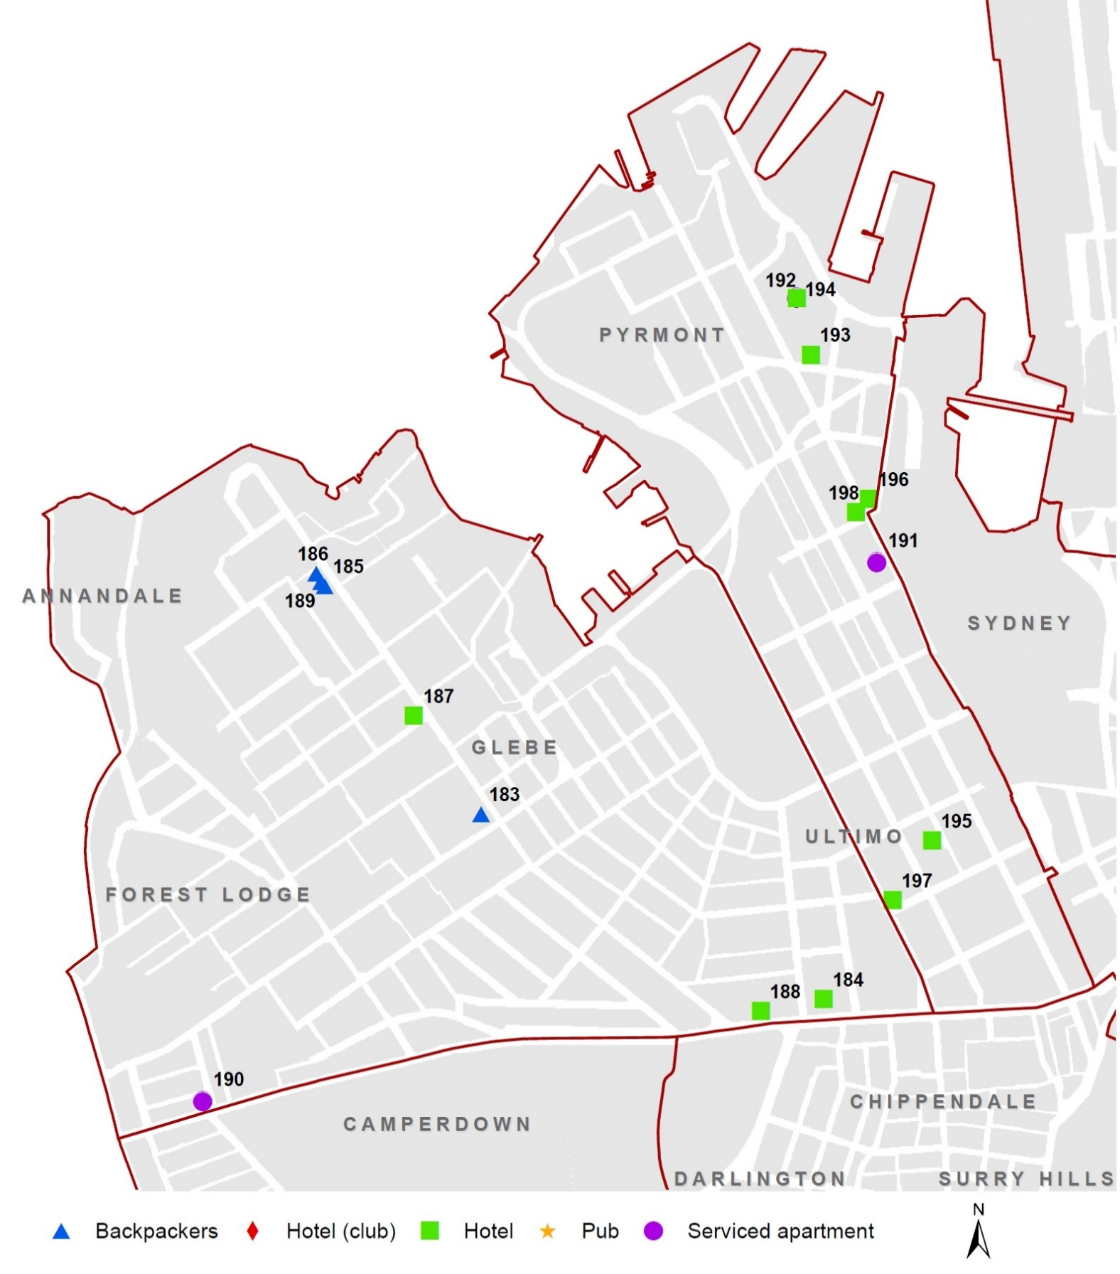

City West existing accommodation, June 2016
CITY WEST EXISTING ACCOMMODATION (20 + rooms/ units / beds), 30 JUNE 2016
Map Ref. | Address | Name | Type | Capacity  (rooms / units/ beds)
183 | 146-148 Glebe Point Road, Glebe | ROOFTOP TRAVELLERS LODGE | BP | 100 - 199
184 | 185-211 Broadway, Ultimo | UNILODGE | HT | 100 - 199
185 | 254-256 Glebe Point Road, Glebe | VILLAGE LIVING AUSTRALIA GLEBE | BP | 50 - 99
186 | 262-264 Glebe Point Road, Glebe | GLEBE POINT YHA HOSTEL | BP | 50 - 99
187 | 196 Glebe Point Road, Glebe | THE HAVEN INN | HT | 50 - 99
188 | 247-253 Broadway, Glebe | PARKVIEW HOTEL | HT | 20 - 49
189 | 258 Glebe Point Road, Glebe | VILLAGE LIVING AUSTRALIA GLEBE | BP | 20 - 49
190 | 108 Parramatta Road, Camperdown | ADARA CAMPERDOWN | SA | 20 - 49
191 | 243-271 Pyrmont Street, Pyrmont | OAKS GOLDSBROUGH APARTMENTS | SA | 200+
192 | 20-80 Pyrmont Street, Pyrmont | ASTRAL TOWER (HOTEL) | HT | 200+
193 | 20-80 Pyrmont Street, Pyrmont | THE DARLING | HT | 100 - 199
194 | 20-80 Pyrmont Street, Pyrmont | ASTRAL RESIDENCES (APARTMENTS) | SA | 100 - 199
195 | 383-389 Bulwara Road, Ultimo | ASPIRE HOTEL SYDNEY | HT | 50 - 99
196 | 139 Murray Street, Pyrmont | OVOLO 1888 DARLING HARBOUR | HT | 50 - 99
197 | 494-500 Wattle Street, Ultimo | VULCAN HOTEL | HT | 20 - 49
198 | 22 Allen Street, Pyrmont | THE WOOLBROKERS BED & BREAKFAST | HT | 20 - 49

City South existing accommodation, June 2016

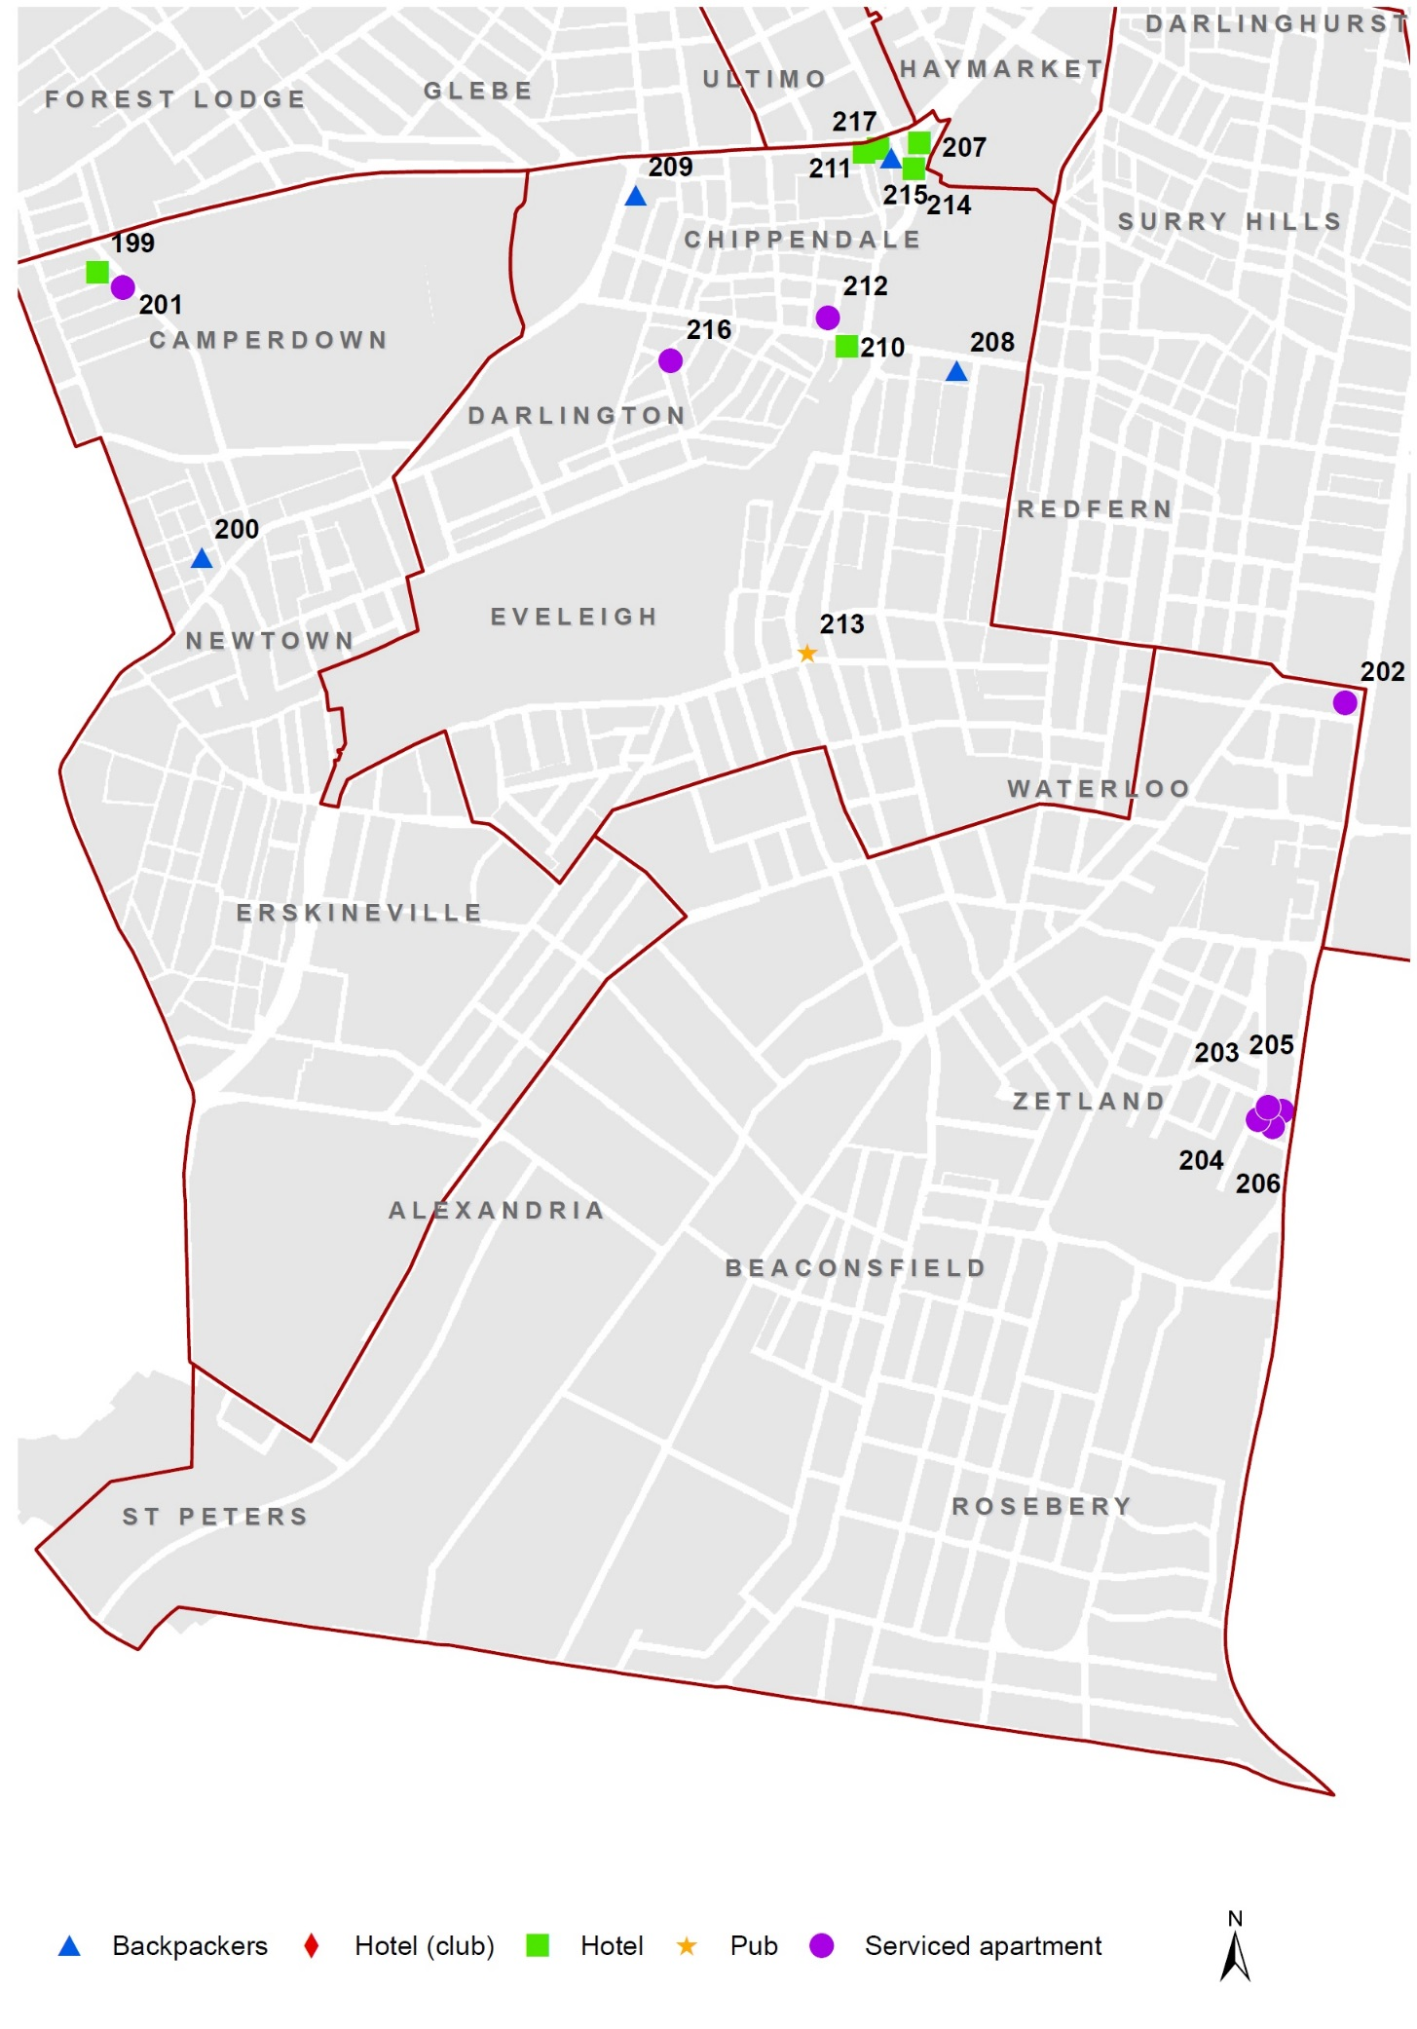
City South existing accommodation, June 2016
CITY SOUTH EXISTING ACCOMMODATION (20 + rooms/ units / beds), 30 JUNE 2016
Map Ref. | Address | Name | Type | Capacity  (rooms / units/ beds)
199 | 3-19 Missenden Road, Camperdown | RYDGES | HT | 100 - 199
200 | 5-11 Egan Street, Newtown | BILLABONG GARDENS HOSTEL | BP | 50 - 99
201 | 23-33 Missenden Road, Camperdown | QUEST | SA | 50 - 99
202 | 782 Bourke Street, Waterloo | MERITON SERVICED APARTMENTS | SA | 100 - 199
203 | 8A Defries Avenue, Zetland | MERITON SERVICED APARTMENTS | SA | 100 - 199
204 | 8B Defries Avenue, Zetland | MERITON SERVICED APARTMENTS | SA | 50 - 99
205 | 8 Defries Avenue, Zetland | MERITON SERVICED APARTMENTS | SA | 50 - 99
206 | 8D Defries Avenue, Zetland | MERITON SERVICED APARTMENTS | SA | 50 - 99
207 | 6-10 Little Regent Street, Chippendale | MERCURE SYDNEY | HT | 200+
208 | 207 Cleveland Street, Redfern | VILLAGE LIVING AUSTRALIA | BP | 100 - 199
209 | 20 City Road, Chippendale | MAD MONKEY BACKPACKERS | BP | 50 - 99
210 | 179 Cleveland Street, Redfern | Y HOTEL CITY SOUTH | HT | 50 - 99
211 | 1 Kensington Street, Chippendale | THE OLD CLARE HOTEL | HT | 50 - 99
212 | 47-49 Chippen Street, Chippendale | WALDORF SYDNEY CENTRAL | SA | 20 - 49
213 | 45-47 Botany Road, Waterloo | ABBOTS HOTEL | Pub | 20 - 49
214 | 28-30 Regent Street, Chippendale | LEISURE INN SYDNEY CENTRAL | HT | 20 - 49
215 | 11-13 Regent Street, Chippendale | CASA CENTRAL BACKPACKERS | BP | 20 - 49
216 | 74-80 Ivy Street, Darlington | ADINA APARTMENT HOTEL | SA | 20 - 49
217 | 8-14 Broadway, Chippendale | POSH HOTEL | HT | 20 - 49

Summary of pipeline activity, 2015/16

In 2015/16, 11 new visitor accommodation establishments were completed in the City of Sydney LGA. Seven of these establishments represented hotel accommodation contributing to an overall capacity of 668 additional rooms. The remainder represented serviced apartment establishments and contributed to an overall capacity of 68 units. There were also four existing establishments which had either a refurbishment, alteration, addition and/or fit-out completed in 2015/16 and thus contributing to a total expanded capacity of 51 additional rooms in the City of Sydney LGA. One refurbishment of an existing hotel establishment was also completed in 2015/16 which resulted in an overall net loss of 8 rooms. Of the seven new hotel establishments completed in the City of Sydney LGA, two were located in CBD and Harbour (346 new rooms), two were located in Chinatown and CBD South (249 new rooms) and one was located in Redfern Street village area which is based in the larger area known as City South (62 new rooms). The remainder were located in Macleay Street and Woolloomooloo (City East) and Glebe Point Road (City West) with a total of 11 new rooms.
At 30 June 2016, there were a total of 5,986 potential hotel rooms, 596 potential backpacker beds, 721 serviced apartment units and 27 rooms in pub based accommodation in the pipeline representing the following:
- 2,559 rooms / units / beds were linked to 18 development applications lodged but yet to be determined. Of these, there were
  - 2,237 rooms in hotel establishments (2,156 linked to new and 81 linked to existing establishments)
  - 318 backpacker beds in new backpacker establishments
  - 4 units in a serviced apartment establishment
- 2,535 rooms / units / beds were linked to 27 approved development applications but where works have not yet commenced. Of these, there were
  - 2,083 rooms in hotel establishments (2,038 rooms linked to new and 45 rooms linked to existing establishments)
  - 401 units in serviced apartment establishments (380 units linked to new and 21 units linked to existing serviced apartment establishments)
  - 33 backpacker beds in existing backpacker establishments
  - 18 rooms in a pub based establishment
- 2,236 rooms / units / beds were linked to 23 approved development applications but where works have commenced. Of these, there were
  - 1,666 rooms in hotel establishments (1,342 rooms linked to new and 324 rooms linked to existing establishments)
  - 316 units in new serviced apartment establishments
  - 245 beds in new backpacker establishments
  - 9 rooms in a pub based establishment

In developments where works had commenced as at 30 June 2016, Chinatown and CBD South followed by CBD and Harbour had the largest representation of hotel rooms under construction with 776 and 394 rooms respectively in each area. For approved developments where works have not yet commenced, Chinatown and CBD South followed by CBD and Harbour had the largest representation of hotel rooms approved with 1,139 and 729 rooms respectively in each area.

CBD & Harbour recent completions & pipeline, June 2016
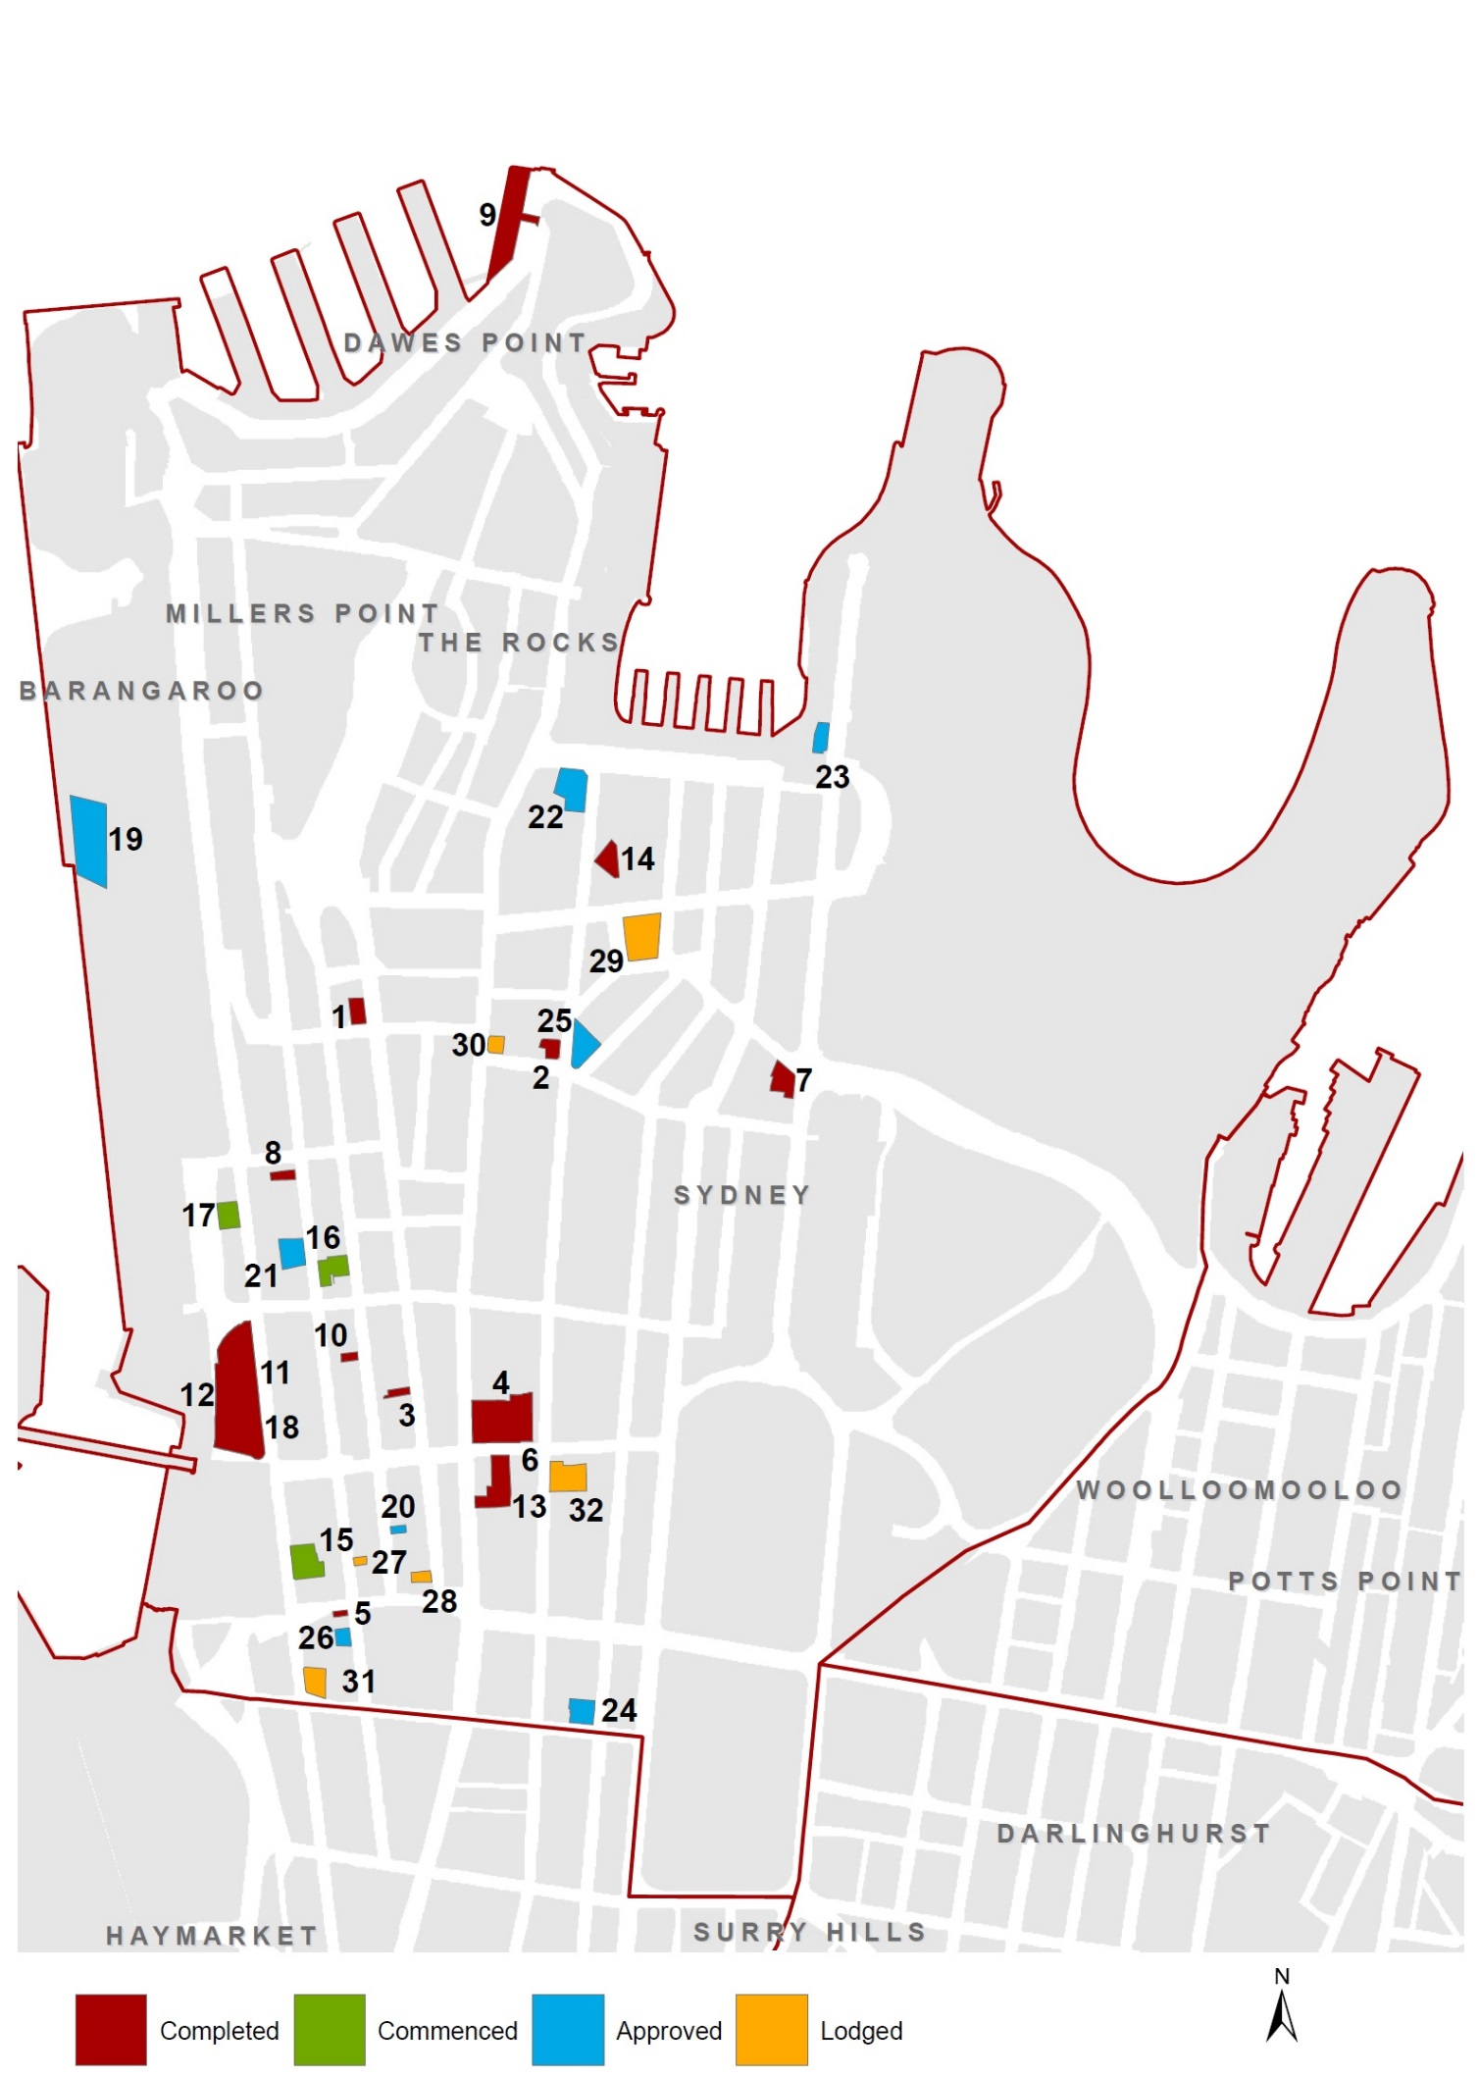

CBD & Harbour recent completions & pipeline, June 2016
COMPLETED (July 2011 - June 2016)
Map  Ref. | Address | Name | DA  lodged | DA approved | Completion date | VA type | DA type | #
1 | 7-9 York Street, Sydney | Travelodge Wynyard | Dec-2014 | Mar-2015 | Apr-2016 | E-HT | A | 4
2 | 34-36 Hunter Street, Sydney | Tank Stream Hotel | Dec-2011 | May-2012 | Dec-2015 | N-HT | C | 282
3 | 93 York Street, Sydney | Megaboom City Hotel | May-2014 | Jul-2014 | Dec-2015 | N-HT | AR | 64
4 | 68 Market Street, Sydney | Swissotel | Mar-2014 | Apr-2014 | Jul-2015 | E-HT | C | 8
5 | 465 - 467 Kent Street, Sydney | Base Backpackers | Mar-2014 | Jul-2014 | Jan-2015 | E-BP | C | 36
6 | 68 Market Street, Sydney | Swissotel | Oct-2013 | Nov-2013 | Aug-2014 | E-HT | C | 1
7 | 165-169 Macquarie Street, Sydney | The Australian Club | May-2013 | Jun-2013 | Apr-2014 | E-HT | C | 5
8 | 301 Kent Street, Sydney | Siesta Inn | Dec-2011 | Mar-2012 | Oct-2013 | N-HT | C | 97
9 | 11 Hickson Road,  Dawes Point | Sebel Pier One Hotel | Sep-2009 | Jan-2010 | Mar-2013 | E-HT | A | 32
10 | 193-195 Clarence Street, Sydney | Breakfree on Clarence | Jul-2009 | Oct-2009 | Nov-2012 | N-HT | C | 50
11 | 121-185 Sussex Street, Sydney | Four Points by Sheraton | Feb-2012 | Apr-2012 | Oct-2012 | E-HT | R | 29
12 | 121-185 Sussex Street, Sydney | Four Points by Sheraton | Feb-2012 | Apr-2012 | Sep-2012 | E-HT | R | 47
13 | 49-51 Market Street, Sydney | QT Sydney | Feb-2010 | Sep-2010 | Aug-2012 | N-HT | C | 203
14 | 30 Pitt Street, Sydney | Marriott Hotel | Jul-2011 | Aug-2011 | Dec-2011 | E-HT | C | 17
 |  |  |  |  |  | Total |  | 875
COMMENCED
Map Ref. | Address | Name | DA  lodged | DA approved | Completion date | VA type | DA type | #
15 | 230-234 Sussex Street, Sydney |  | Nov-2015 | Apr-2016 | May-2020 | N-SA | NB | 195
16 | 161-165 Clarence Street, Sydney |  | Nov-2013 | Jun-2014 | Nov-2017 | N-SA | NB | 36
17 | 65-79 Sussex Street,  Sydney | Quest Hotel | May-2015 | Sep-2015 | Sep-2017 | N-HT | NB | 163
18 | 121-185 Sussex Street, Sydney | Four Points by Sheraton | Oct-2011 | Aug-2013 | Mar-2017 | E-HT | NB | 231
 |  |  |  |  |  | Total |  | 625

CBD & Harbour recent completions & pipeline, June 2016
APPROVED (YET TO COMMENCE CONSTRUCTION
Map  Ref. | Address | Name | DA  lodged | DA approved | Completion date |  | VA type | DA type | #
19 | 29-51 Hickson Road, Barangaroo | Crown Barangaroo | Apr-2015 | Jun-2016 |  | N-HT |  | NB | 350
20 | 206a-208 Clarence Street, Sydney |  | Aug-2015 | Feb-2016 |  | N-HT |  | NB | 97
21 | 477-481 Kent Street, Sydney | Base Backpackers | Oct-2015 | Feb-2016 |  | E-BP |  | C | 43
22 | 1 Alfred Street, Sydney | Rugby Club | Jul-2015 | Dec-2015 |  | N-HT |  | NB | 179
23 | 71-79 Macquarie Street, Sydney | AMP site | Mar-2014 | Apr-2015 |  | N-SA |  | NB | 62
24 | 110A Bathurst Street, Sydney | Porter House | Jun-2014 | Mar-2015 |  | N-HT |  | AR | 102
25 | 64-66 Pitt Street, Sydney | Radisson Blu | Nov-2014 | Feb-2015 |  | E-HT |  | A | 1
26 | 331-337 Kent Street, Sydney |  | Nov-2013 | Oct-2014 |  | N-SA |  | NB | 120
 |  |  |  |  |  | Total |  |  | 954

LODGED
Map  Ref. | Address | Name | DA  lodged | DA approved | Completion date | VA type | DA type | #
27 | 422-424 Kent Street, Sydney |  | Jun-2016 |  |  | N-HT | NB | 72
28 | 143-145 York Street, Sydney |  | Apr-2016 |  |  | N-HT | C | 87
29 | 23-33 Bridge Street, Sydney | Sandstone Precinct | Feb-2016 |  |  | N-HT | AR | 240
30 | 280-288 George Street, Sydney |  | Dec-2015 |  |  | N-HT | NB | 194
31 | 286-296 Sussex Street, Sydney |  | Nov-2015 |  |  | N-HT | NB | 152
32 | 194 Pitt Street, Sydney | Tattersall's Club | Aug-2015 |  |  | N-HT | NB | 106
 |  |  |  |  |  |  |  | 851

Chinatown & CBD South recent completions & pipeline, June 2016 2200016
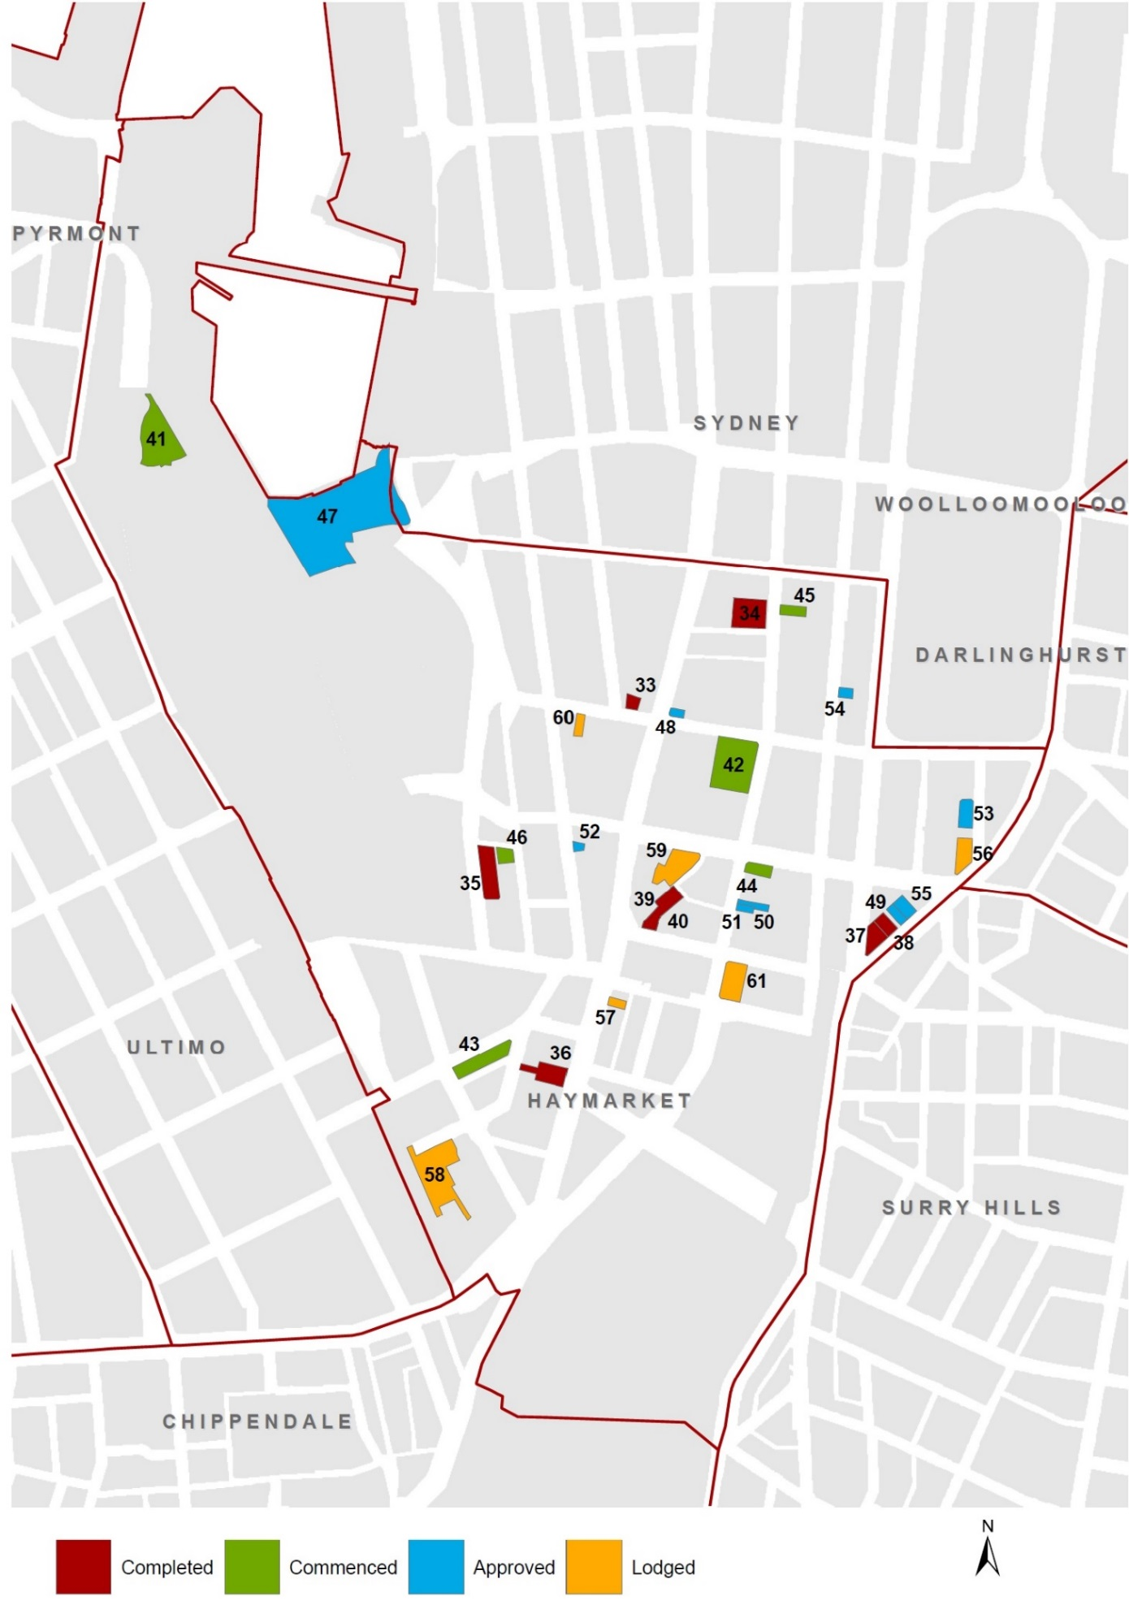

Chinatown & CBD South recent completions & pipeline, June 2016
COMPLETED (July 2011 - June 2016)
Map  Ref. | Address | Name | DA  lodged | DA approved | Completion date | VA type | DA type | #
33 | 88 Liverpool Street, Sydney | Spanish Club | Dec-2012 | May-2013 | Jan-2016 | N-HT | C | 77
34 | 115-119 Bathurst Street, Sydney | Primus Hotel | Nov-2013 | Jun-2014 | Dec-2015 | N-HT | AR | 172
35 | 68 Harbour Street, Haymarket | Holiday Inn | May-2014 | Sep-2014 | Sep-2015 | E-HT | A | 24
36 | 715-723 George Street, Haymarket |  | Jun-2013 | Jul-2013 | Oct-2014 | E-HT | A | 1
37 | 184-196 Elizabeth Street, Sydney |  | May-2013 | Jun-2013 | Jul-2014 | E-HT | R | -21
38 | 61-65 Wentworth Avenue, Sydney | Zara Tower | Jun-2012 | Oct-2012 | Jul-2013 | N-SA | C | 38
39 | 4-10 Campbell Street, Haymarket | Meriton | Jun-2010 | Jul-2010 | Nov-2011 | N-SA | NB | 35
40 | 4-10 Campbell Street, Haymarket | Meriton | Aug-2008 | Dec-2008 | Aug-2011 | N-SA | NB | 212
 |  |  |  |  |  | Total |  | 538

COMMENCED
Map Ref. | Address | Name | DA  lodged | DA approved | Completion date | VA type | DA type | #
41 | 1 Darling Drive, Sydney | ICC Darling Harbour | Sep-2013 | Jun-2014 | Sep-2017 | N-HT | NB | 616
42 | 391-395 Pitt Street, Sydney | Rydges | Sep-2014 | Dec-2014 | Aug-2017 | E-HT | C | 3
43 | 35-39 Ultimo Road, Haymarket | Aarons Hotel | Oct-2008 | Mar-2009 | May-2017 | E-HT | A | 21
44 | 390-396 Pitt Street, Haymarket |  | Oct-2013 | Apr-2014 | Dec-2016 | N-BP | C | 179
45 | 302 Pitt Street, Sydney | Druids House | Apr-2014 | Sep-2014 | Nov-2016 | N-HT | AR | 136
46 | 31-37 Dixon Street, Haymarket |  | Mar-2008 | Jun-2008 | Nov-2016 | N-BP | C | 66
 |  |  |  |  |  | Total |  | 1,021

Chinatown & CBD South recent completions & pipeline, June 2016
APPROVED (YET TO COMMENCE CONSTRUCTION)
Map  Ref. | Address | Name | DA  lodged | DA approved | Completion date | VA type | DA type | #
47 | 31-33 Wheat Road, Sydney | IMAX | Nov-2015 | Jun-2016 |  | N-HT / SA | NB | 561
48 | 640-642 George Street, Sydney |  | Dec-2015 | Jun-2016 |  | E-BP | R | -10
49 | 55-57 Wentworth Avenue, Sydney |  | Mar-2016 | May-2016 |  | N-HT | NB | 204
50 | 410 Pitt Street, Haymarket |  | May-2015 | May-2016 |  | N-HT | NB | 202
51 | 412 Pitt Street, Haymarket | Westend Hotel | Dec-2015 | Apr-2016 |  | E-HT | A | 9
52 | 398-402 Sussex Street, Haymarket |  | Oct-2015 | Mar-2016 |  | N-SA | AR | 26
54 | 9-25 Commonwealth Street, Sydney |  | Aug-2014 | Sep-2015 |  | N-HT | NB | 132
54 | 262-266 Castlereagh Street, Sydney |  | May-2014 | May-2015 |  | N-HT | NB | 92
55 | 49-53 Wentworth Avenue, Sydney |  | Oct-2014 | Mar-2015 |  | N-HT | C | 98
 |  |  |  |  |  | Total |  | 1,314

LODGED
Map  Ref. | Address | Name | DA  lodged | DA approved | Completion date | VA type | DA type | #
56 | 27-33 Wentworth Avenue, Sydney | Travelodge | Jul-2016 |  |  | E-HT | C | 4
57 | 746-748 George Street, Haymarket |  | May-2016 |  |  | N-HT | NB | 127
58 | 169-179 Thomas Street, Haymarket | Novotel Central | Mar-2016 |  |  | E-HT | A | 72
59 | 59-69 Goulburn Street, Haymarket |  | Feb-2016 |  |  | N-HT | A | 398
60 | 53-55 Liverpool Street, Sydney | Buckle Chambers | Dec-2015 |  |  | N-HT | AR / C | 152
61 | 136 Hay Street, Haymarket |  | Oct-2015 |  |  | N-HT | NB | 291
 |  |  |  |  |  | Total |  | 1,044

City East recent completions & pipeline, June 2016

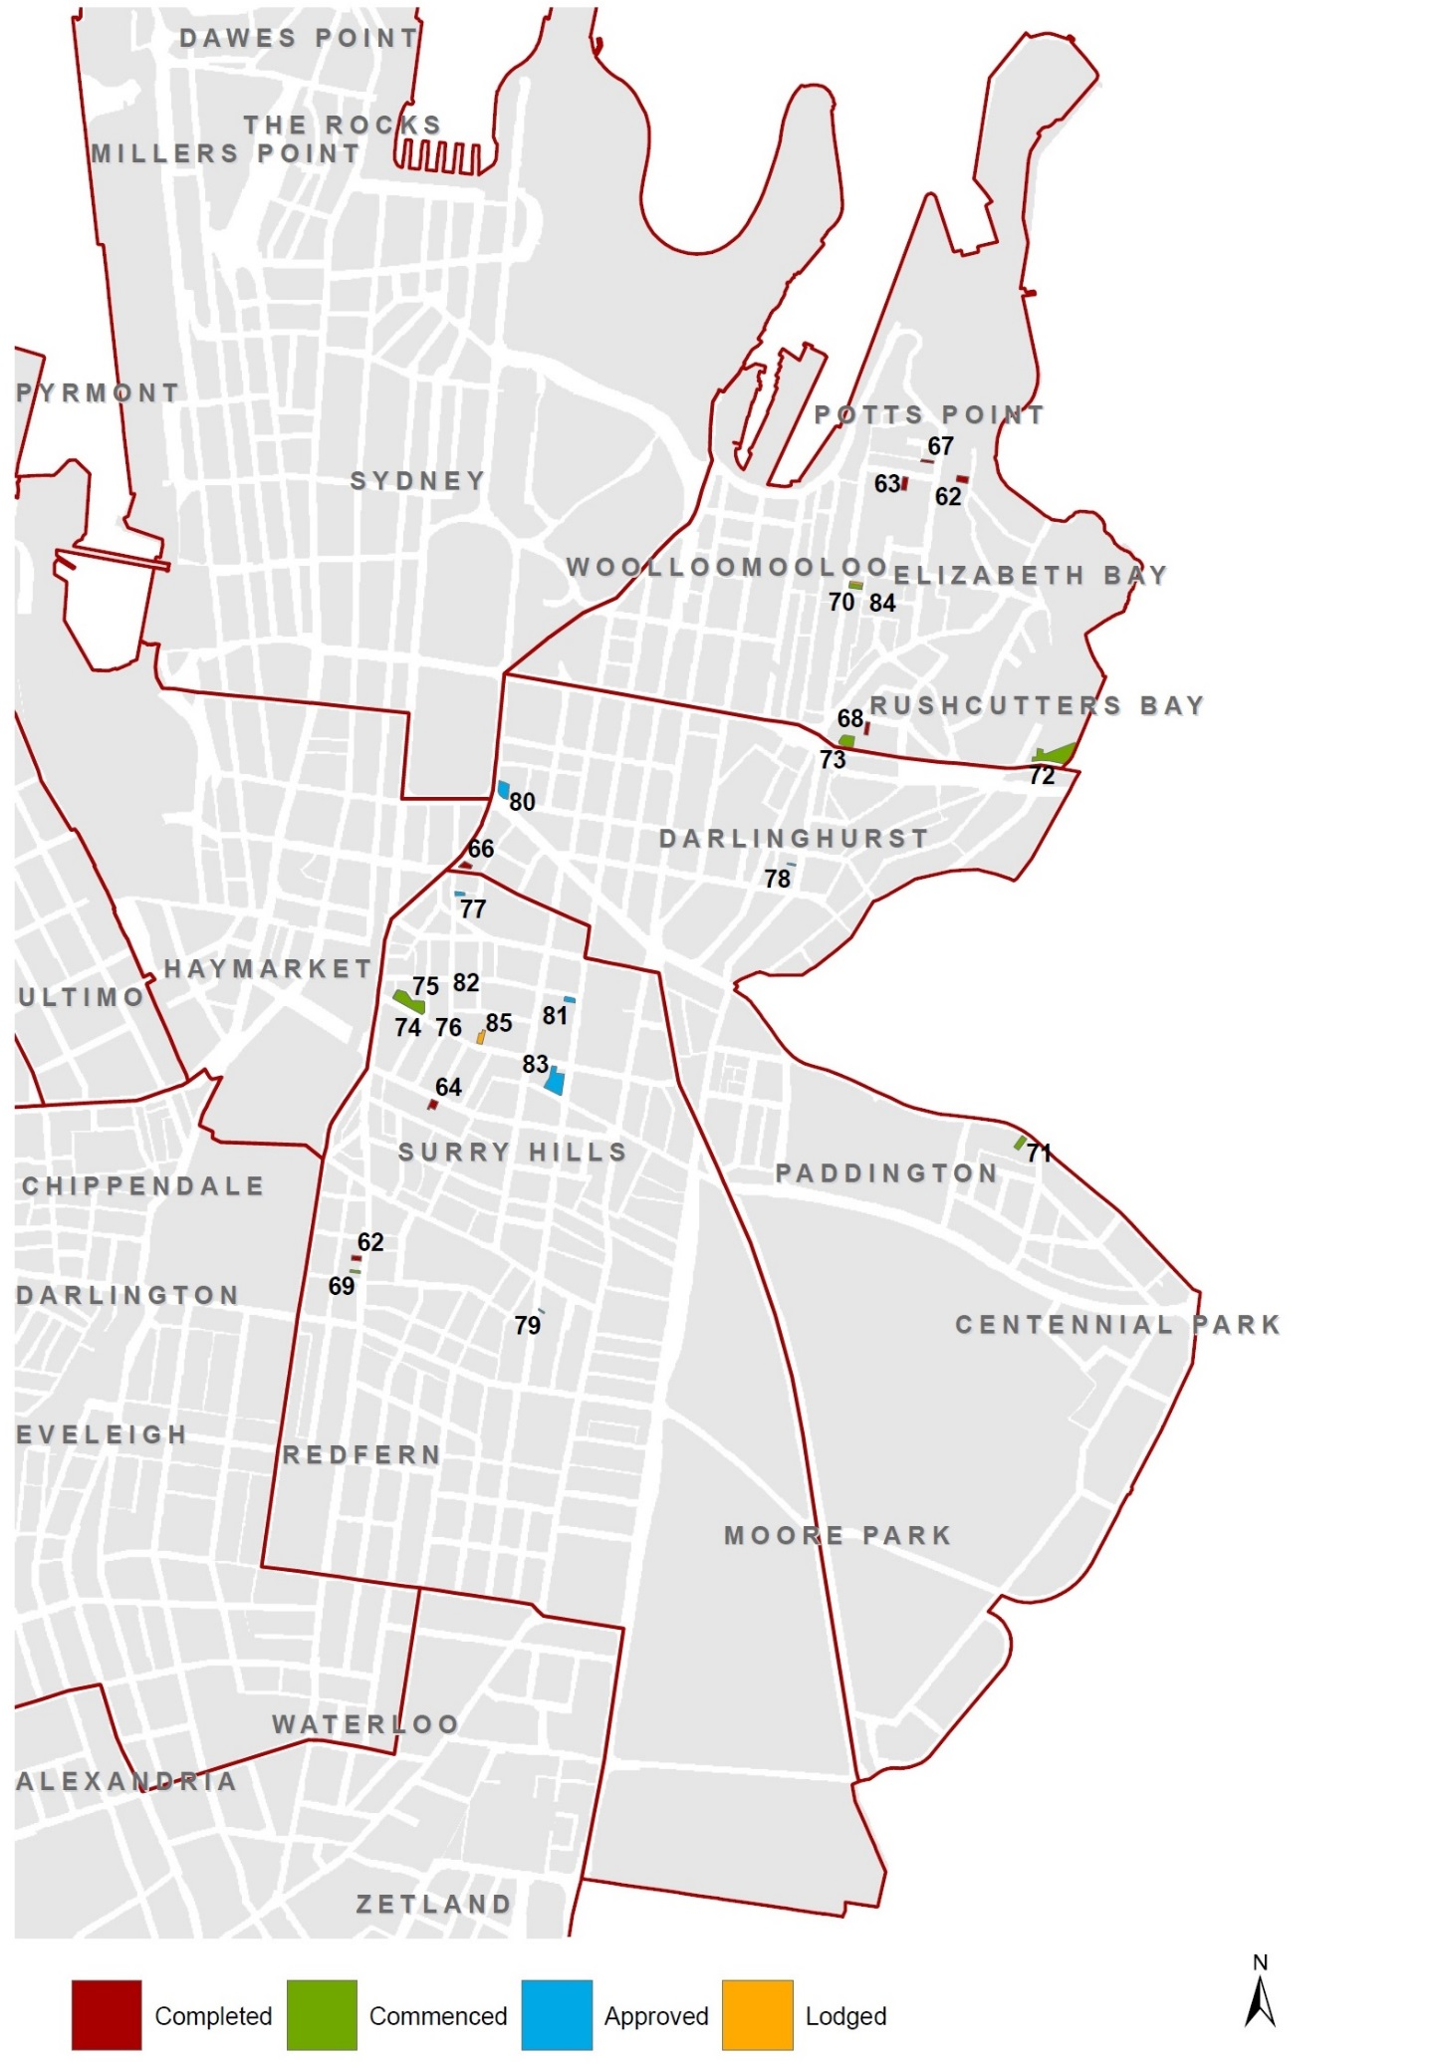
City East recent completions & pipeline, June 2016
COMPLETED (July 2011 - June 2016)
Map  Ref. | Address | Name | DA  lodged | DA approved | Completion date | VA type |  | DA type |  | #
62 | 17 Billyard Avenue, Elizabeth Bay |  | Oct-2010 | May-2011 | Dec-2015 | N-HT |  | C |  | 9
63 | 517-521 Elizabeth Street, Surry Hills | East Central | Jul-2012 | Sep-2012 | Nov-2015 | N-SA |  | C |  | 22
64 | 21-23 Challis Avenue, Potts Point | Challis Lodge | Jul-2009 | May-2010 | Sep-2015 | E-HT |  | R |  | -8
65 | 57-61 Foveaux Street, Surry Hills | 57 Hotel | Mar-2013 | Jul-2013 | Mar-2015 | N-HT |  | C |  | 92
66 | 40-44 Wentworth Avenue, Surry Hills | Hotel Harry | Oct-2013 | May-2014 | Nov-2014 | E-PB |  | A |  | -2
67 | 55 Macleay Street, Potts Point | Holiday Lodge Hotel | May-2010 | Dec-2010 | Dec-2012 | E-HT |  | A |  | 10
68 | 17 Bayswater Road, Potts Point | Bayswater Lodge | May-2010 | Nov-2010 | Sep-2011 | E-HT |  | C |  | 6
 |  |  |  |  |  | Total |  |  |  | 129
COMMENCED
Map Ref. | Address | Name | DA  lodged | DA approved | Completion date |  | VA type |  | DA type | #
69 | 533 Elizabeth Street, Surry Hills | Botanik | Oct-2012 | Feb-2013 | Aug-2017 |  | N-SA |  | C | 22
70 | 122-124 Victoria Street, Potts Point | Spicers Potts Point | Dec-2014 | Jun-2015 | Jun-2017 |  | E-HT |  | A | -10
71 | 259 Oxford Street, Paddington |  | Nov-2014 | Jun-2015 | Jun-2017 |  | N-HT |  | A | 30
72 | 100 Bayswater Road, Rushcutters Bay | Vibe Hotel | Nov-2015 | Feb-2016 | May-2017 |  | E-HT |  | A | 13
73 | 2-14 Kings Cross Road, Potts Point | Larmont Hotel | Dec-2015 | Mar-2016 | Dec-2016 |  | E-HT |  | C | 28
74 | 28 Albion Street,  Surry Hills | Rydges Central | Apr-2015 | May-2015 | Nov-2016 |  | E-HT |  | A | 19
75 | 28 Albion Street,  Surry Hills | Rydges Central | Oct-2012 | Mar-2013 | Nov-2016 |  | E-HT |  | A | 14
76 | 28 Albion Street,  Surry Hills | Rydges Central | Oct-2010 | Nov-2010 | Nov-2016 |  | E-HT |  | A | 5
 |  |  |  |  |  |  | Total |  |  | 121

City East recent completions & pipeline, June 2016
APPROVED (YET TO COMMENCE CONSTRUCTION)
Map  Ref. | Address | Name | DA  lodged | DA approved | Completion date | VA type |  |  | DA type |  | #
77 | 74-80 Commonwealth Street, Surry Hills |  | Feb-2015 | Dec-2015 |  | N-HT |  |  | A |  | 30
78 | 255 Victoria Street, Darlinghurst |  | Apr-2015 | Nov-2015 |  | N-HT |  |  | NB |  | 8
79 | 592 Crown Street, Surry Hills |  | Jul-2015 | Sep-2015 |  | N-SA |  |  | C |  | 2
80 | 38-52 College Street, Darlinghurst | Oaks Hyde Park Plaza | Oct-2014 | Jun-2015 |  | E-HT |  |  | C |  | 10
81 | 287-289 Crown Street,  Surry Hills |  | Aug-2013 | Jul-2014 |  | N-SA |  |  | NB |  | 11
82 | 28 Albion Street, Surry Hills | Rydges Central | Nov-2011 | Apr-2012 |  | E-HT |  |  | C |  | 4
83 | 353-359 Crown Street,  Surry Hills | Adina Apartment Hotel | Aug-2007 | Feb-2008 |  | E-SA |  |  | A |  | 21
 |  |  |  |  |  |  | Total |  |  | 86
LODGED
Map  Ref. | Address | Name | DA  lodged | DA approved | Completion date | VA type |  |  | DA type |  | #
84 | 120 Victoria Street, Potts Point | Spicers Potts Point | May-2016 |  |  | E-HT |  |  | A |  | 5
85 | 88 Albion Street, Surry Hills |  | Aug-2015 |  |  | N-HT / SA |  |  | AR |  | 43
 |  |  |  |  |  |  | Total |  |  | 48

City West recent completions & pipeline, June 2016

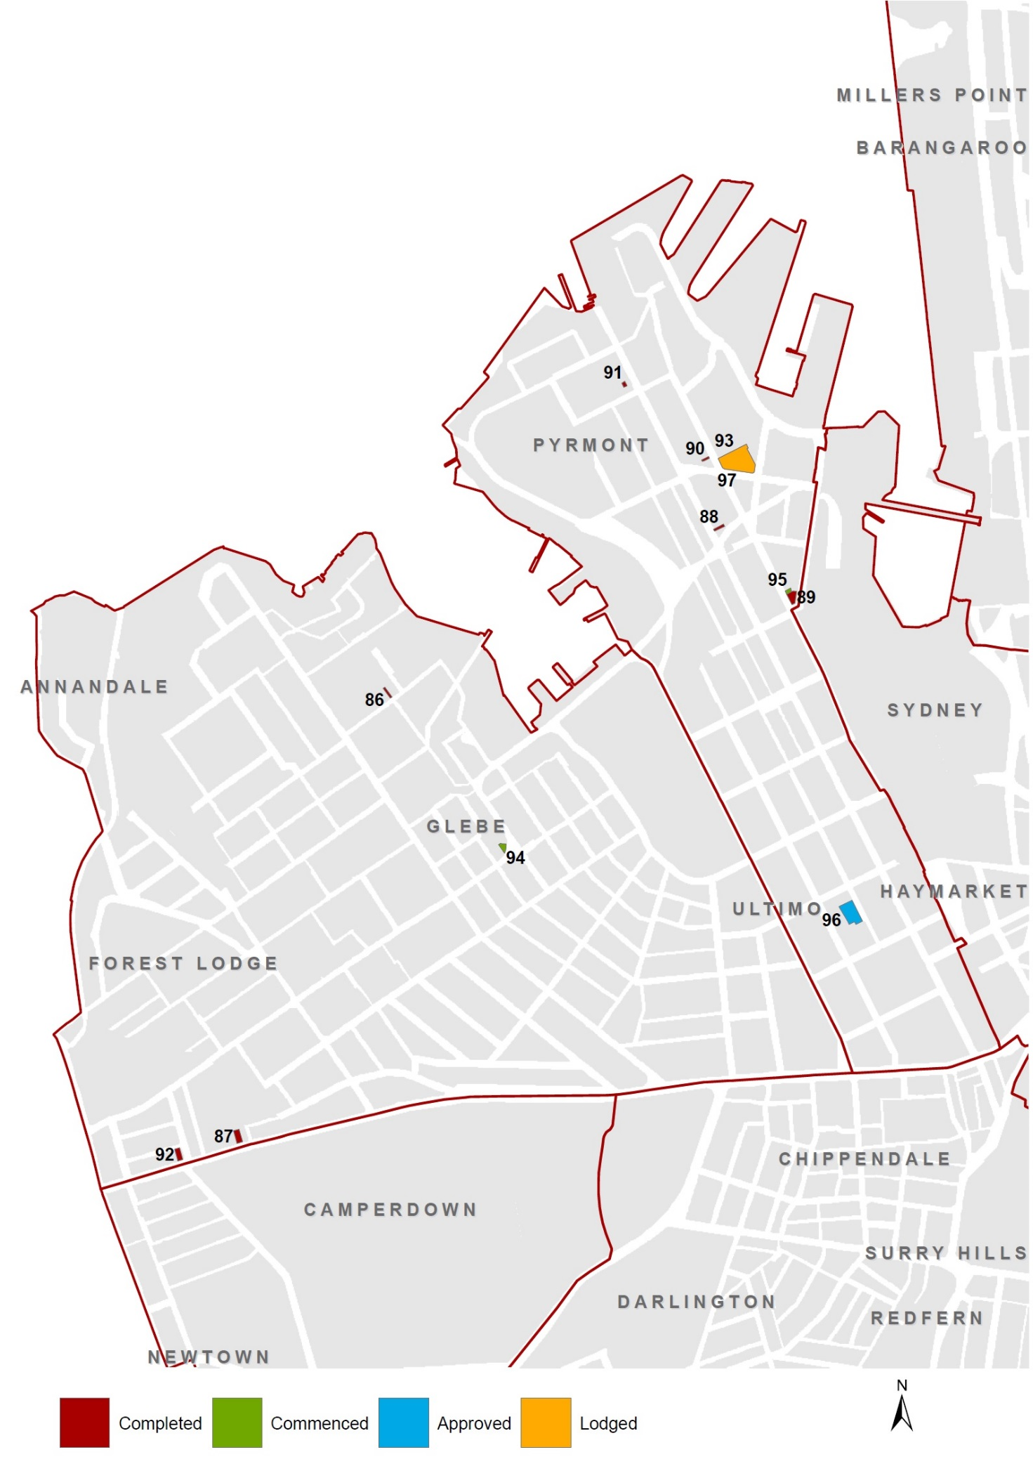
City West recent completions & pipeline, June 2016
COMPLETED (July 2011 - June 2016)
Map  Ref. | Address | Name | DA  lodged | DA approved | Completion date | VA type |  | DA type |  | #
86 | 3 Forsyth Street, Glebe |  | Jan-2013 | Apr-2013 | Jun-2016 | N-HT |  | C |  | 2
87 | 84 Parramatta Road, Camperdown |  | Jul-2015 | Sep-2015 | Mar-2016 | N-SA |  | AR |  | 28
88 | 212 Harris Street, Pyrmont |  | Mar-2012 | Sep-2012 | Oct-2015 | N-SA |  | A |  | 4
89 | 139 Murray Street, Pyrmont |  | Jul-2011 | Nov-2011 | Jul-2013 | N-HT |  | AR |  | 88
90 | 93 Pyrmont Street, Pyrmont |  | Oct-2011 | May-2012 | Feb-2013 | N-HT |  | C |  | 4
91 | 45-55 Harris Street, Pyrmont |  | Jun-2011 | Oct-2011 | Feb-2013 | N-SA |  | C |  | 1
92 | 108 Parramatta Road, Camperdown | Adara Camperdown | Apr-2011 | Jul-2011 | Mar-2012 | N-SA |  | C |  | 37
93 | 20-80 Union Street, Pyrmont |  | Jun-2008 | Jan-2009 | Mar-2012 | N-HT |  | NB |  | 178
 |  |  |  |  |  | Total |  |  | 342

COMMENCED
Map Ref. | Address | Name | DA  lodged | DA approved | Completion date | VA type | DA type | #
94 | 101-103 Bridge Road, Glebe | Excelsior Hotel | Nov-2009 | Aug-2010 | Jan-2017 | N-PB | A | 9
95 | 170 Pyrmont Street, Pyrmont | Mystique | Apr-2009 | Dec-2009 | Dec-2016 | N-SA | A / C | 14
 |  |  |  |  |  | Total |  | 23

APPROVED (YET TO COMMENCE CONSTRUCTION)
Map  Ref. | Address | Name | DA  lodged | DA approved | Completion date | VA type | DA type | #
96 | 383-389 Bulwara Road, Ultimo | Aspire Hotel | Jul-2014 | Nov-2014 |  | E-HT | A | 21
 |  |  |  |  |  | Total |  | 21

LODGED
Map  Ref. | Address | Name | DA  lodged | DA approved | Completion date | VA type | DA type | #
97 | 20-80 Pyrmont Street, Pyrmont | The Star Casino | Feb-2016 |  |  | N-HT | NB | 220
 |  |  |  |  |  | Total |  | 220

City South recent completions & pipeline, June 2016

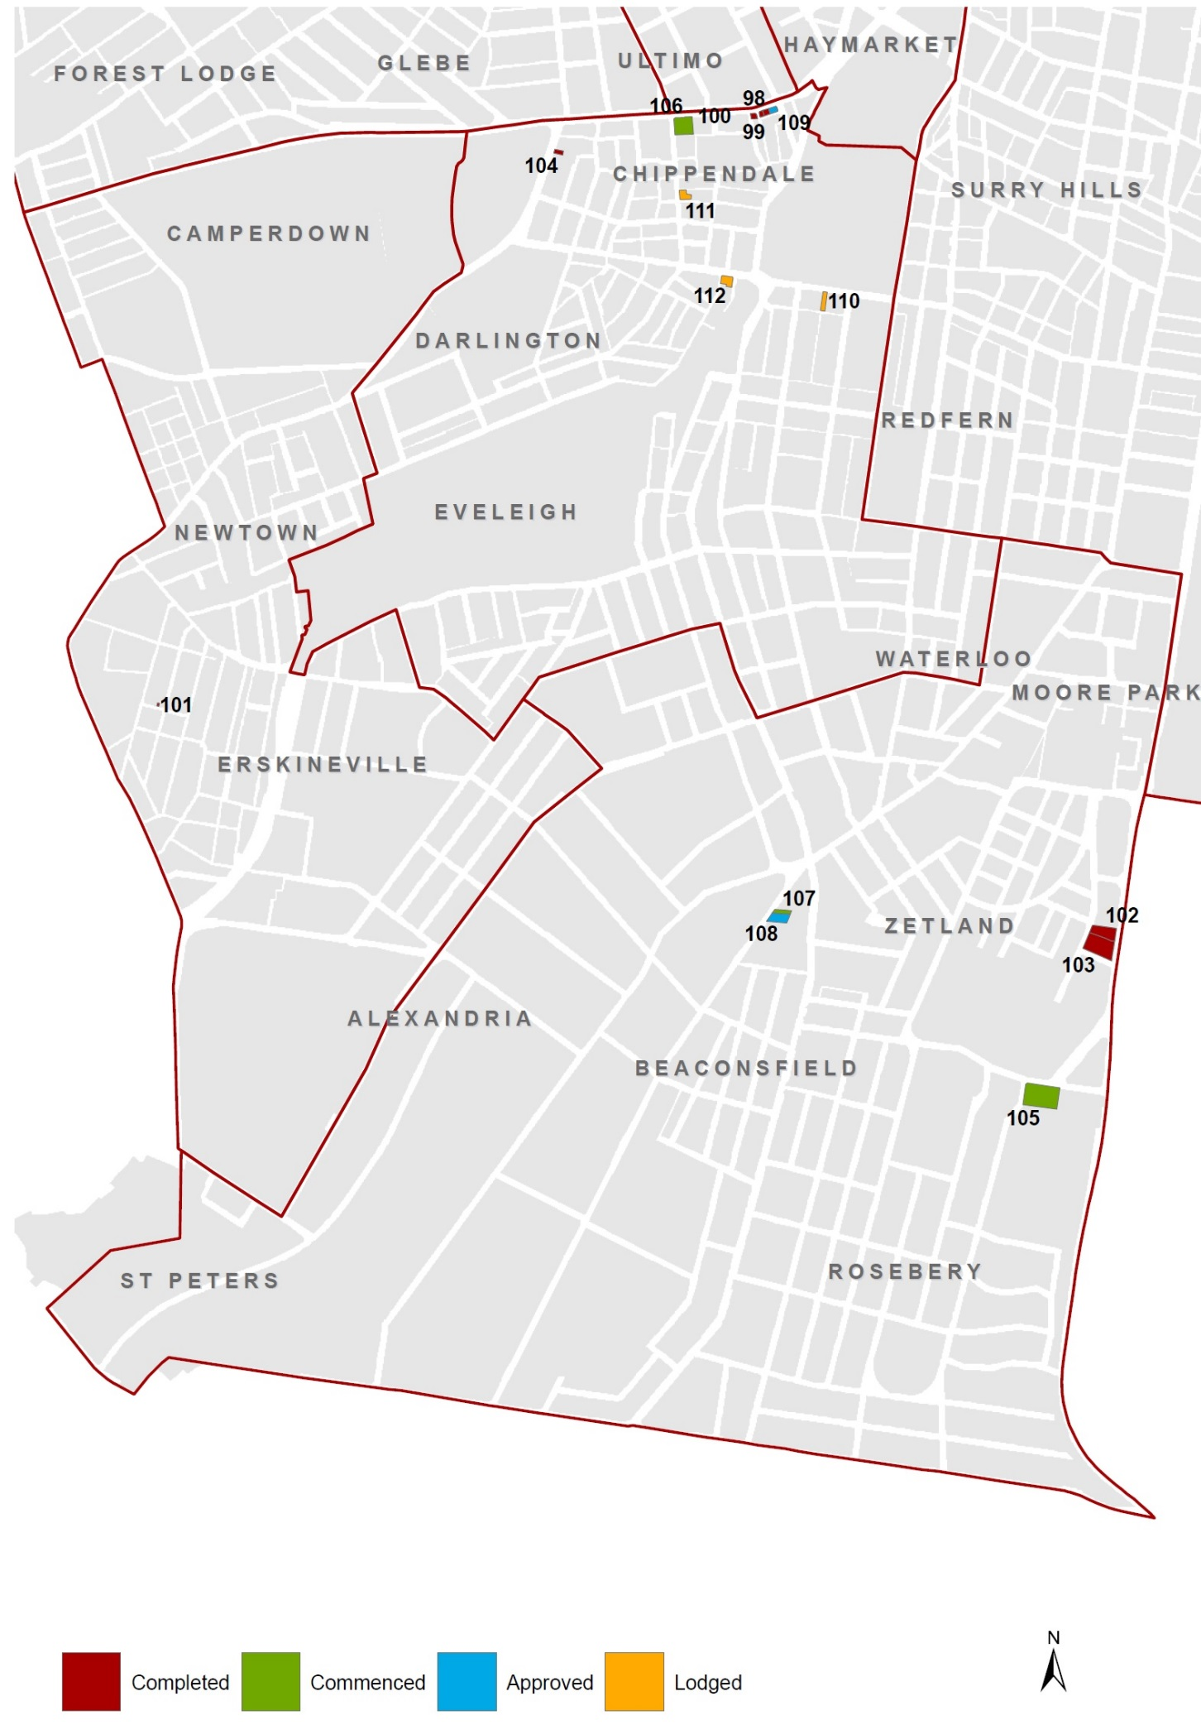
City South recent completions & pipeline, June 2016
COMPLETED (July 2011 - June 2016)
Map  Ref. | Address | Name | DA  lodged | DA approved | Completion date | VA type | DA type | #
98 | 8-14 Broadway, Chippendale | Posh Hotel | Nov-2012 | Mar-2013 | Dec-2015 | E-HT | A | 15
99 | 16-18 Broadway, Chippendale |  | Jul-2013 | Dec-2013 | Nov-2015 | N-SA | C | 14
100 | 26-98 Broadway, Chippendale | Clare Hotel | Jul-2011 | Apr-2013 | Sep-2015 | N-HT | AR | 62
101 | 13B Harold Street, Newtown |  | Aug-2014 | Dec-2014 | Apr-2015 | N-HT | C | 2
102 | 8 Defries Avenue, Zetland | Meriton Zetland | Oct-2011 | Dec-2011 | Dec-2012 | N-SA | C | 188
103 | 8 Defries Avenue, Zetland | Meriton Zetland | Jan-2012 | Mar-2012 | Dec-2012 | N-SA | C | 146
104 | 20 City Road, Chippendale |  | Aug-2008 | Feb-2009 | Dec-2011 | N-BP | C | 66
 |  |  |  |  |  | Total |  |  | 493

COMMENCED
Map  Ref. | Address | Name | DA  lodged | DA approved | Completion date | VA type | DA type |  | #
105 | 67-77 Epsom Road, Rosebery |  | May-2015 | Mar-2016 | May-2019 | N-SA | NB |  | 49
106 | 62-98 Broadway,  Chippendale | Duo, Central Park | Sep-2014 | Aug-2015 | Dec-2018 | N-HT | NB |  | 297
107 | 16 O'Riordan Street, Alexandria |  | Dec-2013 | Jul-2014 | Dec-2016 | N-HT | NB |  | 100
 |  |  |  |  |  | Total |  |  |  | 446

APPROVED (YET TO COMMENCE CONSTRUCTION)
Map  Ref. | Address | Name | DA  lodged | DA approved | Completion date | VA type | DA type |  | #
108 | 18 O'Riordan Street, Alexandria |  | Dec-2015 | Oct-2016 |  | N-HT | NB |  | 142
109 | 2-6 Broadway , Chippendale | Bar Broadway | Aug-2012 | Jan-2013 |  | E-PB | A |  | 18
 |  |  |  |  |  | Total |  |  |  | 160

LODGED
Map  Ref. | Address | Name | DA  lodged | DA approved | Completion date | VA type |  | DA type |  | #
110 | 203 Cleveland Street, Redfern |  | Jun-2016 |  |  | N-BP |  | C |  | 114
111 | 72-80 Abercrombie Street, Chippendale |  | Apr-2016 |  |  | N-BP |  | C |  | 204
112 | 175 Cleveland Street, Redfern |  | May-2015 |  |  | N-HT |  | NB |  | 78
 |  |  |  |  |  |  | Total |  |  |  | 396

Disclaimer
Any data, representation, statement, opinion or advice expressed or implied in this publication is made in good faith but on a basis that the City of Sydney, its agents and employees are not liable (whether by reason of negligence, lack of care or otherwise) to any person for any damage or loss whatsoever which has occurred or may occur in relation to that person taking or not taking (as the case may be) action in respect of data representation, statement or advice referred to above. The City of Sydney reserves the right to revise previously published entries or totals without notice.
City of Sydney. All rights reserved. No part of this work will be reproduced, translated, modified, transmitted or stored in any form or by any means without the prior permission of the City of Sydney.

Enquiries regarding this document should be made to:

Research, Strategy and
Corporate Planning GPO Box 1591
Town Hall House Sydney NSW 2000
456 Kent Street Tel: 02 9265 9333
Sydney

E-mail: research@cityofsydney.nsw.gov.au
Internet: www.cityofsydney.nsw.gov.au

The City of Sydney as an organisation is abbreviated to the “City” and the local government area is abbreviated to the “city”.
Tourism Research Australia International and National Visitor Surveys (IVS and NVS), year ending June 2016
Captured under the # column in the reported tables
Welfare and institutional based accommodation is excluded from reporting
Includes rooms captured in private hotels, motels, member based hotels, guest houses, bed and breakfasts and licensed clubs offering accommodation
Visitor statistics from the ABS Tourist Accommodation (Cat No 8635.0) and TRA International and National Visitor Surveys (IVS / NVS) have been calculated by aggregating the eleven SA2 geographic areas falling wholly or partly within the City of Sydney local government area,
Tourism Research Australia IVS and NVS
Please note estimates were assumed for the SA2s of Pyrmont – Ultimo and Glebe – Forest Lodge between March 2013 – June 2014 inclusive when deriving total LGA stock figures from the ABS Tourist Accommodation (Cat No 8635.0) release
This property was recently sold and is likely to cease operation by next reporting period
This property is under renovation and will re-open early 2017.
This count also includes one bed and breakfast establishment
New building and refurbishment linked to existing hotel complex
Indicative capacity and subject to change
Refurbishment of existing hotel will result in the number of rooms fall from 71 to 50. This has been rectified in total stock figures as at June 2016
402 hotel rooms and 159 serviced apartments
Refurbishment of existing backpackers will result in backpacker beds ‘converting’ to capsule beds. Number of beds will decrease from 80 to 70. This will be rectified in total stock figures captures in the future.
Alteration of existing hotel will result in ensuites for 15 existing rooms and 9 new rooms. Number of rooms will be rectified in total stock figures captured in the future.
Refurbishment of existing hotel will result in the number of rooms fall from 61 to 53. This has been rectified in total stock figures as at June 2016
Alterations to existing hotel will result in number of rooms falling from 25 to 15 at 122 Victoria Street. DA has also been lodged for 120 Victoria Street which will result in 5 additional rooms.
Replaces existing motel where new development will result in 11 net additional studio apartments. This will be rectified in total stock figures as at June 2016 (42 studio apartments).
Number of rooms across both sites (120 – 124 Victoria Street) will be rectified in total stock figures captured in the future.
39 hotel rooms and 4 serviced apartments
Bed & breakfast establishment.
Historically provided accommodation but currently not operating – DA is seek to construct new rooms and reinstate accommodation
Indicative capacity only and subject to change
This is bed and breakfast establishment

