Inclusion (disability) action plan survey 2025-29

Survey for people with lived experience of disability, their families and carers, and disability service providers.

Your views matter. Share your experiences of living, working, studying or visiting our local area by completing this anonymous survey.
Survey  20 August – 17 September 2024 | The City of Sydney acknowledges the Gadigal of the Eora Nation as the Traditional Custodians of our local area.

Contents
Introduction 3
Definitions 4
Survey instructions 5
Map of City of Sydney local area 7
Positive community attitudes and behaviours 8
Creating liveable communities 9
Meaningful employment 12
Systems and processes 13
Your information 15
Thank you 17

Introduction
All NSW councils must review their previous disability inclusion action plans and develop a new 4-year plan under the NSW Inclusion Act 2014, amended by the Disability Inclusion Amendment Act 2022.
Our current inclusion (disability) action plan is due to finish on 30 June 2025 and we’re now developing our new plan for 2025–2029.
At every stage of the planning process, we’ll collaborate with those with lived experience of disability, and people who care for people with disability to make sure our new plan is aligned with the legislated 4 directions of:
- Positive community attitudes and behaviours
- Liveable communities
- Meaningful employment
- Equitable access to mainstream services.
To better understand barriers and challenges, we’re inviting feedback from people with lived experience of disability, family and carers, and disability service providers and disability representative organisations. We want to be able to respond to emerging issues and provide opportunities for co-designing solutions that will enhance access and inclusion for people with disability.
Once we’ve collated the data we get from the survey we’ll publish a community engagement report. This report will include the consultation and co-design of actions with the community throughout the development process. We’ll publish this on our website with the draft plan for comment in early 2025, as shown in the timeline below.

Engagement timeline
20 August –17 September 2024

August –September 2024

9 October 2024

November – December 2024

March – April 2025
June 2025

Your feedback is important to help guide the development of responsive actions. If you would like to be updated on the progress of the plan, ensure you share your contact information with us.

Easier online? Complete the survey at:

city.sydney/inclusion-disability
If you complete the survey online, please pass this printed copy to another member of your household or a friend who lives in the City of Sydney area.

Definitions

People with disability

When we talk about people with disability, it includes people with mental health conditions, people who are neurodivergent, and people with long-term or chronic health conditions.

What is the social model of disability?
We recognise disability in terms of the barriers that are created by how society is organised. For example, how buildings are laid out or how services are provided, and not by an individual’s condition or medical diagnosis. Barriers may be physical, communication, social or attitudinal that impact on their ability to fully participate in social, economic and civic life, not as a result of a person’s particular disability. A social model perspective does not deny the reality of disability, nor its impact on the person. However, it does challenge the physical, attitudinal, communication and social environment to accommodate disability as a natural part of human diversity.

What is access?
- In an accessible community you can go anywhere you need to
- It is easy to get around
- It is easy to take part in social and cultural life, for example, events and programs
- It is easy to find good jobs you enjoy
- It is easy to get information you need on services, facilities, events, and programs
- People with disability have a right to access and inclusion

What is inclusion?
People with disability feel welcomed and included in the community. We aim to be truly inclusive and welcoming of all people, including people with disability.
What is a liveable community?
A liveable community is a place where people can live, learn, work, play, feel safe, belong, connect with others and grow old. Making a community liveable includes physical access, giving people the chance to participate and make social connections, and improving the way connect.

What is intersectionality?
The interaction between multiple forms of inequality is known as ‘intersectionality’. According to the International Disability Alliance, intersectionality is a concept that many people with disability resonate with. We’re looking to better understand intersectional experiences of people with disability, and to do this we’re asking personal information to understand if respondents have multiple intersecting identities.

Language used in this survey
Language is dynamic and constantly evolving. We recognise that there is no one way of using language or terms that will be right for all people. Our intention for this survey is to be as clear as we can for a diverse audience and to be as inclusive as possible. We invite and encourage further feedback and have included open text field boxes in this survey.

Survey instructions
Your answers to these questions will help us understand what we can do to make our city more accessible and inclusive for people with disability and those with caring responsibilities.
Please complete this survey by 17 September 2024, and return to City of Sydney Council,
Inclusion (disability) action plan survey, C/O Social Policy Team, GPO Box 1591, SYDNEY NSW 2001.

What is this survey about?

We’re seeking information to better understand strengths and opportunities, barriers and challenges, including your ideas to help improve access and inclusion for people with disability in the City of Sydney local area. We’ll use the information collected from this survey to help inform the development of our inclusion (disability) action plan 2025–29.

Who is this survey for?
- People with disability, people with mental health conditions or psychosocial disability, people who are neurodivergent, and people with long-term health conditions who live in the City of Sydney or visit the area for work, study, leisure or events
- Family members or carers of people with disability
- Not-for-profit organisations or disability service providers operating in the City of Sydney local area

What does participation in this survey involve?
- Answering some questions about yourself so we know who is represented in the survey
- Questions about topics included in the Inclusion (disability) action plan
- Questions with an asterisk (*) are mandatory
- Sixteen questions are mandatory – you don’t have to complete any that are not mandatory, but it is encouraged if you have time
- Your responses are anonymous and confidential – no personal or identifying information will be used in the plan. Please refer to our privacy management plan.
- If you complete the survey you are consenting to us using this data for the purpose of developing our new inclusion (disability) action plan

How long will this take?
This survey has been designed to take around 20 minutes to complete (unless you want to include more detailed information, then it may take a little longer). We recognise that some people may need more time to complete the survey.

Need help?
If you need help filling out this survey, you can call the social policy team on 02 9265 9333 or email inclusiondisability@cityofsydney.nsw.gov.au
This survey is also available in Chinese Simplified, Chinese Traditional, Indonesian, Spanish, Thai and Easy Read.

Getting support
We recognise that by sharing your lived experience of disability or caring, it may bring up distress or discomfort. If you need to speak with someone for confidential support, you may wish to contact:

- Lifeline
lifeline.org.au
13 11 14
- Beyond Blue Support Service
beyondblue.org.au
1300 22 4636
- 1800 RESPECT
1800respect.org.au
1800 737 732

Map of City of Sydney local area
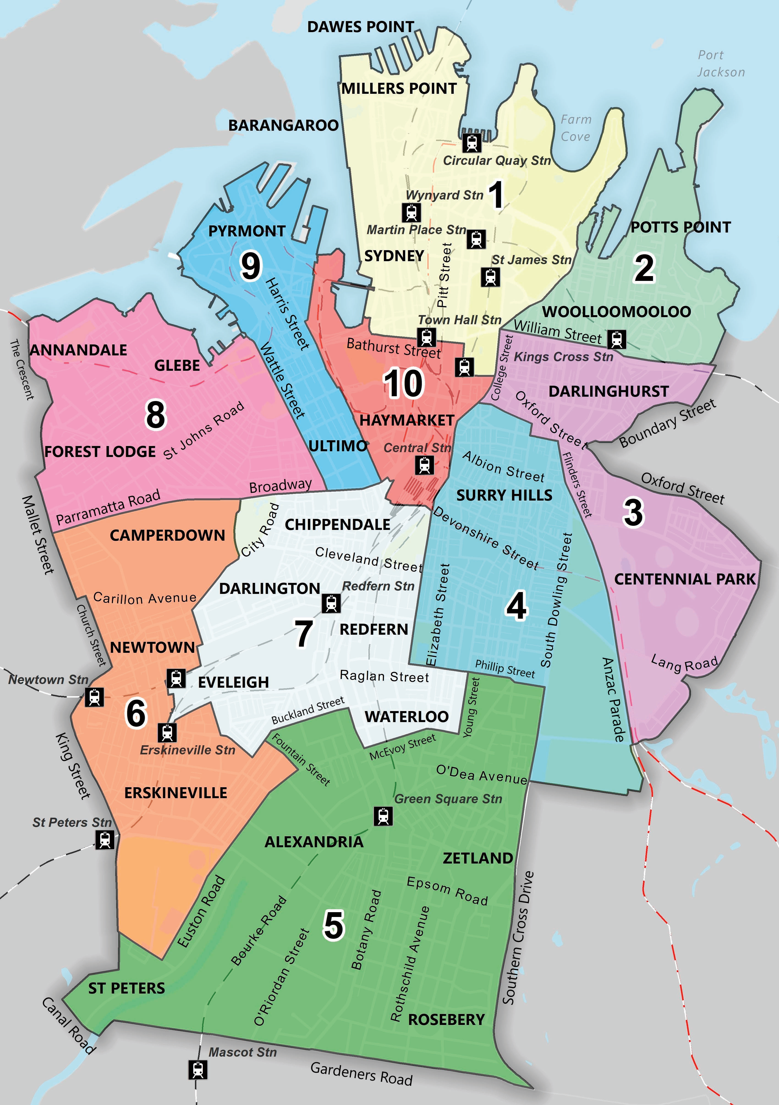

Positive community attitudes and behaviours
            - * What do you feel people’s attitudes are generally towards people with disability in the City of Sydney local area:

Very positive | Positive | Neutral | Negative | Very negative
□ | □ | □ | □ | □
- If you have a disability, how do you feel about this statement: “I feel welcome and included in the City of Sydney local area.”

Strongly Agree | Agree | Neutral | Disagree | Strongly disagree | Not relevant
□ | □ | □ | □ | □ | □
- How can we support positive community attitudes towards people with disability?

- * Have you or the person with disability that you care for, experienced the following in the City of Sydney local area? (Please select all that apply)
□ Disability discrimination □ Ableism □ Ageism
□ Sexism □ Racism □ Homophobia
□ Other (please specify): ___________________________ □ No, I have not
If you need to speak with someone for confidential support, you may wish to contact:

- Lifeline
Crisis support and suicide prevention services
lifeline.org.au
13 11 14
- Beyond Blue Support Service
Crisis support and suicide prevention
beyondblue.org.au
1300 22 4636
- 1800 RESPECT
Domestic violence counselling
1800respect.org.au
1800 737 732

Creating liveable communities
- * How satisfied are you that City of Sydney services, programs and events are inclusive of people with disability?

 | Very satisfied | Satisfied | Neutral | Unsatisfied | Very unsatisfied | Not applicable
Customer service | □ | □ | □ | □ | □ | □
Aquatic centres | □ | □ | □ | □ | □ | □
Community centres | □ | □ | □ | □ | □ | □
Libraries | □ | □ | □ | □ | □ | □
Childcare centres | □ | □ | □ | □ | □ | □
City of Sydney events | □ | □ | □ | □ | □ | □

- * How satisfied are you with the accessibility of the following services and facilities in the City of Sydney area?

 | Very satisfied | Satisfied | Neutral | Unsatisfied | Very unsatisfied | Not applicable
Mobility parking | □ | □ | □ | □ | □ | □
Accessible drop-off/ pick-up areas | □ | □ | □ | □ | □ | □
Footpaths | □ | □ | □ | □ | □ | □
Cycleways | □ | □ | □ | □ | □ | □
Bus stops | □ | □ | □ | □ | □ | □
Public toilets | □ | □ | □ | □ | □ | □
Public seating | □ | □ | □ | □ | □ | □
Aquatic centres | □ | □ | □ | □ | □ | □
Community centres | □ | □ | □ | □ | □ | □
Libraries | □ | □ | □ | □ | □ | □
Venues for hire | □ | □ | □ | □ | □ | □
Childcare centres | □ | □ | □ | □ | □ | □
Playgrounds | □ | □ | □ | □ | □ | □
Parks and reserves | □ | □ | □ | □ | □ | □

- How can the City of Sydney improve accessibility and inclusion of our services and facilities?

- * How satisfied are you with the accessibility of businesses located in the City of Sydney area?

Very satisfied | Satisfied | Neutral | Unsatisfied | Very unsatisfied
□ | □ | □ | □ | □

- If you live in the City of Sydney local area, how do you feel about your housing meeting your needs?

Very satisfied | Satisfied | Neutral | Unsatisfied | Very unsatisfied | Not applicable
□ | □ | □ | □ | □ | □

- In relation to your home, which of the following applies to you?

Outright owner | Paying it off/ mortgaged | Renting | Living rent free with family or friends | No fixed home | Living in social housing | Other
□ | □ | □ | □ | □ | □ | □
- What best describes your household?

Just me | A couple | I live with family or friends | I live in a group home | Other
□ | □ | □ | □ | □ (please specify)  ___________

- How often do you feel lonely or socially isolated?

Never | Hardly ever | Sometimes | Often | Always
□ | □ | □ | □ | □

- Do you have any suggestions for the City of Sydney to help create a more liveable community for people with disability?

- * What kind of place would you like the City of Sydney local area to be in the future for people with disability, and what suggestions do you have to help us achieve this?

Meaningful employment
- * Are you currently in paid employment?
□ Currently in paid employment □ Not currently in paid employment
□ Retired □ Unable to work

- How can the City of Sydney support access to meaningful employment for people with disability?

______________________________________________________________________________
- Do you do any of these types of unpaid work? (Please select all that apply)

Volunteering | Internship | Domestic work | Unpaid caring | Other
□ | □ | □ | □ | □ (please specify)

- * Are you currently enrolled as a student or completing study?

□ No, I’m not currently enrolled as a student or completing study.

□ Yes, I’m currently enrolled as a student and completing study.

- If yes, what level of study are you enrolled in?

Secondary  (high school) | Post-secondary  (tertiary) | Other
□ | □ | □ (please specify)

Systems and processes
- * How do you hear about City of Sydney services, facilities, programs, events and information? (Tick all that apply)

 | Tick all that apply
City of Sydney website | □
What’s On Sydney website and email newsletters | □
City of Sydney email newsletters | □
Sydney Your Say emails | □
City of Sydney social media | □
Libraries | □
Community centres | □
Aquatic centres | □
Customer service | □
Through service providers | □
Through family/carers/friends | □
Other (please specify): _______________________________ | □

- How satisfied or dissatisfied are you with the accessibility and usability of the following provided by the City of Sydney?

 | Very satisfied | Satisfied | Neutral | Unsatisfied | Very unsatisfied | Not applicable
Website | □ | □ | □ | □ | □ | □
Social media | □ | □ | □ | □ | □ | □
Information and documents | □ | □ | □ | □ | □ | □
Options to provide feedback | □ | □ | □ | □ | □ | □
Grants and sponsorship | □ | □ | □ | □ | □ | □
Procurement | □ | □ | □ | □ | □ | □
Public access computers | □ | □ | □ | □ | □ | □

- * How do you feel about this statement: “There are enough opportunities for me to have a say on issues that are important to me.”

Strongly agree | Agree | Neutral | Disagee | Strongly disagree
□ | □ | □ | □ | □

- Do you have any suggestions on how we can improve systems or processes to be more accessible and inclusive of people with disability? For example, grants and sponsorships, procurement, customer service, engagement, or communications and information.

Your information

Please tell us about yourself
- * I am completing this survey as:
□ A person with disability □ On behalf of a person with disability (family or carer)
□ A person who provides services to a person or people with disability

- * Are you: (Please select all that apply)
□ A person with disability
□ Family member or carer of a person with disability
□ Business
□ Not-for-profit organisation or disability service provider
□ Disability peak or disability representative organisation
□ Other (please specify): ___________________________________________________________

- If you’re a person with disability, what type of disability do you have?
(Please select all that apply)
□ physical disability
□ sensory disability (for example, blindness or low vision, d/Deaf or hard of hearing)
□ mental health condition or psychosocial disability (for example, anxiety, depression)
□ cognitive or intellectual disability (for example, learning difficulties, Down syndrome)
□ developmental disability (for example, developmental delay, cerebral palsy)
□ neurodivergent (for example, autism, attention deficit hyperactivity disorder)
□ long term or chronic health condition (for example, chronic pain, dementia)
□ Other (please specify): ______________________________________________________

- If you live in City of Sydney local area, which suburb do you live in?

Suburb: _______________________________________ Postcode: ___________________
- * Do you, or the person with disability, visit the City of Sydney local area to:
(Tick all that apply)
□ Go out and/ or socialise □ Work □ Study
□ Use services, including GPs, post office, banks, gyms, libraries and social services
□ Exercise, do sport or physical activity □ Go to cultural events
- * How old are you, or the person with disability you care for?
□ 0 – 4 □ 5 – 9 □ 10 – 15 □ 16 – 19 □ 20 – 29 □ 30 – 39
□ 40 – 49 □ 50 – 59 □ 60 – 69 □ 70 – 79 □ 80 or older

- What is your cultural background? (please specify) _______________________________

- Were you born overseas?
□ No □ Yes What country were you born in? _______________________

- Which language or languages do you speak in your household?
□ English □ Mandarin □ Cantonese □ Thai □ Indonesian
□ Vietnamese □ Spanish □ French □ Italian □ Greek
□ Russian □ Other (please specify) ___________________________________________
33. How would you describe your sexual orientation? (Please select all that apply)

□ Lesbian □ Gay □ Bisexual □ Queer
□ Heterosexual (Straight) □ I use a different term (Please specify) __________________
□ Don't know □ Prefer not to say

34. How do you describe your gender? (Please select all that apply)
□ Woman □ Man □ Non-binary
□ I use a different term (please specify) _____________________________________________
□ Don’t know □ Prefer not to say

35. Were you born with a variation of sex characteristics (this is sometimes called intersex or differences of sex development)?
□ Yes □ No □ Don’t know □ prefer not to say

36. * Do you provide regular unpaid support to a person with disability, long term health condition, mental health condition or an older person?
□ No □ Yes

37. * Would you like to receive updates on the progress of the inclusion (disability) action plan 2025–29?
□ No □ Yes

Email: ________________________________________________________________________

Thank you
Please return your completed survey by 17 September 2024, addressed to:

City of Sydney Council
Inclusion (disability) action plan survey
C/O Social Policy Team (Level 3)
GPO Box 1591
SYDNEY NSW 2001

Completed surveys can also be dropped off at City of Sydney libraries, community centres or customer service centres.

Accessibility

Easier online? Complete the survey at:

city.sydney/inclusion-disability
If you complete the survey online, please pass this printed copy to another member of your household or a friend who lives in the City of Sydney area.

Surveys are available in:
- 请完成此问卷调查 city.sydney/inclusion-disability
- 請完成此問卷調查 city.sydney/inclusion-disability
- Harap isi survei ini city.sydney/inclusion-disability
- Complete esta encuesta ciudad.sídney/inclusión-discapacidad
- กรุณาตอบแบบสำรวจนี้ city.sydney/inclusion-disability
- Easy Read

Need to contact us?

Call: 02 9265 9333
(Ask for the social policy team)

Email: inclusiondisability@cityofsydney.nsw.gov.au

Translating & Interpreting Service (TIS): 13 14 50

National Relay Service: 133 677 TTY (speak and read) or visit www.accesshub.gov.au



People with Disability Australia, Social Model of Disability, July 2024

