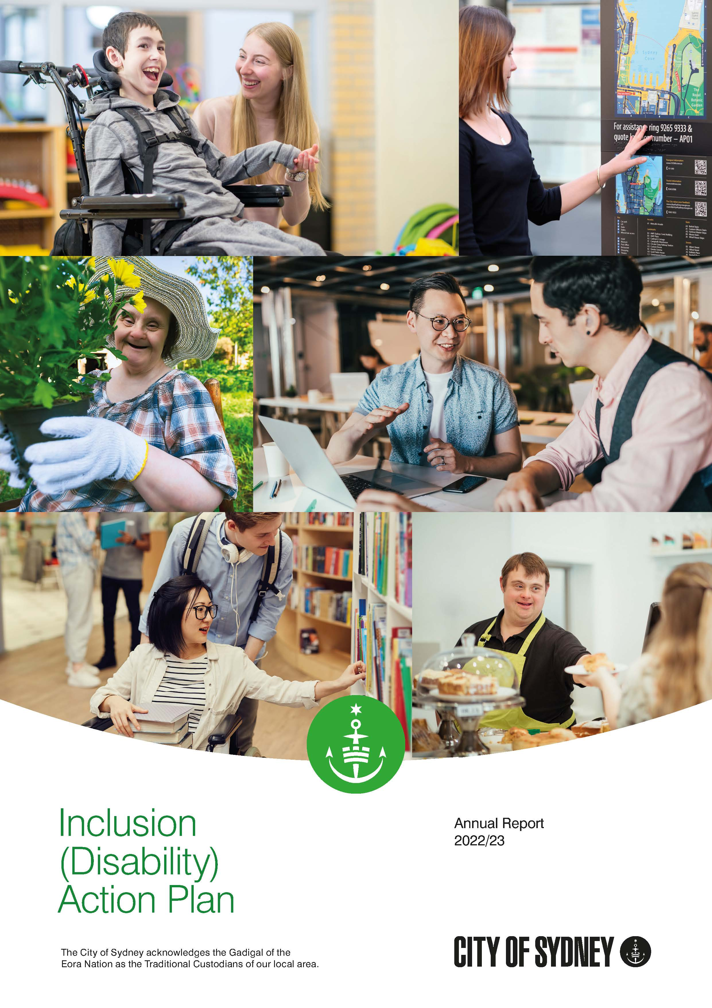

The Council of the City of Sydney acknowledges the Gadigal of the Eora Nation as the Traditional Custodians of our local area. We acknowledge Elders past and present and celebrate the diversity of Aboriginal and Torres Strait Islander peoples and their ongoing cultures and connections to Country.

Contents
Introduction 4
Key achievements 6
Direction 1: Positive community attitudes and behaviours 10
Direction 2: Liveable communities 15
Direction 3: Meaningful employment 28
Direction 4: Equitable access to mainstream services 31

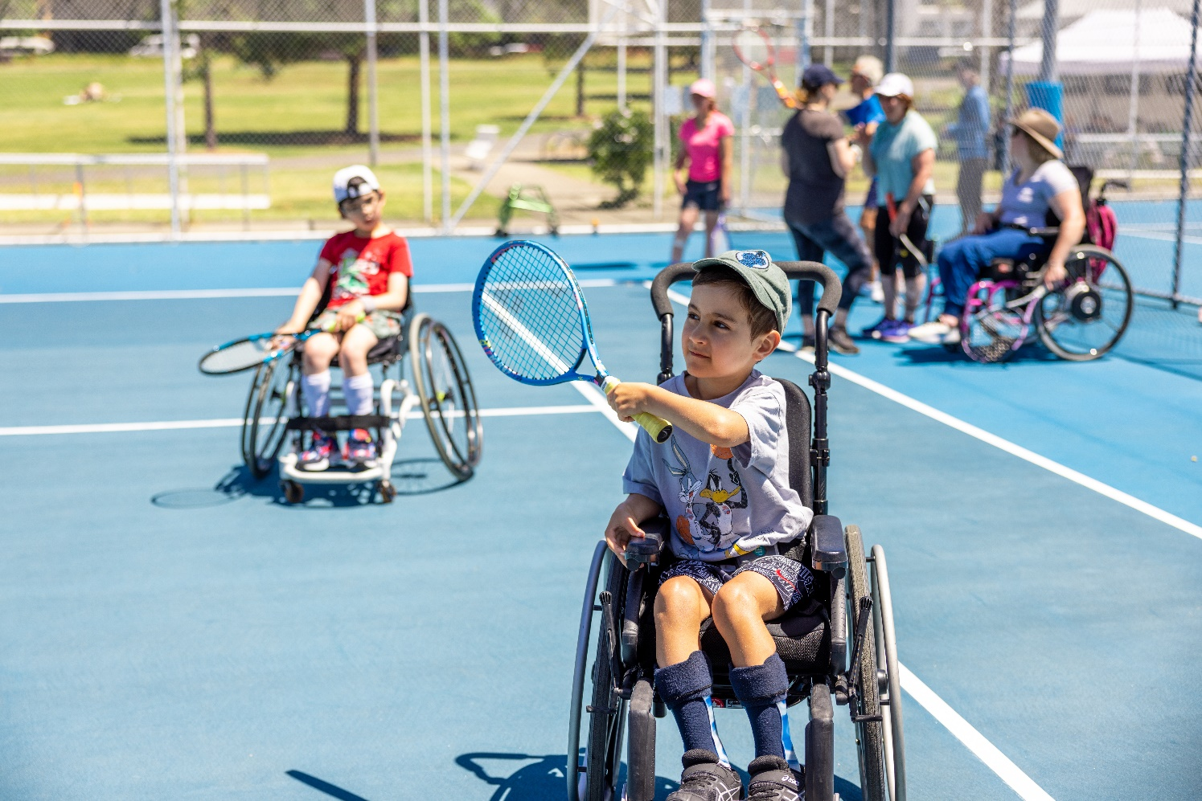
Photo: Young boy playing adaptive tennis using a wheelchair at Prince Alfred Park, Surry Hills. Photographer: Katherine Griffiths

Introduction

The City of Sydney has an ongoing commitment to making Sydney truly inclusive and welcoming. This commitment is embodied in our inclusion (disability) action plan.
The plan aligns with our long-term vision of an inclusive city and includes 29 actions designed to actively address barriers faced by people with disability. The actions build on the success of previous plans, and harness new and emerging opportunities.
The plan was developed through extensive consultation with people with disability and/or caring responsibilities, local disability service providers, peak disability representatives, advocacy organisations and members of our Inclusion (Disability) Advisory Panel.

Plan governance
The plan is a living document that was designed to be flexible in how outcomes can be achieved over time. This allows the City of Sydney to adapt its implementation approaches to changing contexts such as legislation and new technology.
Each year, relevant business unit managers review the draft implementation plan and confirm resources for work to be carried out in the forthcoming year.
Relevant business units are required to report on the progress of implementing the actions as part of the business planning process, at regular intervals each year.
Working groups meet twice a year to report on progress and share challenges and opportunities around actions.
Our social policy officer – access and inclusion is responsible for overseeing the implementation of the plan, coordinating the working groups, and collating progress reports, including the annual reports.

The purpose of this report
This annual report details progress made during the 2022/23 financial year on the scheduled actions identified in A City for All: Inclusion (Disability) Action Plan 2021–2025.
The report includes commentary on the progress of ongoing and new actions. Where actions are not yet scheduled to commence, this is noted. The report details progress and outcomes achieved in each action area, with measures of performance where applicable. Case studies highlight key achievements from the past year.
The development of the annual report is overseen by the City of Sydney’s Inclusion (Disability) Advisory Panel, which plays a vital role in monitoring the implementation of the plan.
This report is published with our annual report under the integrated planning and reporting framework.
In line with requirements of the NSW Disability Inclusion Act 2014, a copy of this report is also made available to the Minister for Families and Communities and Minister for Disability Inclusion, and the Disability Council of NSW.

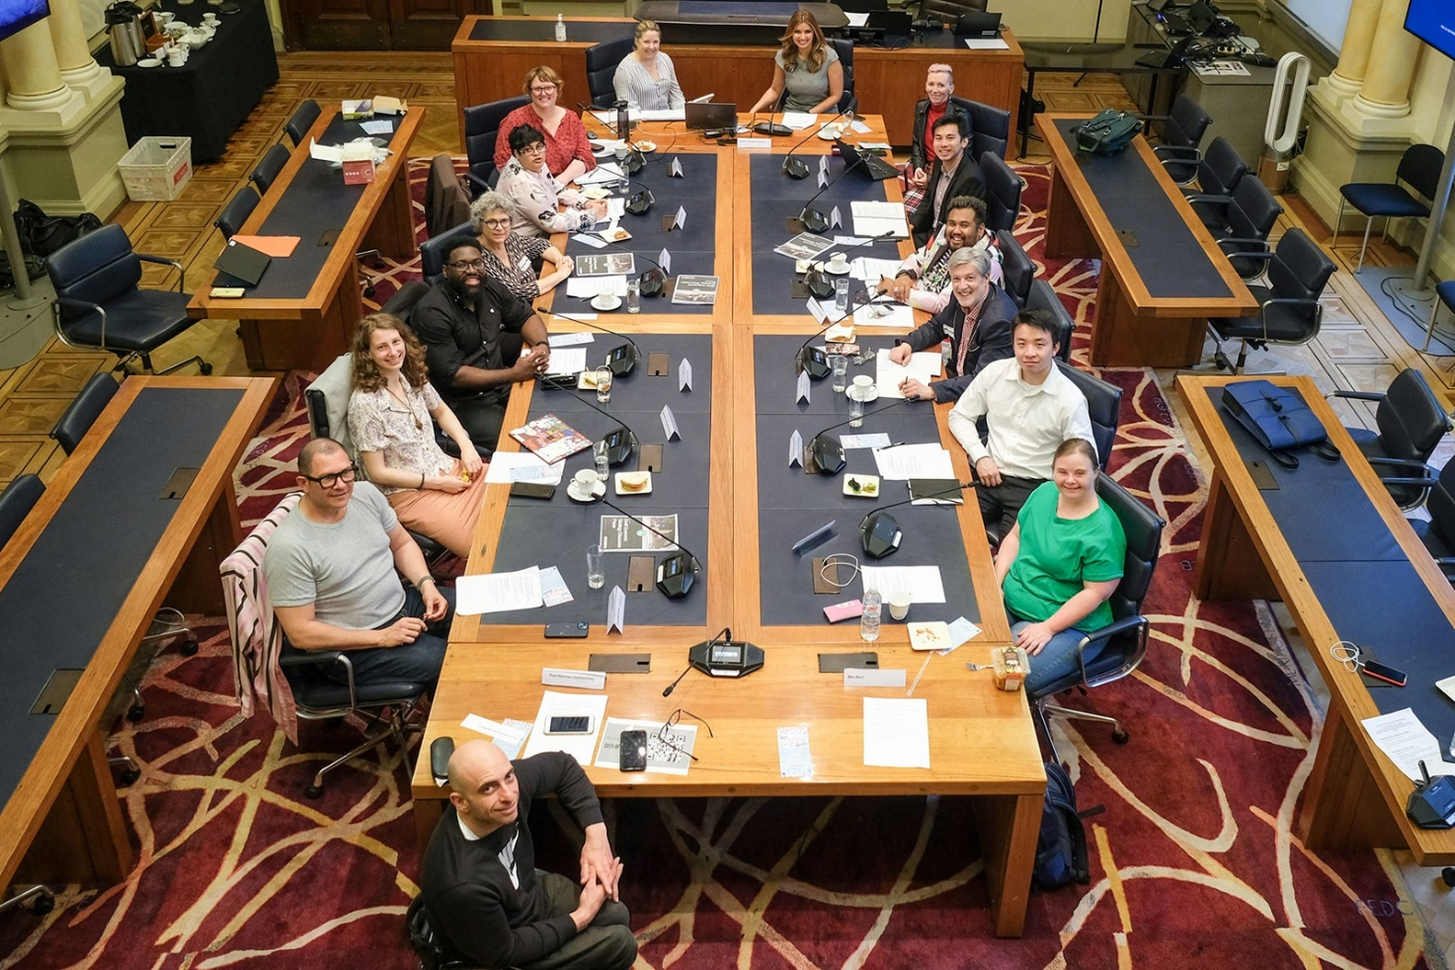
Photo: Group photo of the Inclusion (disability) advisory panel sitting at desks in Council Chambers.

Inclusion (Disability) Advisory Panel
The City of Sydney’s Inclusion (Disability) Advisory Panel provides strategic, expert, and impartial advice to the organisation on the development, implementation and review of the its policies, strategies and plans to advance the inclusion of people with disability.
As part of its role, the panel monitors and provides advice on the plan’s implementation. More information about the panel is available on the City of Sydney website.

Key achievements
Over the past year, the City of Sydney has continued to complete priority actions, identified by our community, that advance the inclusion of people with disability.
A key focus has been to integrate accessible and inclusive programming into the everyday – including in community centres, libraries, recreation centres and spaces, through arts and cultural programs and our grants and sponsorships.
Building an inclusive workplace that welcomes and thrives on diversity has been a priority, along with challenging stereotypes and promoting positive images of people with lived experience of disability. Included below are some key highlights and key achievements.

Positive community attitudes and behaviours
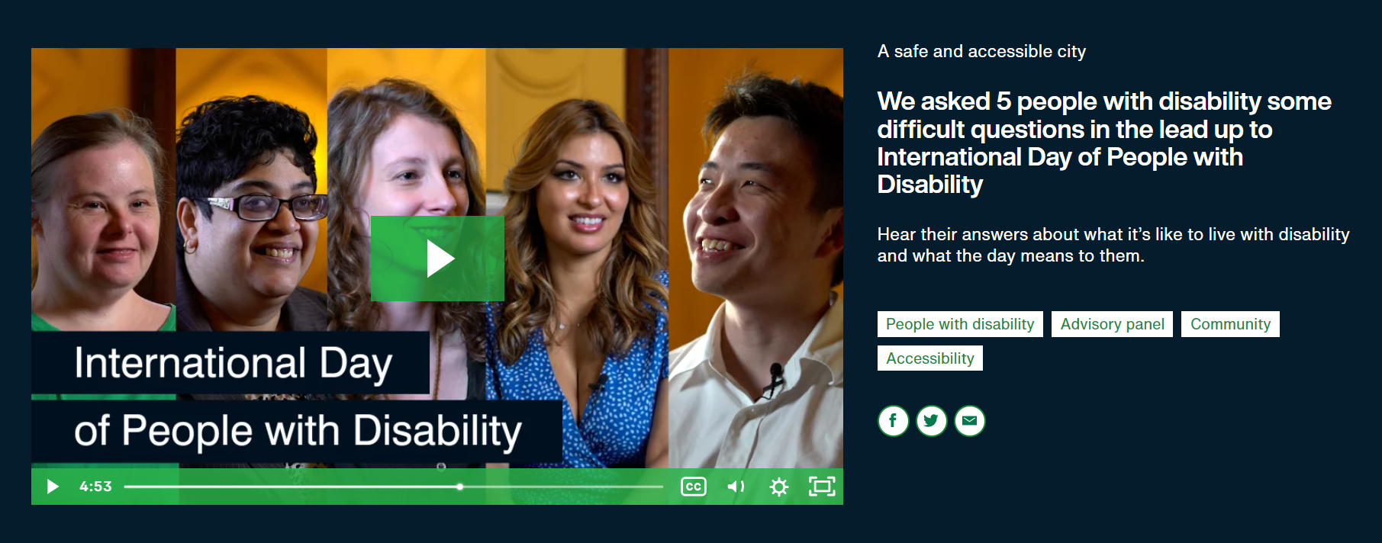
Photo: Screenshot of the video showing portrait photos of 5 Inclusion (Disability) Advisory Panel members

Smashing stereotypes and stigma through an impactful video for International Day of People with Disability
The video ‘We asked 5 people with disability some difficult questions in the lead up to International Day of People with Disability’ was developed with and featured 5 members of the City of Sydney’s Inclusion (Disability) Advisory Panel.
In the video panel members answered some difficult questions about what it is like to live with disability and what the day means to them. The objective of the video was to increase public awareness, understanding and acceptance of people with disability.
The video was posted on our social media channels, City of Sydney News and What’s On websites. In total, the video was viewed more than 23,000 times and received positive engagement across our social media channels, particularly on LinkedIn.
“For young people – a disability can be daunting and uncomfortable to come to terms with when going through your career, studies and social life. Therefore, I wanted to get involved to inspire young people with disabilities to speak up and be proud of who they are. Opening up about my own disability made me realise the superpower, capability and talent I had within myself, and that anybody can do it!” – Charles

Liveable communities
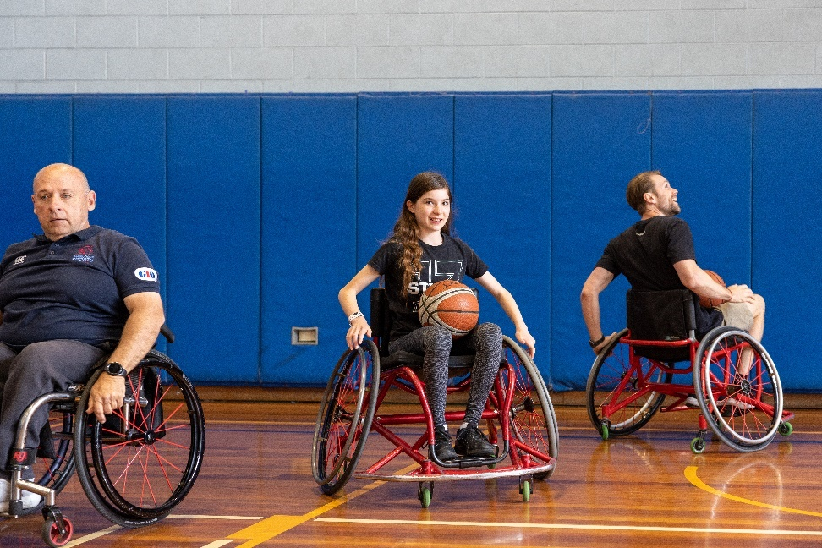
Photo: Wheelchair basketball at Ultimo Community Open Day 2022. Photographer: Katherine Griffiths

Making disability and mental wellbeing a part of everyday programming
The City of Sydney produced 137 programs to promote social inclusion, connection and participation, with 259,908 attendances across community centres and community-based programs. Seven events were held in conjunction with R U OK Day and International Day of People with Disability, including talks with people with disability at Cliff Noble Community Centre, Alexandria and at Green Square Library, as well as an Activate Inclusion Sports Day at Perry Park, Alexandria for young people.
A range of inclusive programming was produced across our network of libraries and community facilities. We hosted 21 Auslan and English storytime online videos presented by deaf presenters with videos viewed 48,689 times, and 12 in-person Auslan storytime events with 84 attendees. Eighteen Auslan interpreted talks and performances were hosted during the period with 917 attendees, with topics including Glebe archives, FEAST, Australian Life and International Day of People with Disability.
Educational, creative and cultural topics were Auslan interpreted at 166 events for adult audiences. Highlights included 'Welcome to Consent', a talk about the impact of mental health through non-consensual sexual experiences and a filmmakers’ panel discussion led by artists with disability for International Day of People with Disability.
Our aquatic centres continue to offer programs that look to improve inclusiveness and participation for those with a disability through the Take Charge, Swim Champs and New Horizons programs for people with disability and mental health conditions. A highlight was Gunyama Park Aquatic and Recreation Centre, Green Square which hosted a program ‘I Can, You Can, We Can’ that featured community ability ambassadors who shared their life stories alongside short films shown from the 2022 Focus on Ability short film festival.
The City of Sydney encourages all grant recipients to ensure their events are inclusive and accessible for people with disability as audience members and artists. Over the past year funded creative projects produced over 861 events and activities that catered for audiences with disability, including 329 artists with disability and 45 people with disability participating in creative activities.
In 2022/23 our grants and sponsorship program approved 18 projects that enhance access and inclusion for people with disability, from events and festivals to community development and business innovation. The program has a focus on promoting and supporting diversity and inclusion. The grant process individually caters for different access needs of applicants with disability and the newly updated guidelines are also available in Easy Read.

Meaningful employment

Creating new opportunities and supporting people with disability in the workplace
The City of Sydney was reaccredited as a disability confident recruiter by the Australian Network on Disability. The accreditation involved reviewing our policies, processes and supports for employees with disability to ensure accessibility and inclusiveness.
We were proud member of the Australian Human Rights Commission’s IncludeAbility Employer Network demonstrating our commitment to improve the long-term employment of people with disability.
We offer an individualised recruitment pathway for people with disability, including fast tracking to interview stage if a person with disability meets the minimum requirements of a role. Adjustments are made during recruitment according to need and access requirements, as we aim to provide greater opportunities for employment for people with disability.
We continued to provide flexible working arrangements for employees to accommodate individual circumstances, as well as implementation of a new teams-based flexible working approach.
This year, we partnered with specialist disability recruiter Jigsaw to support the employment of 3 neurodiverse people. We will continue to form strategic partnerships with disability organisations to implement supported employment opportunities for people with diverse range of disabilities.

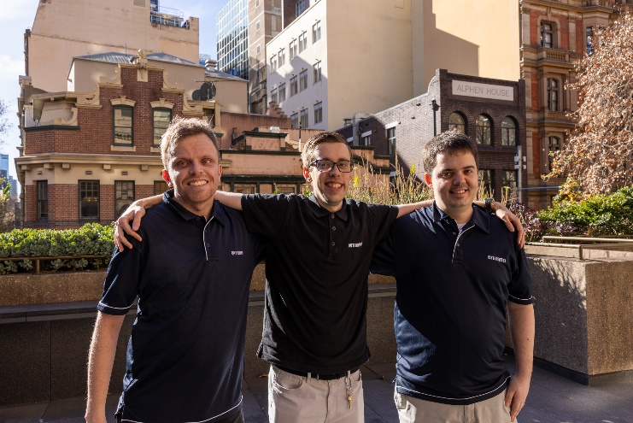Photo: Ari, Frazer and Matt. Photographer: Tanisha Lafitani
There are a lot of misconceptions about people with disability. Given that my disability is invisible, others won’t understand my disability at all, and others might see me as an unskilled worker. They will think I don’t fit in or that I’m less productive than people that don’t have a disability, which is not true in my case. – Ari

In 2022/23, 350 City of Sydney employees completed Inclusion (Disability) Awareness e-learning, and 189 employees completed Diversity and Inclusion e-learning. Employees also continued to access further training and resources on disability, mental health and inclusion topics as it relates to their roles.
Focusing on building awareness and support for less-visible disabilities, we continued to provide mental health awareness training for managers and employees through Beyond Blue. We also provided mental health first aid training, and piloted training for Managing Psychosocial Hazards in the Workplace. We are currently undertaking a learning needs analysis to enable specialised training provision to build greater awareness, skills and development according to roles and responsibilities.

Equitable access to mainstream services
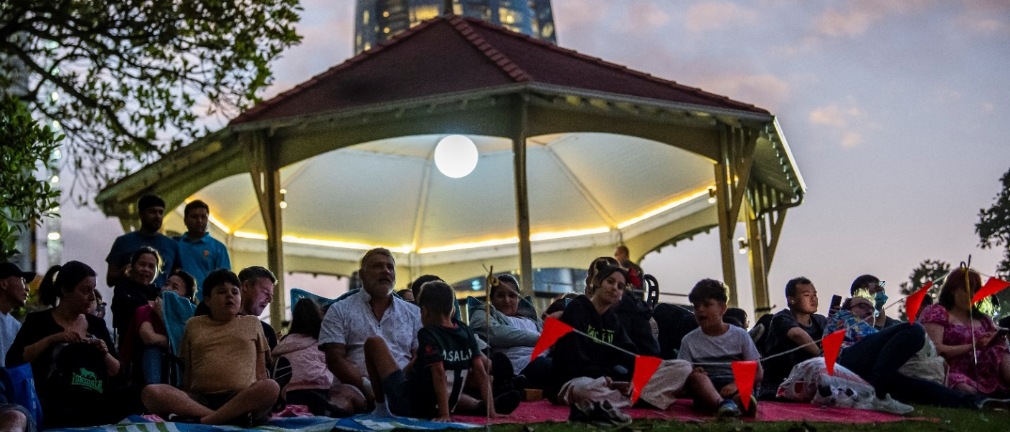
Photo: Families sit on Observatory Hill on Sydney New Year’s Eve 2022. Photographer: Justin Sanson

Updated inclusive and accessible event guidelines
The City of Sydney reviewed and updated the inclusive and accessible events guidelines. The new guidelines include best-practice case studies, testimony and advice from people with lived experience of disability attending inclusive events, inclusions for neurodiverse people, considerations for online events and a clear business case for improving access and inclusion.
Inclusive and accessible events provide equitable opportunities for people who live, work and visit the City of Sydney local area to enjoy and participate in the diverse social and cultural events on offer.
The guidelines apply to:
- all City of Sydney produced events
- events and festivals produced by groups and organisations that have received a grant from the City of Sydney, in line with the grants and sponsorship policy and guidelines
- event organisers that seek outdoor permits for events and festivals in the City of Sydney area.
Regardless of if the event is a small community event, or a major event across multiple days and sites, the guidelines outline key access and inclusion considerations. These should be referred to and worked towards when planning and producing events in the City of Sydney area.
The guidelines were developed in consultation with members of the Inclusion (Disability) Advisory Panel. Panel members reviewed the guidelines and provided positive feedback. Further resources will be added to the guidelines, including an Easy Read version and training provided on creating best practice inclusive and accessible events.
Suddenly, I could understand! I could engage. And I noticed everyone else around me paying closer attention to the speakers as well – reading those captions along with me – because let’s face it, it’s hard for most people to hear at a big old party! – Sabrina

Direction 1: Positive community attitudes and behaviours

Harmony and social inclusion
Objectives | Actions | Timing | 2022/23 status and progress update | Measures
City of Sydney employees are disability aware and confident and have access to specialists training and development opportunities to deliver inclusive built environments and ensure our communications and services are accessible and inclusive of people with disability. Employees will have the skills to meet requirements under the Commonwealth Disability Discrimination Act 1992 and the NSW Disability Inclusion Act 2014 and deliver services that consider inclusion, not just compliance. | 1. Continue to implement a program of disability inclusion training for City of Sydney employees. | Ongoing | The City of Sydney continues to implement a program of disability awareness and confidence training and provide resources on disability, mental health, and inclusion topics to employees.  Online Inclusion (Disability) Awareness training  350 employees completed the Inclusion (Disability) Awareness e-learning and 189 employees completed the Diversity and Inclusion e-learning.  Aquatic centre staff training  523 Belgravia Leisure employees completed the You Me Us disability awareness and inclusion training.  Specialist disability training  City of Sydney employees had access to a range of specialist disability access and inclusion training, development opportunities and resources, including:  - training in creating accessible documents and Web Content Accessibility Guidelines 2.1  - Access Standards and accessible buildings, parks, streetscapes and transport  - implementing strategies for inclusion to meet the needs of children with disability  - working with neurodiverse people.  Mental health training  The City of Sydney continued to offer mental health training to support employees in managing their work and life demands in a way that supports their mental wellbeing and that of others.  This range of training also helps improve our responsiveness to people with disability.  Employees completed the following mental health courses:  - Mental health first aid  - Managing psychosocial hazards in the workplace  - Managing mental health risks at work  - Approaching an employee you are concerned about  - Mindfulness and resilience to stress at work  - Building resilience in your team in difficult times  - Workplace wellbeing: How to build confidence and manage stress.  Aquatic centre staff mental health training  Belgravia Leisure’s Mental Health eLearning Program provided access to a 2-hour mental health training module. 24 employees completed the course, including the regional leadership team, centre managers and assistant centre managers. | 350 new employees (91%) completed the Inclusion (Disability) Awareness e-learning.  189 new employees (86%) completed the Diversity and Inclusion e-learning.  523 Belgravia Leisure employees (75%) completed You Me Us disability awareness training.  87 employees completed specialist disability inclusion training.  654 employees (36%) completed mental health training in 2022/23.  24 employees completed the Mental Health eLearning Program.
Positive community attitudes towards people with disability and mental health conditions are enhanced through City of Sydney programs that foster greater awareness, understanding and respect. | 2. Continue to provide community programming aimed at fostering positive community attitudes towards people with disability, including people with less visible disabilities and people with mental health conditions. | Ongoing | The City of Sydney continues to produce a range of programming aimed at fostering positive community attitudes toward people with disability, including people with less visible disabilities and people living with a mental health condition.  Over the 2022/23 period, we delivered and supported the following inclusive library, recreation, cultural and community programs and events:  - The video ‘We asked 5 people with disability some difficult questions in the lead up to International Day of People with Disability’ was developed with and featuring members of the Inclusion (Disability) Advisory Panel. It was viewed more than 23,000 times and aimed to challenge stereotypes and stigma and promote positive community attitudes and behaviours towards people with disability.  - We produced 137 programs to promote social inclusion, connection and participation, with 259,908 attendances across community centres and community-based programs. Seven events were held in conjunction with R U OK Day and International Day of People with Disability, including talks with people with disability at Cliff Noble Community Centre, Alexandria and in Green Square Library, Zetland as well as an Activate Inclusion Sports Day at Perry Park, Alexandria for young people.  - We hosted 21 Auslan and English storytime online videos presented by Deaf people. The videos were viewed 48,689 times by audience members remotely. 12 in-person Auslan Storytime sessions were provided which had 84 attendees and 18 Auslan interpreted talks and performances were hosted during the period with 917 attendees. Topics including Glebe archives, FEAST, Australian Life and International Day of People with Disability.  - 166 events for adult audiences on educational, creative and cultural topics were Auslan interpreted. Highlights included ‘Welcome to Consent’, a talk about the impact of mental health through non-consensual sexual experiences and a filmmakers’ panel discussion led by artists experiencing disability for International Day of People with Disability.  - The City of Sydney’s aquatic centres continue to offer programs that look to improve inclusiveness and participation for those with a disability, including people with less visible disabilities and people with mental health conditions through the Take Charge, Swim Champs and New Horizons programs for people with disability. A highlight was Gunyama Park Aquatic and Recreation Centre, Green Square hosted a program ‘I Can, You Can, We Can’ which featured community ability ambassadors who shared their life stories alongside short films shown from the 2022 Focus on Ability short film festival.  - A new inclusive adaptive tennis program was launched at Prince Alfred Tennis Courts with regular group sessions and a ‘Come and try’ day to introduce people with disability to the sport.  - A local services expo has held at Ron Williams Community Centre in Redfern to show older people where they can get support.  - A calming sensory afternoon was held at Cliff Noble Community Centre in Alexandria for young people.  - The City of Sydney ran Together: Access and Inclusion Training online in collaboration with Youth Disability Advocacy Service, as part of the City’s Connect Sydney program.  - Our grants and sponsorship program approved 18 projects that enhance access and inclusion for people with disability, from events and festivals to community development and business innovation. The program has a focus on promoting and supporting diversity and inclusion.  - Over the past year funded creative projects produced over 861 events and activities that catered for audiences with a disability, including 329 artists with disability and 45 people with disability participating in creative activities. | 378 inclusive and accessible programs produced, an increase of 267% from last year.  86 per cent of attendees of some adult programs where Auslan interpreting and captioning were provided, agreed that they had a “greater appreciation of why library programs should be accessible to everyone”.
Positive community attitudes towards people with disability and mental health conditions are promoted through the City's digital and print platforms. | 3. Increase the usage of images of people with disability across City publications, digital platforms and media channels. | Ongoing | A video ‘We asked 5 people some difficult questions in the lead up to International Day of People with Disability’ was viewed more than 23,000 times.  The City of Sydney’s digital image library has 188 images tagged 'disability' (1.8% of images in the digital library).  New images include a shoot for Adaptive Tennis Festival at Prince Alfred Park, Surry Hills in December 2022.  Images of people with disability were included in the following strategies and plans:  - Community Engagement Strategy  - Resilience Strategy | One video viewed more than 23,000 times.  25 new images of people with disability were catalogued for use in the image library.

Direction 2: Liveable communities

Accessible places and spaces
Objectives | Actions | Timing | 2022/23 status and progress update | Measures
Streets, parks, footpaths and open spaces in the City of Sydney area are accessible. The design, maintenance and management of infrastructure and places enables people with disability to travel through the City with dignity and independence. | 4. Continue to improve the accessibility of streets, footpaths, parks and open places through renewal programs, upgrades and new capital projects in compliance with the Inclusive and Accessible Public Domain Policy and Guidelines. | Ongoing | Pedestrian access  - The City of Sydney’s pedestrian and access program focuses on upgrades and renewal projects to improve safety and accessibility across the City of Sydney area. In 2022/23, 159 access ramps were constructed to current standards, 24 continuous footpath treatments were completed across side streets, removing the need for 52 access ramps, and 9 raised pedestrian crossings were constructed, removing the need for 16 access ramps and 139 provisions of tactile surface ground indicators to meet compliance.  - Our upgrades to pedestrian access are ongoing, with over $28.2 million spent in 2022/23, including major projects such as the pedestrianisation of George Street. Access upgrades and renewal projects to improve safety and accessibility across the City of Sydney area includes:  - upgrading non-compliant ramps, including ramps at intersections  - providing ramps where missing  - footpath renewal and upgrade  - intersection improvements to improve access including signalised crossings, continuous footpath treatments and pedestrian crossings  - paver infill program to upgrade footpath surface materials  - providing tactile ground surface indicators where they were missing or non-compliant  - providing 680 accessible seats in public areas  - renewal and upgrade to lighting.  New street furniture  - 330 new accessible bus shelters were installed  - 6 new street vending kiosks, designed and placed with accessibility in mind.  Inclusive and accessible public domain policy and guidelines  The inclusive and accessible public domain policy was reviewed and approved by Council in August 2022. The inclusive and accessible public domain guidelines are currently being reviewed and will be available in 2023/24. | Number of non-compliant kerb ramps remediated.  7,832 metres² of footpath in 2022/23.  183 pedestrian access and inclusion improvements constructed, including new kerb ramps, continuous footpath treatments and 9 raised pedestrian crossings.  330 new accessible bus shelters installed.  6 accessible vending kiosks installed.
 | 5. Improve access to information about City of Sydney facilities and open spaces to assist people with disability including people with Autism. | Ongoing | Access at a glance  The access at a glance project aims to provide key access features of the City of Sydney’s community facilities on its website.  Access Key  An Access Key has been implemented for Gunyama Park Aquatic and Recreation Centre, Green Square, Prince Alfred Park Pool, Surry Hills, Victoria Park Pool, Camperdown and Andrew (Boy) Charlton Pool, The Domain, helping to support people with diverse disabilities to access and use the facilities.  Accessibility map  There was a total of 4,946 views of the accessibility map in 2022/23. | Monthly updates to the City of Sydney’s Accessibility Map.  4,946 views of the accessibility map.  4 people’s positive feedback was received on accuracy of map and access information on the City of Sydney’s website.
 | 6. Review the current provision of seating and provide additional rest opportunities on streets and in outdoor spaces, where appropriate. | 2021–2024 | Additional seating is being rolled out as part of the implementation of the new street furniture project. 580 new outdoor seats were updated, and 100 new seats were installed across the City of Sydney area. | 680 new seats.
 | 7. Advocate to other government agencies and landowners to provide additional Adult Change Facilities in the City of Sydney area. | Ongoing | The number of adult change facilities in the local area is 8.  An opportunity for advocacy was identified during this reporting period at Darling Harbour.  Advocacy for adult change facilities was carried out with the City of Sydney’s submission for the 2022 Review of the disability standards for accessible public transport 2002, for the CBD metro and train stations.  There is still an absence of a changing places facility in the Town Hall and Circular Quay areas, where further advocacy will be targeted. | 8 Adult change facilities are installed in City of Sydney area.  Advocacy was undertaken for 3 adult change facilities in the City of Sydney area.
 | 8. Explore opportunities to provide designated quiet spaces, places for sensory seeking and places for respite in City of Sydney facilities and in parks and playgrounds. | Ongoing | The ‘Design Across the Spectrum’ guide for play spaces was incorporated into 9 parks, playgrounds or reserves. Design principles have been developed to inspire more inclusive design within our parks and playgrounds, and encompass a broader spectrum of sensory, cognitive and social disabilities to offer opportunities in fostering social inclusion and enhance wellbeing.  Through the parks and playgrounds renewal program 2021/2022 and 2022/2023, the City of Sydney is upgrading 9 parks listed below to ensure they are inclusive and welcoming for people with different sensory needs:  - Minogue Reserve, Glebe  - Robyn Kemmis Reserve, Glebe  - Regent Street Reserve, Paddington  - Mountain Street Reserve, Ultimo  - Glebe Street Playground, Glebe  - Alexandria Park Playground, Alexandria  - Arthur Street Reserve, Surry Hills  - Douglas Street Playground, Redfern  - McKee Street Reserve, Ultimo. | 9 quiet space/sensory seeking places provided in existing or new parks.
 | 9. Provide charging points for personal devices such as phones, electric bikes and mobility scooters in City of Sydney facilities. | 2021–2022 | Charging points are available at 8 community centres.  Additional charging points will be investigated in 2022-23 and beyond in City venues and the public domain. | Charging points available at 8 community centres.
 | 10. Continue to explore and implement strategies to increase access to on-street and off-street accessible parking and drop-off points in the City of Sydney area. | 2021–2024 | The City of Sydney has begun introducing timed mobility parking where kerb space is changed in conjunction with capital works (cycleways, for example). This approach shares access to these spaces across multiple drivers.  7 locations within the Central Sydney area were identified through a gap analysis of mobility parking spaces. In addition, 31 possible locations were identified in areas outside of the Central Sydney area that may benefit from more mobility parking spaces. Detailed investigation and implementation, where feasible, is scheduled in 2023/24. Reporting and approvals will be sent to the Local Pedestrian, Cycling and Traffic Calming Committee.  We continue to provide information about mobility parking spaces on the City of Sydney website on the mobility parking page and the online accessibility map.  The City of Sydney’s website has been updated to reflect parking rules for mobility parking scheme permit holders, drawing attention to the fact that mobility parking scheme permit holders can stop in a no parking zone for up to 5 minutes to drop off or pick up passengers or goods if the driver remains within 3m of the vehicle. | Number of spaces within 200m of key social infrastructure:  - community centres (15 spaces across 8 centres)  - community venues for hire (47 spaces across 23 venues)  - libraries (19 spaces across 11 branches)
Accessible City of Sydney community facilities and venues provide the foundation of inclusive participation. | 11. Identify the most appropriate hearing augmentation systems to be used across the City of Sydney’s facilities and venues, where appropriate. | 2021–2023 | Since the introduction of the Disability (Access to Premises – Buildings) Standards in 2010, new City of Sydney community facilities have been designed to include hearing augmentation. The following community facilities have hearing augmentation installed:  – Alexandria Town Hall  – Darling Square Library  – Erskineville Town Hall  – Glebe Town Hall  – Green Square Library  – Gunyama Park Aquatic and Recreation Centre, Green Square  – Harold Park Community Hall, Glebe  – Juanita Nielson Community Centre, Woolloomooloo  – Perry Park Recreation Centre, Alexandria  – Redfern Town Hall  – Surry Hills Function Hall  – Surry Hills Library  – Sydney Town Hall  – Marconi Room, Town Hall House, Sydney  – Ultimo Community Centre.  In 2020/21 an audit carried out on 51 of Class 9(b) community facilities and venues was completed which found hearing augmentation systems are provided where appropriate and as required by the relevant standards.  Further opportunities and actions have been identified to ensure ongoing compliance and improved access for programs and facilities.  These include:  - Promote the use of the City of Sydney’s portable hearing augmentation systems in all community facilities and venues for hire.  - Continue to provide captioning (where possible) to support participation of people who are hard of hearing.  - Ensure permanent hearing augmentation systems are well maintained and operational.  - Ensure all new buildings and upgrade works include hearing augmentation systems where appropriate and required.  Portable hearing augmentation devices have been purchased for use across all community facilities to support participation of people who are hard of hearing in programs and events in spaces where the use of in built amplification is not suitable. | 15 (29%) of our community facilities, aquatic centres, venues and libraries have permanent hearing augmentation installed.  All community facilities, including libraries, have access to portable hearing augmentation systems.
Businesses in the City of Sydney area are more accessible and inclusive to people with disability, parents with prams and older people, as well as their friends and families. | 12. Collaborate with local businesses and disability-led organisations to build their capacity to be more inclusive and accessible. | Ongoing | Three economic projects were approved through the grants program valued at $60,712 towards improving accessibility and inclusion for people with disability. | 3 grants awarded.

Diverse housing tenures and types
Objectives | Actions | Timing | 2022/23 status and progress update | Measures
More housing in the City of Sydney is accessible and adaptable. It will meet the needs of people with disability and support people to age in place. | 13. Through the implementation of the City's Housing for All Strategy investigate opportunities in the planning controls to increase the amount and improve the standard of housing that is universally designed. | Ongoing | As part of the Sydney Local Environmental Plan and Sydney Development Control Plan update, the City of Sydney will propose controls to increase the amount of universally designed housing and family friendly apartments in new apartment developments.  The City of Sydney is an advocate of 100% affordable housing to the Liveable Housing Guideline’s gold level on all NSW Government sites. Most recently we advocated for this outcome on the state-led rezoning of the Explorer Street, South Eveleigh social housing site.  The City of Sydney also delivers affordable housing through its planning controls, the affordable and diverse housing fund and by selling land below cost to community housing providers. | Changes proposed to planning controls in the LEP and DCP to be reported to Council in 2023/24.

Sense of belonging and connection to place
Objectives | Actions | Timing | 2022/23 status and progress update | Measures
Opportunities for inclusive participation are available at City of Sydney Facilities, and people with disability can easily identify opportunities that meet their preferences and needs. | 14. Continue to deliver a range of inclusive community, learning, sport and recreation programs and major events that ensure equitable access and participation for people with disability. | Ongoing | The City of Sydney continued to offer a wide range cultural and community programming for improved inclusivity and wellbeing. In 2022/23, 492 adults, young people and children participated in a total of 48 inclusive cultural programs across our library network.  Cultural program highlights include:  - 21 Auslan and English storytime videos with over 48,689 views  - 30 programs were Auslan interpreted, and 15 programs were offered online  - the return of face-to-face Auslan and English storytime at Glebe Library and a filmmakers’ panel discussion led by artists experiencing disability for International Day of People with Disability.  A total of 137 programs were offered to promote social inclusion, connection and participation, with 259,908 attendances across community centres and community-based programs. This included 87 programs to increase inclusion and diversity and 36 programs offered to support the participation of people with disability  Community program highlights include:  - several health and fitness programs with adaptive or modified exercises including chair yoga, chair Sheng Zhen meditation, move for all, gentle exercise, tai chi and Living Longer, Living Stronger  - an art therapy program was produced at Reginald Murphy Community Centre, Potts Point and Ron Williams Community Centre, Redfern held a ‘How to Manage Arthritis’ talk  - Ultimo Community Centre’s open day included the opportunity to try wheelchair sports as well as Headis (an adaptive sport played on a table tennis table)  - talks with people with disability were held at Cliff Noble Community Centre, Alexandria and Green Square Library, Zetland for International Day of People with Disability, and an Activate Inclusion sports day for young people was held at Perry Park Recreation Centre, Alexandria  - the Seniors Festival Comedy Show at Sydney Town Hall attracted 1,000 participants and featured Auslan interpreters  - hosting Together: Access and inclusion online training workshop in partnership with Youth Disability Advocacy Service for International Day People with Disability.  Aquatics centre program highlights include:  - Swim Champs, a swimming and water safety program for children with intellectual or physical disability at Ian Thorpe Aquatic Centre, attended by 801 participants.  - pickleball, a social sport popular among seniors at the Cook + Phillip Park Pool, Sydney attracted 5,230 participants.  - 2 wheelchair sports events were developed and presented at the Cook + Phillip Park Pool attended by 38 people.  - WAVES Group classes continue at Gunyama Park Aquatic and Recreation Centre, Green Square with 860 attendances in 2022/23.  What’s On event listings:  - The City of Sydney continued to improve event listings and ensure adequate access to information about events and programs is provided to allow people with disability to plan for their journey before events.  - What’s On gives local creatives, businesses and community groups a free platform to publicise events and attractions in Sydney. The website is also used by the City of Sydney to publicise its events. Visitors to the website can find events by date, venue and type, as well as by accessibility features. For example, a visitor can browse events that feature audio description or sign language, or are held at venues with mobility access, or assistance for people who are blind or have low vision. Eight access features, with appropriate icons, have been designed for the site and are available to event submitters.  - To support their use, we provide event organisers with 3 articles in a dedicated help section called ‘Accessibility at your event’. We provide guidelines for disability-inclusive events, show how to use the access features and tags in What’s On, and provide ways to share events with access features.  - In 2022/23 there were 1,759 events published on What’s On with at least one accessibility feature. Feedback from people with disability has resulted in enabling events to have an inclusion statement, and a person to contact to assist further with access needs.  - Organisers that promote inclusion of people with disability can also tag their events as ‘disability-inclusive’. In the reporting period, 132 events were listed disability inclusive  - The article 'Disability inclusive things to do in Sydney' was regularly updated and featured across What's On throughout the reporting period. The article received 1,524 page views mostly through Google search. In addition to year-round and new events, the article also provides resources for people with disability to access other initiatives, events and programs across Sydney. | 378 inclusive and accessible programs produced.  1,759 events published on What’s On with at least one accessibility feature.  132 events tagged as ‘disability-inclusive’.  1,524 webpage views.
Opportunities for inclusive participation are available at City of Sydney Facilities, and people with disability can easily identify opportunities that meet their preferences and needs. | 15. Continue to provide programming that empowers people to manage their stressors and social and emotional wellbeing. | Ongoing | - Juanita Nielsen Community Centre, Woolloomooloo and Redfern Community Centre hosted R U OK? day events with talks, resources, gentle exercise classes, meditation and opportunities for people to connect and share their experience to reduce stigma.  - Juanita Nielsen Community Centre, Woolloomooloo celebrated Women's Health Week with the inclusion of mental health as a key focus.  - A range of programs including singing, painting, BYO instrument ensemble, yoga classes, Sheng Zhen meditation, and music and movement for older people all use creativity, rhythm and the body to support physiological regulation and wellbeing.  - The City of Sydney’s aquatic centres continue to offer programs that look to improve inclusiveness and participation for those with a disability, including people with less visible disabilities and people with mental health conditions through the Take Charge, Swim Champs and New Horizons programs for people with disability.  - Gunyama Park Aquatic and Recreation Centre, Green Square hosted a program ‘I Can, You Can, We Can’ which featured community ability ambassadors who shared their life stories alongside short films shown from the 2022 Focus on Ability short film festival. | 91 events/programs delivered to manage stressors and social and emotional wellbeing.

Diverse Thriving Communities
Objectives | Actions | Timing | 2021/22 status and progress update | Measures
Major events in the City of Sydney area are accessible, inclusive and encourage greater participation of people with disability. | 16. Deliver and facilitate major events in line with the City's Inclusive and Accessible Event Guidelines. | Ongoing | The City of Sydney has reviewed and updated the inclusive and accessible event guidelines to include best-practice case studies, testimony and advice from people with lived experience of disability attending inclusive events, inclusions for neurodiverse people, considerations for online events and a clear business case for improving access and inclusion.  Employees continued to produce and facilitate major events in line with the inclusive and accessible event guidelines.  Both the major events and festivals core team members and event staff on a casual or temporary base were provided with comprehensive disability awareness training as part of the induction process. This was a live online training session and key learning was also provided to all relevant employees.  Audio description was arranged for several occasions, including Australian Life and Little Sydney Lives photography finalists, Art & About Tidal, Art & About Here Lies Your Story, the Martin Place Christmas tree, Sydney New Year’s Eve fireworks and the Sydney Lunar Festival Lunar Lanterns.  There are also designated employees to provide information on parking and transport options for City of Sydney produced events.  Sydney New Year’s Eve  Sydney New Year’s Eve is Australia’s biggest public event that displays Sydney as a city of resilience and inclusion.  Sydney New Year's Eve event staff collaborated with the accessible working group to plan and provide accessible viewing areas and other aspects of the event to ensure it was accessible and inclusive. This working group drew on the feedback and experiences of representatives with lived experience and provided invaluable support and guidance on the event design and production process. The group also assisted in training staff of partnership organisations, and disability awareness training was also offered to suppliers.  As part of Sydney New Year’s Eve, the City of Sydney provided an accessible viewing area for 130 patrons, including support persons. A golf cart service and Changing Places facility was available at Observatory Hill Park, and an accessible change room and drop-off zone at Pirrama Park, Pyrmont.  All City of Sydney designated accessible viewing areas have seating available as well as a staff member to assist patrons where required. There are 9 designated accessible viewing areas listed on the Sydney New Year’s Eve website.  The Sydney New Year's Eve website has an online copy of the event guide in translated versions available in 6 different languages and an audio guide. Large print and Easy Read event guides are also available on the website and at information booths. An accessibility officer is available to help participants plan for the night. | 6 major events (100%) that comply with the inclusive and accessible event guidelines.

Vibrant Creative Life
Objectives | Actions | Timing | 2021/22 status and progress update |  | Measures
People with disability have equitable opportunities to participate in cultural life and events in the City. | 17. Continue to promote participation of artists with disability and audience members with disability in arts programs through implementation of the Creative City Strategy. | Ongoing |  | The City of Sydney continues to encourage grant recipients to offer accessible and inclusive events for everyone, including people with disability to be involved as lead artists as well as audience members.  In this reporting period, funded creative programs produced over 961 events and activities that catered for audiences with disability, including 329 artists with disability and 45 people with disability participating in creative activities.  While all events have been produced in accessible venues and/or provided online/live streaming services to overcome physical accessibility, many project organisers undertook more significant steps to ensure inclusive participation of people with disability, including:  - audio description  - Auslan interpretation  - sensory tours  - developing a disability inclusion action plan  Many projects also engaged consultancy services for quality staff training and expert advice, had people of disability represented on advisory panels and boards, and embedded a broad spectrum of access and inclusion considerations into their organisational systems and cultures.  An example of best practice was seen with Limitless, an accessibility hub launched for the Sydney Fringe Festival. The 2-week micro festival celebrated and supported D/deaf and disabled artists and audiences, with 176 artists with disability involved. A dedicated access coordinator managed the micro festival, which included 8 performances showcasing diverse performers and styles and 5 visual artists. The Disability (Inclusion) Advisory Panel provided guidance and an accessibility handbook was produced and distributed, along with a free online access masterclass. | 329 artists with disability supported.  45 programs that supported audience members with disability.

Direction 3: Meaningful employment

Inclusive Growth Opportunities
Objectives | Actions | Timing | 2022/23 status and progress update | Measures
Build organisational capability for disability inclusion. | 18. Build the capacity of managers and employees to foster an inclusive workplace through training and induction programs. | Ongoing | 350 City of Sydney employees completed the Inclusion (Disability) Awareness e-learning, and 189 employees completed the Diversity and Inclusion e-learning. Employees continued to access further training and resources on disability, mental health and inclusion topics.  We continued to provide mental health awareness training for managers and employees through Beyond Blue. In addition, we implemented Mental Health First Aid training and piloted training for managers in managing psychosocial hazards in the workplace to be rolled out to all managers in 2023/24.  Key initiatives and projects for this action are scheduled for completion in 2023/24 and beyond, including work to capture data on:  - the number of employees with disability who reported that they felt the workplace supported them and encouraged inclusion and diversity | 350 new employees (91%) completed the Inclusion (Disability) Awareness e-learning.  189 new employees (86%) completed the Diversity and Inclusion e-learning.  654 employees (36% of employees) completed mental health training in 2022/23.  87 employees completed specialist disability and inclusion training, which is a 42% decrease from last year.
Invest in building the capabilities of people with disabilities, in our workforce. | 19. Build the capacity of employees with disability as leaders through management. and leadership programs. | 2023–2024 | This action is due to be completed in 2023/24.
Attract and recruit people with disability into meaningful roles at the City of Sydney. | 20. Increase employment and development opportunities for people with disability. | Ongoing | The City of Sydney has successfully attained its disability confident recruiter accreditation from the Australian Network on Disability. This included reviewing and assessing all systems and processes to ensure they meet the standard required for accreditation, and all employees within the recruitment team participated in training led by the network.  We established a partnership with disability recruitment organisation Jigsaw to support internships and appointed 3 neurodiverse people into professional roles.  Vacant positions approved for recruitment are being released to disability employment services providers when they become available.  Further initiatives and projects for this action are scheduled for completion in 2023/24 and beyond. | 36 employees formally identified themselves as living with disability, representing 2% of the workforce.  3 entry level traineeships were offered to people with disability.
Build an inclusive workplace culture where employees with disability are valued and respected. | 21. Creating opportunities to engage employees with disability and allies of people with disability as advocates and champions of change. | Ongoing | The City of Sydney hosted events for Carer’s Week, R U OK? Day, and International Day of People with Disability to raise awareness and celebrate achievements.  Further initiatives and projects for this action are scheduled for delivery in 2023/24, including work to measure the number of employees who reported that they felt the workplace supported and encouraged inclusion and diversity. | Average employment tenure for people with disability is 15 years as compared to 11 years for other employees.
The City of Sydney's procurement policies and practices improve employment outcomes for people with disability. | 22. Strengthen procurement practices by building relationships with Australian Disability Enterprises and educating City of Sydney staff. | 2023–24 | Community wealth building to improve employment outcomes for people with disability will be included in the City of Sydney’s economic strategy being developed in 2023/24.  Further work to establish relationships with Australian disability enterprises is planned for 2023/24.  Key initiatives and projects for this action are scheduled for completion in 2023/24 and beyond, including work to capture data to report:  - number of suppliers of Australian disability enterprises utilised  - amount spent on Australian disability enterprises. | Number of suppliers of Australian disability enterprises utilised.  Amount spent on Australian disability enterprises

Direction 4: Equitable access to mainstream services

Balanced and inclusive local decision making
Objectives | Actions | Timing | 2022/23 status and progress update | Measures
People with disability are informed, consulted and actively participate in Council decision-making processes. | 23. Identify and implement strategies to inform people with disability about how they can be involved in Council decision making. | Ongoing | The City of Sydney produced an accessible guide to decision making at Council to ensure people with disability are informed and can actively take part in Council decision-making processes.  The guide is presented as a webpage, with a PDF version that can be printed on request at community centres and customer and neighbourhood service centres. It explains the types of activities used to enable direct public participation and how people can get involved. We worked with the NSW Council for Intellectual Disability to develop an Easy Read version of the community engagement strategy, to ensure everyone, including people with intellectual disability and/or limited English can understand how the City of Sydney engages its communities. The Easy Read version is published online at: cityofsydney.nsw.gov.au/strategies-action-plans/community-engagement-strategy | The accessible guidelines to decision making at Council have been developed and published.  1,167 views of the guidelines webpage and 107 downloads of the accessible PDF and MS Word Guides.
People with disability are informed, consulted and actively participate in Council decision-making processes. | 24. Actively engage people with disability in Council decision-making processes including through the City's Inclusion (Disability) Advisory Panel. | Ongoing | In 2022/23, 6 Inclusion (Disability) Advisory Panel meetings were held, which provided valuable feedback and advice on City of Sydney policies, strategies and initiatives, including:  - review of the inclusive and accessible public domain policy, and things to consider when reviewing the associated guidelines  - display of goods on the footway policy and outdoor dining policy and guidelines review  - events planned for International Day of People with Disability and associated social media to raise awareness and create more positive attitudes towards people with disability  - economic strategy discussion paper, which will inform the next economic development strategy  - review of inclusive and accessible event guidelines  - issues faced by people with non-visible disabilities  - draft resilience strategy and how best to support people with disability during disasters, shocks or stressors  - experiences of people with disability using public transport in the city, including issues and barriers faced, and possible solutions to enhance access and inclusion  - how the City of Sydney creates meaningful employment for people with disability, and actions it can implement to recruit, retain and develop employees with disability  - programming ideas to mark the International Day of People with Disability in 2023  - draft walking strategy and the need for it to consider the diverse needs of people with different types of disability, universal design principles, and motivate more people to ‘walk’ through placemaking initiatives. | 11 initiatives, projects and/or strategies for which consultation was undertaken with the Inclusion (Disability) Advisory Panel.

Transparent Accountable Governance
Objectives | Actions | Timing | 2022/23 status and progress update | Measures
City of Sydney digital and print information is accessible to all. | 25. Strengthen the City of Sydney's practices in providing information and communication channels by implementing the Digital and Print Accessibility Procedures. | Ongoing | The City of Sydney's digital and print accessibility policy and procedures were reviewed and updated. The policy scope was broadened to all employees including contractors and contracted third parties involved in the procurement, design, development or publishing of web-based applications and websites (including updates), native apps (including updates), online tools and services, digital documents and content and print materials.  The corporate communications team continued to promote the digital and print accessibility guidelines to all employees, with the webpage viewed 214 times. An article titled ‘8 tips for online meetings and events’ was shared in the internal newsletter on 12 April to share learning among employees. | Qualitative

Public Participation in Community Life
Objectives | Actions | Timing | 2022/23 status and progress update | Measures
City of Sydney customer service is accessible to people with disability. | 26. Investigate opportunities to further improve the service experience for people with disability. | Ongoing | City of Sydney employees continue to apply customer service principle 3: ‘Make sure everyone can use the service’ across our service delivery and projects aimed at improving the experience for people accessing our services. We have 448 externally facing forms, which are going through a review process to ensure they meet the needs of our community, are easy to use and accessible to people with disability. The first group of 86 reviewed forms will now be available to our community in in late 2023/early 2024, aligning with the revised implementation period for our new digital platform.  A new accessible form for lodging a complaint was developed and added to the City of Sydney website in 2022/23. | Qualitative
People with disability are informed of inclusive and accessible City events, programs and services available to them. | 27. Identify and implement effective marketing and communications strategies to attract more people with disability to participate in City events, programs and services. | 2021–2024 | City of Sydney employees continued to implement several inclusive communication principles in content development, including:  - writing in plain English  - diversifying the image library  - increasing diverse representation in the images used in our publications.  We have reviewed and updated the inclusive and accessible event guidelines to include best-practice case studies, testimony and advice from people with lived experience of disability attending inclusive events, inclusions for neurodiverse people, considerations for online events and a clear business case for improving access and inclusion. The guidelines apply to:  - all City of Sydney produced events  - events and festivals produced by groups and organisations that have received a City of Sydney grant, in line with the grants and sponsorship policy and guidelines.  These guidelines will also be provided to all event organisers who seek outdoor permits for events and festivals in the City of Sydney area. | Qualitative
People with disability can access City of Sydney grants. | 28. In consultation with people with disability review the City of Sydney's grants processes and practices to identify and remove barriers to people with disability applying for grants. | 2021–2023 | As part of the grants review, we have developed an implementation plan to carry out key recommendations for a more inclusive and accessible grants experience, including a tailored application support process for people with disability, developing an Easy Read version of the grants and sponsorship guidelines, and providing disability confidence training for all grants management employees.  The review included a workshop for people with disability to identify user enhancements to provide a more inclusive and accessible grants and sponsorship program.  Council approved the new grants and sponsorship guidelines in August. All grant programs now include new diversity, inclusion and equity assessment criteria against which every grant application will be scored. This means grant applicants must now demonstrate evidence of diversity, inclusion and equity in the planning of their project. In the grant application form, all grant applicants are required to address a question about how their project ensures participation, access and inclusion across our diverse communities, including people with disability. | One consultation with 5 people with disability.  2 barriers and 8 solutions identified.  3 recommendations implemented.  2 barriers removed.
New ICT (Information and Communication Technologies) Systems procured by the City are accessible | 29. Provide a range of accessible hardware and software to increase the accessibility of the City's public access computers. | 2022/2023 | Public access IT hardware and software upgrade to commence roll-out in 2023/24, including employee training in accessible hardware and software features. | Number of accessible hardware and software installed.

Currently, the City of Sydney does not have data about the exact number and location of kerb ramps (including missing and non-compliant kerb ramps), as part of asset data for footpaths. A kerb ramp audit is scheduled for 2023/24. As our processes mature, we aim to identify areas where a finer grain of detail would support better asset management objectives, for example, measuring improvements to access as a percentage of total kerb ramps in the City of Sydney area.

